Brief for design

Hi - we’re Croud. We are a digital performance agency - but with a difference. A unique combo of Tech, In-house teams and talent on-demand. www.croud.com

We’re five years old - and so is our website / overall design style. So we think it’s time for an update - and that’s where we’d love your help.

But - whilst we want to modernise - we want to want this to be an evolution not a revolution - so we still look like us.

And - to be a bit more specific…

Colours

These are the 3 main colours we wish it to be designed in, with the white being dominate across all designs. White: #FFFFFF
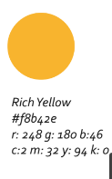


But - if you feel strongly it would look better with more colours - then give it a try.

Fonts

Currently we use Oswald for the headings and Roboto/ Muli for body.

But ignore that and suggest what you think would look best. Only request - the fonts need to be applicable to word, google docs and across all online platforms - and not need to be purchased or downloaded. They also need to be easily readable and not trivial or childish.

As for our personality?

We would love for our look and feel to convey…

- Clarity
- Vibrancy
- Professionalism (and definitely not childish or trivial)
- Tech Savvy
- Simplicity

And how would we like you to express your ideas?

Ideally - we’d love you to re-visualise the first part of our website - specifically these bits…

When it comes to icons- please feel free to completely redesign them

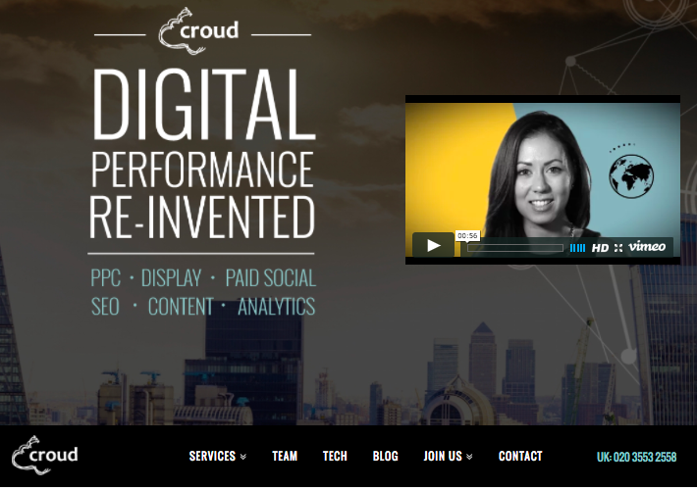
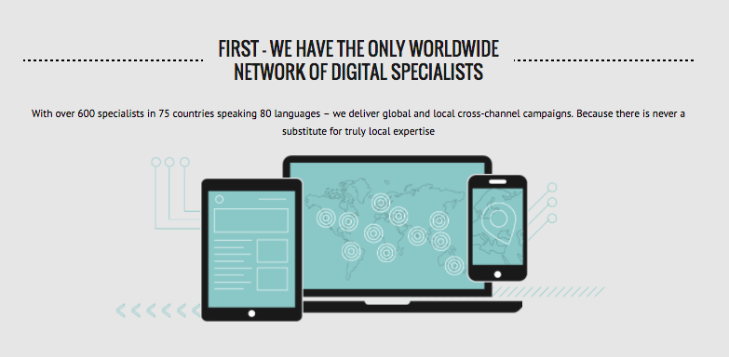
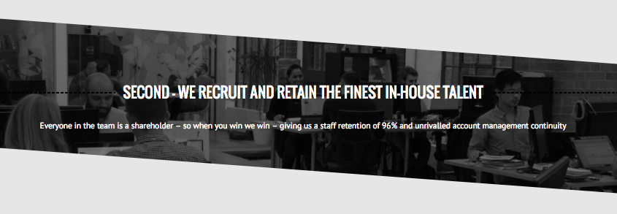
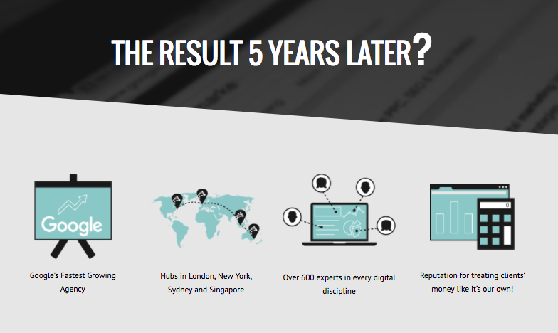
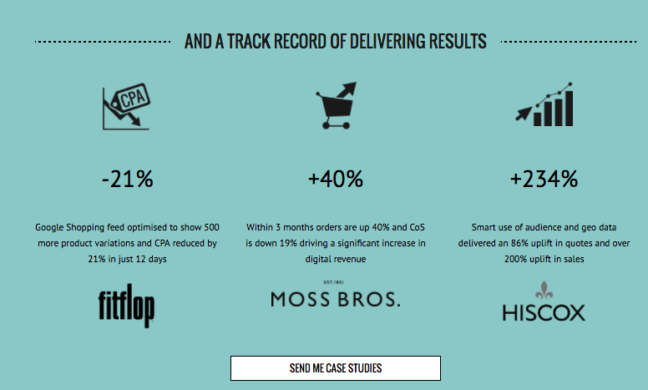

And to avoid time-absorbing re-typing

We’ve attached an editable photoshop file...

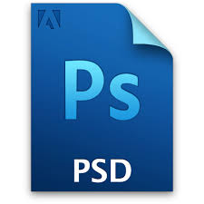

And finally

We will be using the basis of this design to re-do our entire website / decks / reports / business cards etc etc - so we want a design that is simple, but is also all the above - plus we would love to find someone we can work with to do all of this other design work.

Please include all your designs in open design files such as photoshop etc.

Thanks for your interest!

Regards

Croud

