Good afternoon,
- Can we also have the ‘Pioneerkids selections of the month’ moved to the left side and smaller than the logo quote ‘inquisitive minds on adventure’ as it’s just a subheading. That said can we have the ‘Inquisitive minds on adventure’ a little larger.
- Can we have the order of the drop down menus as. Age then Theme then Location (no price). Next to these titles can we have a small image such as a locator point next to ‘location’, two people holding hands adult and child net to ‘age’ and something adventure/city next to ‘theme’, an image to represent the drop down menus. See below:
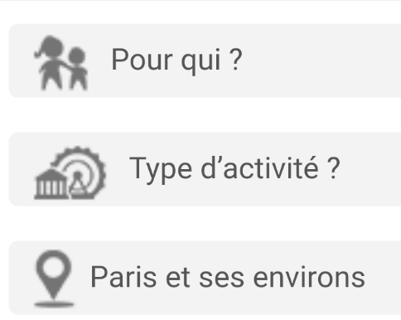

- Can we please use this as a logo instead of what we have at the moment. And the same type of setup as what I have here. I really like this map of Australia. We have the rights to it and I have attached it as a file for you to use.

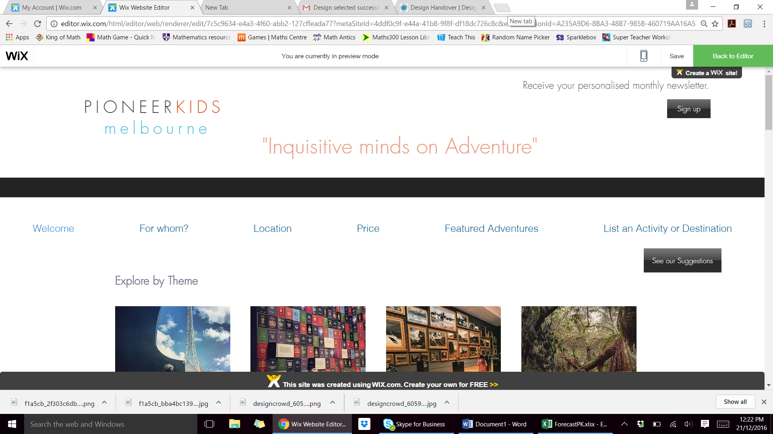
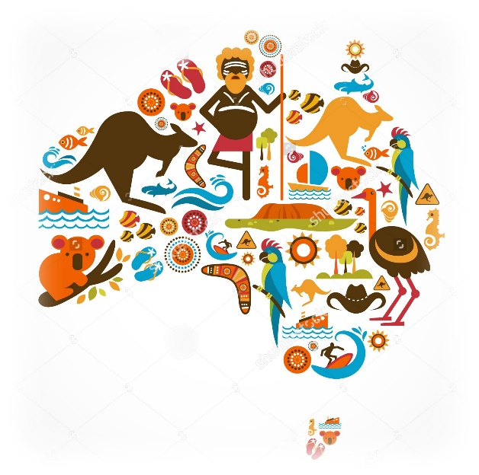

- Can the selection buttons all be the same blue as the blue in the logo please. Can every part of the page have the logo blue/dirty orange also? Makes it calmer.

- Could you please add a ‘calendar’ to the tabs (in blue at the top of the page, on the left of ‘add and activity’ .
Let me know how you go. Thanks

