

Mission Statement:
The HusomeStrong Foundation is a non-profit charitable organization established to assist people who have experienced the loss of a limb and are seeking assistance to realize their full potential, and live their lives to the fullest after amputation.

Services:
- Financial Assistance
- Peer support
- Awareness and Advocacy
For more information, please visit our web site: www.husomestrong.com

How you can help:
- Tell all your friends, neighbors and colleagues about our mission
- Visit our web site at www.husomestrong.com and make a donation
- Like and share our story on facebook: www.facebook.com/husomestrong2016

What your donations will be used for: 1) Aid in the purchase of prosthetic devices for those unable to pay 2) Sending kids to Amp Camp 3) Help qualified amputees access high tech devices to improve their daily lives

Who benefits from our services: We would love to help everyone who applies for a grant, unfortunately that won’t be possible in some cases. If needed, our priorities will be to help children, veterans and then everyone else possible.

We’re not asking for much, just an arm and a leg!

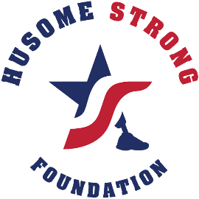
Some facts about limb loss:
- There are nearly 2 million people living with limb loss in the United States
- Among those living with limb loss, the main causes are vascular disease (54%) – including diabetes and peripheral arterial disease – trauma (45%) and cancer (less than 2%)
- Approximately 185,000 amputations occur in the United States each year
- In 2009, hospital costs associated with amputation totaled more than $8.3 billion
- Nearly half of the individuals who have an amputation due to vascular disease will die within 5 years. This is higher than the five-year mortality rates for breast cancer, colon cancer, and prostate cancer
- The majority of traumatic injury amputees are between the ages of 15-40
- 80% of traumatic injury amputees are men

The need in the Cedar Valley has never been greater:

When a person becomes an amputee, they are faced with staggering emotional and financial lifestyle changes. Fortunately, high tech prosthetic devices that restore a person’s basic skills and independence are available. Unfortunately, many amputees lack the financial resources to obtain adequate prosthetic care.
That’s where the HusomeStrong Foundation steps in. Our goal is to provide a financial bridge between those amputees needing assistance and the quality prosthetic care needed to restore their lives.

