Now
Enrolling
2016-17 for Grades k-6th






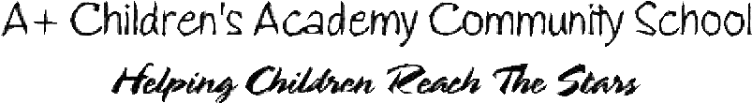

A+ Children’s Academy Community School is the most innovative public elementary school program in Central Ohio through integration of the fine arts in all subjects.
All grade levels take visual arts, music, drama, and dance.
Small class sizes with Highly Qualified teachers in the core subjects, beautiful facilities with a five acre campus provide for
an outdoor learning experience, and a dedicated staff committed to a positive learning environment are just a few reasons that
you will be amazed by this performing arts community school.
Breakfast and lunch are provided at no cost to you! All of this tuition free! Please contact us for a tour of our school.
Classes fill up quickly so call today to ensure your child’s enrollment for the 2016-17 school year.
A+ Children’s Academy
Community School
114 Obetz Road
Columbus, Ohio 43207
Phone (614) 491-8502 www.APlusChildrensAcademy.org
CO-0006052580-01
 | PROOF O.K. BY:___________________________ PLEASE READ CAREFULLY • SUBMIT CORRECTIONS ONLINE |  | O.K. WITH CORRECTIONS BY:________________________

CO-0006052580-01 (100%)
ADVERTISER: A+ CHILDRENS ACADEMY COM PROOF CREATED AT: 6/16/2016 2:32:49 AM
SALES PERSON: COBJAMESON NEXT RUN DATE: 06/19/16
SIZE: 3X6.6 PROOF DUE: 06/16/16 11:59:55
PUBLICATION: CO-SOUTH SIDE

