Website Content- Changes & Content

Home Page- Contact Information
Call Us- 0487 722 964
Email Us- seniorsmca@outlook.com
Please remove the ‘ENG’ option.
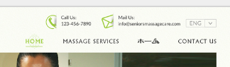

Home Page-
Slideshow Images (2 in total)- the following are in order of appearance
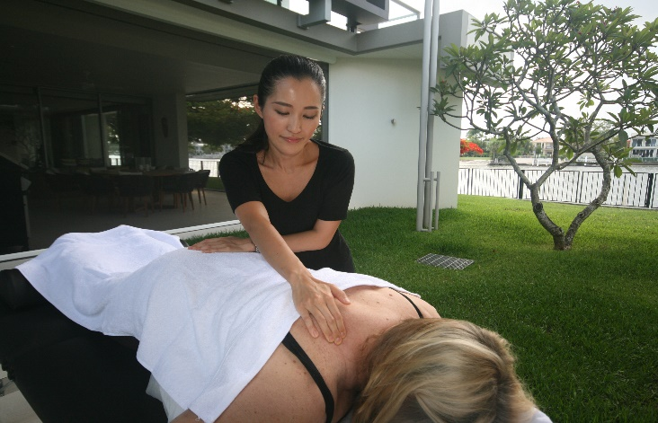
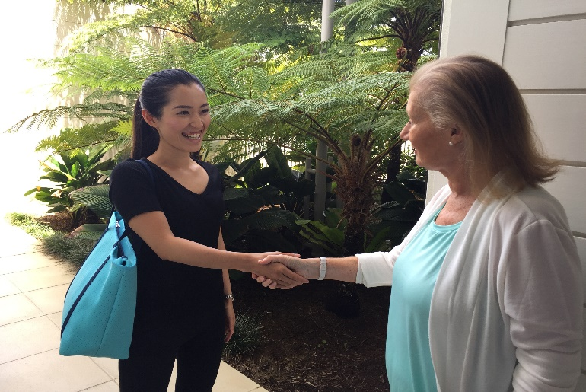

Home Page- (below slideshow)
Example of how this section should look below, however, I have supplied a lot more text for this section so we might need to use 2 images vertically instead of the one.
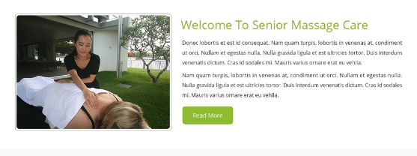

*Please add two images vertically (with the text running down the right-hand side) and a ‘Read More’ tab like the above. The ‘Read More’ tab should lead to the ‘Massage Services’ page if clicked.
Content:
Heading: About Seniors Massage Care Australia
Seniors Massage Care Australia (SMCA) is a mobile massage service for seniors living on the Gold Coast. We offer a variety of different massage treatments, including; relaxation, remedial, shiatsu and reflexology. Most of our clients are over 50’s, however, we also provide massage services for all ages.
What does mobile massage mean? Once you’ve made a booking with us by phone or email, we will arrange for a therapist to come directly to your house, business, facility or apartment. Our therapists bring all the required equipment directly to your place of residence. After you’ve received your amazing massage experience, our therapist will pack up and be on their way.
SMCA is focused on providing a comprehensive service that builds relationships between clients and massage therapists. We take time each session to listen to you and ensure that we understand any ailments, injuries or concerns that you would like us to be aware of. We also track each session with an electronic database to ensure continuity between sessions.
EFTPOS facilities are available for client convenience and gift vouchers can also be purchased.
We invite you to take the time to explore our website as a source of information for learning about the art of massage therapy.
If you would like more information on what massage can do for you, feel free to contact us, we’d love to help.
Images for this section:
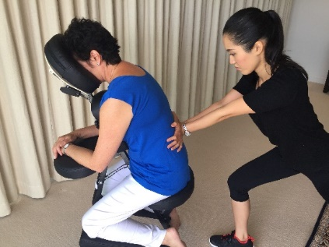
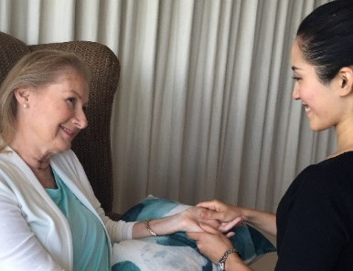

Home Page- Our Massage Services:
Happy to use the images you have already chosen, but can you please insert an image of a man receiving a massage into the remedial section. Also, can you please order the 4 services from left to right as follows:
1.Relaxation
2.Remedial
3.Shiatsu
4.Reflexology
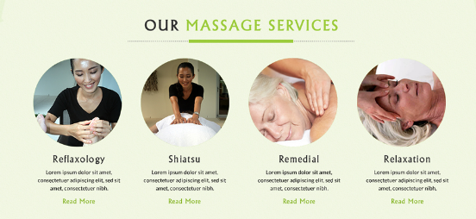

Content for these sections on the home page:
1. Relaxation
A therapeutic massage style that focusses on soft, gentle and relaxing strokes.
2. Remedial
An oil massage treatment that can be gentle or strong, deep or shallow.
3. Shiatsu
Promotes energy flow by applying pressure to tense and sore muscles.
4. Reflexology
Pressure is applied to the feet’s reflexes for a relaxing and relieving experience.

* Please keep the “Read More” tabs and make this link to the ‘Massage Services’ page if clicked.

Massage Services Page- (top of page, Section 1)
Horizontal Image at the Top of the Page:
Please insert a Stock Image of a man receiving a massage.

Content:
Heading: The Benefits of Massage
There are many great benefits from receiving regular massages, including; stress relief, reduced pain and improved sleeping patterns to name a few. Each of the different massage services below share common benefits, however, each style is unique in what it can offer you. To find out more, please read about each of our massage services listed below to discover the right one for you.
Clients of Seniors Massage Care Australia (SMCA) engage us for a variety of reasons, including; relaxation, injury rehabilitation, anxiety relief, pain relief and to improve general overall health and wellness. Other great reasons to consider SMCA is to improve joint mobility, circulation, lymphatic drainage and general massage tension.
Depending on what service you are considering, we can provide our sessions on either a traditional massage bed or a stand-up massage chair. Clients can elect to remain clothed or semi-clothed during the massage session.
If you would like to receive one of our incredible massage services, just follow these three easy steps:
- Choose the massage service that’s right for you
- Decide the length of time that’s right for you
- Contact us to make a booking
It’s that simple!
Heading 2: Client Massage Limitations & Contraindications
It’s important to know that there are times when a massage treatment is not recommended, or a modified session should be considered. A contraindication is a condition or factor that may make an approach harmful (S. Fritz: Mosby’s Fundamentals of Therapeutic Massage, 5th Edition). Contraindications may be further subdivided by severity.
- General avoidance of application: Do not massage- includes but not limited to:
  - Fever
  - Contagious diseases, including any cold or flu
  - Under the influence of drugs or alcohol-including prescription pain medication
  - Skin diseases
- Regional/local avoidance of application: Perform massage but avoid a particular area - includes but not limited to:
  - Varicose veins
  - Pregnancy
  - Cuts and Abrasions
  - Undiagnosed pain
- Application with caution and adaptation, usually requiring supervision from appropriates. medical or supervising personnel: Perform massage but carefully select the type of methods to be used, the duration of application, the frequency, and the intensity of the massage - includes but not limited to:
  - Cardio-vascular conditions (thrombosis, phlebitis, hypertension, heart conditions)
  - Any condition already being treated by a medical practitioner
  - Oedema
  - High blood pressure
  - Cancer
  - Heart problems, angina, those with pacemakers
  - Epilepsy
  - Diabetes

Prior to commencing each treatment, we will ask you to confirm if any of the above mentioned applies to you. This is to ensure that both the client and therapist remain safe at all times.

Massage Services Page- Section 2
Heading:
Step 1- Choose the Massage Service Right for You
1
Add Stock Image to this section:
Relaxation massage

Relaxation massage is a favourite amongst clients that prefer a therapeutic massage style that focusses on softer, flowing strokes, rather than the application of direct pressure to sore muscles. Relaxation massages are a great way to unwind the body’s tension and free the mind from your daily pressures and thoughts.

Massage oils are used during these sessions to ensure that the therapist can glide over the body with ease and grace, whilst still having the ability to work on the client’s sore muscle areas.

- Relaxation massage is a great way to promote:
- Improved sleeping patterns
- lymphatic drainage improvement; allows the body to naturally detoxify
- immune system improvements
- Greater circulation
- Reductions in head aches and muscle fatigue/soreness

Recommended Treatment Length:

30 minutes- one problem area
45 minutes- two to three problem areas
60-90 minutes- fully body treatment

2
Add Stock Image to this section:
Remedial Massage

Remedial massage provides a healing treatment that can be gentle or strong, deep or shallow. When muscles and tendons become damaged, impaired, knotted, tense or immobile, remedial massage provides an effective healing treatment.

Remedial Massage is an effective way to assist in the treatment of the following conditions and ailments:
- Stress and tension
- Neck and back pain
- Frozen shoulder
- Arthritis
- Sciatica
- Tennis elbow
- Plantar fasciitis

Recommended Treatment Length:

30 minutes- one problem area
45 minutes- two to three problem areas
60-90 minutes- fully body treatment
3
Add Stock Image to this section:
Shiatsu

Shiatsu is a form of massage that originated in Japan in the 1970s and involves the therapist using varied pressure on certain points of the body to relieve the client’s muscle tension.
Shiatsu is a great way to promote energy flow and provides a relaxing experience for the client. This style encompasses a dry massage technique, meaning that the client remains clothed during the session.

Shiatsu Massage is an effective way to assist and improve the following:
- Restoring the body’s energy and circulation
- Reducing stress and tension
- Relief from headaches
- Promotes healing and circulation around injuries such as strains
- Assists with relief to arthritis sufferers
- Reduces stiffness in areas like the back and neck

Recommended Treatment Length:

30 minutes- one problem area
45 minutes- two to three problem areas
60-90 minutes- fully body treatment

4
Add Stock Image to this section:
Reflexology

Reflexology works on the fundamental principle that there are reflexes in the feet that correspond to every organ, gland and part of the body. Feet are the body’s connection to the earth and are responsible for bearing a significant load of the body’s weight every day. Whether you are using them for walking to the kitchen, up a flight of stairs or to the top of a mountain, it is incredibly important to take care of your feet.

During Reflexology treatments, pressure is applied to the feet’s reflexes with thumbs and fingers, and lead to the following benefits:

- Improved circulation and energy levels
- Stress reduction
- Improved immune system

Reflexology can also assist with the treatment of:
- Allergies
- Arthritis
- Asthma
- Back Problems
- Frozen Shoulder
- Insomnia
- Muscle Tension
- Neck Problems
- Stress Disorders
- Thyroid Imbalance

Recommended Treatment Length:

30-45 minutes- time will be split between both feet. We don’t recommend treatment on one foot only. This is to do with balancing the body.
60 minutes– we don’t recommend clients receive treatments longer than 60 minutes

Massage Services Page- Section 3
Heading:
Step 2- Decide the Length of Time Right for You
* Please use the format and texts below, however, the images should be changed.
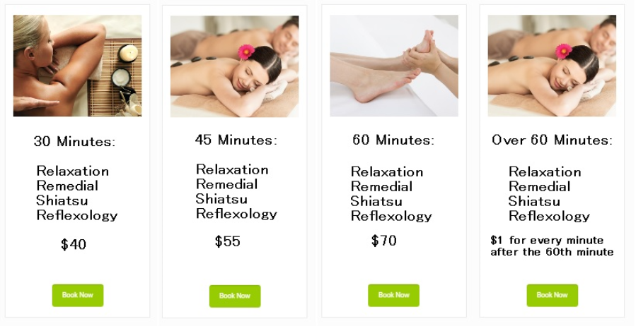

Massage Services Page- Section 4 (bottom of the page)
Step 3: Contact Us to Make a Booking
Insert ‘Book Now’ Tab in large font- once clicked on, this should take the person to the ‘Contact Us’ page.

ホーム – (Top of Page 3, section 1)
Image across the top of the page- same as the ‘Massage Services’ image
All formatting and imagery is the same for these sections as the ‘Massage Services’ page.
定期的にマッサージを受けることによって、疲労回復、筋肉の痛みを和らげる、快適な睡眠に導くなど良いことが沢山あります。

私たちが提供する各マッサージには共通した効果、または変わった効果などがあります。
もし宜しければ詳細をみていただき、あなたにピッタリなマッサージをさせていてただきます。

シニアマッサージケアオーストラリアのお客様が、私たちのマッサージをご利用される理由は、心身ともに安らぐため、ケガをされたあとのリハビリ。またはカラダの動きの助け、新陳代謝を高めるなど様々の素敵な理由があります。

お客様ひとり一人によって、私たちはマッサージをする際に横になるタイプ（マッサージベッド）と椅子に座るタイプ（マッサージチェアー）を選び、施術を致します。

もしマッサージにご興味がある方は、次の3つのステップへお進み下さい。
1、マッサージの種類を選ぶ。
2、マッサージを施術時間を選ぶ。
3、Eメール、テキストまたは電話にて、ご予約下さい。

マッサージを受けられるお客様への制限または、禁忌事項

マッサージを受けられる前に、マッサージをオススメしない方、または状況によって普段とは異なる特別な施術をするかなど 私たちとお客様にとって重要なポイントとなります。

禁忌というのは、万が一マッサージを受けた場合 身体に影響を及ぼし、危険をもたらすことです。

以下に当てはまる方は、体調の悪化、病状の悪化を招くおそれがあるため、マッサージを行うことができません。

- 高熱のある方
- 感染症、伝染病にかかっている方
- お酒を飲んでいる方
- 皮膚の炎症のひどい方 など

以下に当てはまる方は、必ず事前にお申し出ください。

- 静脈瘤がある方
- 妊娠中の方
- 切り傷、擦り傷がある方
- 診断無しの痛みがある方 など

以下に当てはまる方は、必ず主治医の了承得てから、お申し出ください。 マッサージをする際、ひとり一人にあった施術を選び行います。

- 持病のある方 ー 心臓疾患 など
- 医師に処方されたお薬を服用中の方
- 浮腫がある方 ー 静脈瘤、リンパ腫 など
- 高血圧の方
- 癌をお持ちの方
- 神経疾患の方
- 糖尿病の方

※上記に当てはまる方が事前にお申し出をされなかった場合や虚偽の申告をされた場合、体調・症状の悪化に対して私たちが責任を負うことはできませんので、十分にご注意ください。

マッサージを受けられる前に、以上のチェック項目を確認致します。毎回の施術に対し、安全を守るためです。

ホーム –(Section 2)
Heading:
1、マッサージの種類を選ぶ。
5
リラクゼーションマッサージ (Relaxation massage)
リラクゼーションマッサージは、お客様の中で好まれてるマッサージの一つであり、身体的・精神的なストレスから解放された状態へ誘導します。

リラクゼーションの効果
・ 疲労回復
・ 首や背中の痛み
・ 四十肩・五十肩
・ 関節炎
・ 坐骨神経痛
・ テニス肘（上腕骨外側上顆炎）
・ 足底筋膜炎

オススメの施術時間
・ ３０分 １ヶ所を重点的に施術
・ ４５分 ２－３ヶ所を重点的に施術
・ ６０-９０分 全身トリートメント

6
リメディアルマッサージ (Remedial massage)
リメディアルマッサージとは、ひとり一人に合わせたトリートメント治療です。痛みの箇所のみではなく、痛みとなっている元の『原因』を見つけ出し施術をしていきます。

リメディアルマッサージの効果
- 肉体的疲労・筋肉痛を穏和
- 首や背中の痛み
- 四十肩・五十肩
- 関節炎
- 坐骨神経痛
- テニス肘（上腕骨外側上顆炎）
- 足底筋膜炎

オススメの施術時間
- ３０分 １ヶ所を重点的に施術
- ４５分 ２－３ヶ所を重点的に施術
- ６０-９０分 全身トリートメント

7
指圧 (Shiatsu)
指圧とは、１９７０年頃に独自の手技療法とし、全身にあるツボを刺激することで、不調を改善していきます。また自然治癒力を高め、心身をリラックスさせます。また施術中は、衣服の上からマッサージをしますので、薄着でゆったりした格好がおすすめです。

指圧の効果
- 自然治癒力を活性化
- 免疫力を高める
- 疲労回復
- 身体の歪みを改善
- 関節炎
- 筋肉のこり・痛みを穏和（腰痛・首など）

オススメの施術時間
・ ３０分 １ヶ所を重点的に施術
・ ４５分 ２－３ヶ所を重点的に施術
・ ６０-９０分 全身トリートメント

8
リフレクソロジー (Reflexology)
リフレクソロジーとは、足裏などにある身体全体の臓器や器官の「反射ゾーン」を指で刺激することにより、血液やリンパの流れを良くします。足は身体と地球と繋がっており、身体を支えるのに大切な役目をしています。例えば台所まわりを歩いたり、階段を上ったり、山に登ったり、どんなときでも。足のケアはとても重要です。

リフレクソロジーの効果
- アレルギー
- 関節炎
- 喘息
- 腰痛
- 四十肩・五十肩
- 睡眠不足
- 筋肉のこり
- 首の痛み
- ストレス障害
- 甲状腺のバランス

オススメの施術時間
- ３０分－４５分
＊時間を分けて片足ずつの施術となります。片足のみの施術だと、バランスが取れないのでオススメは致しません。
- ６０分
＊６０分以上の施術はオススメ致しません。

ホーム – (Section 3)
Heading:
2、マッサージを施術時間を選ぶ。

ホーム – (Section 4, bottom of page)
Heading:
3、Eメール、テキストまたは電話にて、ご予約下さい。

Insert ‘Book Now’ Tab in large font- once clicked on, this should take the person to the ‘Contact Us’ page.

Contact Us
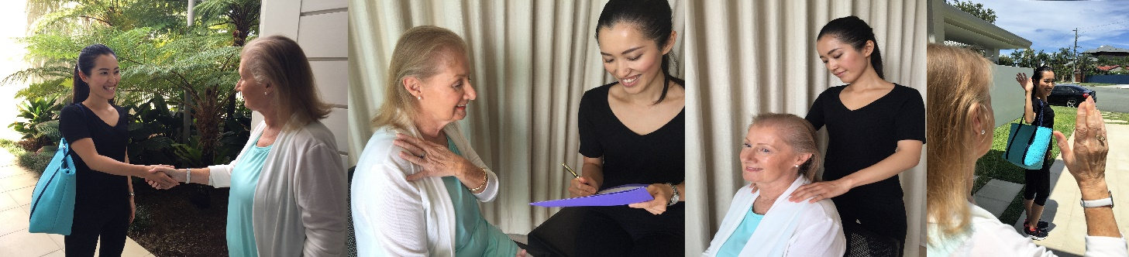
Horizontal Image at the Top of the Page:
*This is a combination of 4 photos.
Content:
If you would like to make a booking, you can do so in one of three ways:
- Call Us- 0487 722 964
- Email Us- seniorsmca@outlook.com
  - Please provide us with your preferred booking date and time, address, length of massage session you require and all other necessary information. We will reply to your email and endeavour to accommodate your request.
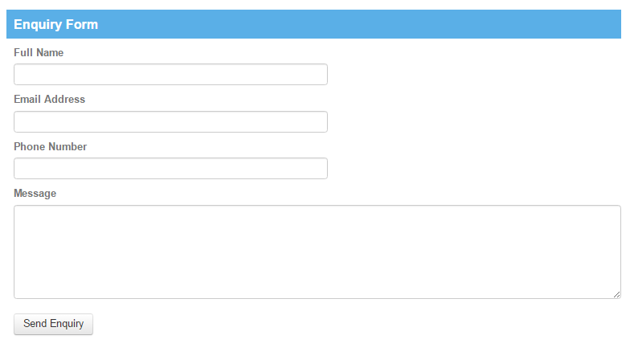
- Enquiry Form- If you would like to make a general enquiry or booking request without sending us an email, please do so by filling out the form below. We will follow up and contact you directly via email or phone.

