GLENCO PRODUCT BROCHURE 2017
Clever Solutions For Your Home
DIMMERS

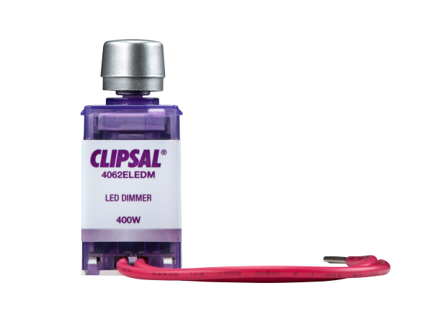
Adapts lighting to brightness preference
Creates mood lighting
Energy saving

DOUBLE POWER POINT WITH USBs
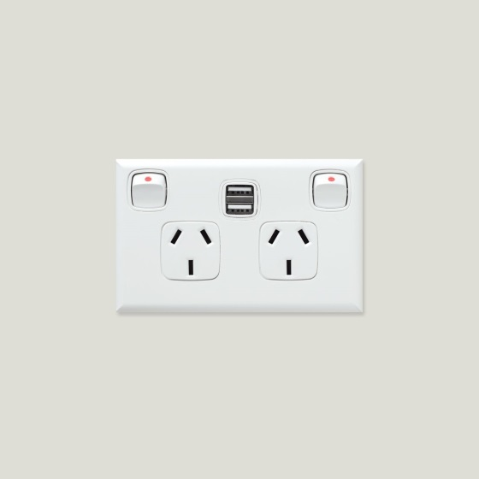
2 x 2.1 AMP USB sockets for faster charging
Reduces clutter and bulky chargers
You can charge two devices such as your smart phone and tablet at once
More space for other appliances to be plugged in

IXL HEAT/LIGHT/FAN – 2 AND 4 HEAT

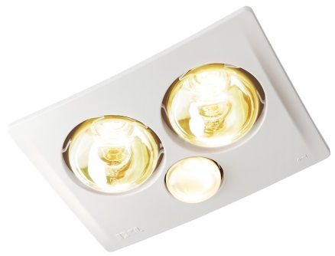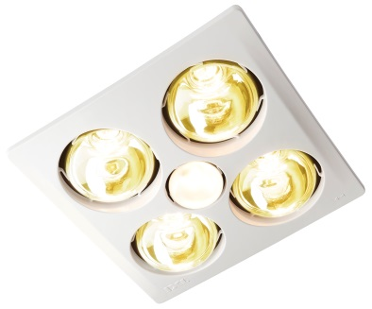
2 or 4 x heat lamps for instant heat and comfort
Powerful extraction to prevent steam and mould build up
Option of 275W or 375W Heat Lamp

PHOTOELECTRIC SMOKE DETECTORS
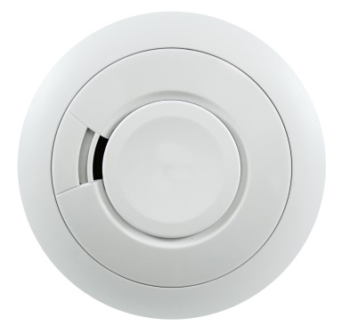
240V HARD WIRED WITH REPLACEABLE BATTERY:
Battery backup with connection to mains power
Hush button in case of false alarms
Separate mains and warning LED’s
Photoelectric alarms are responsive to smouldering fires as opposed to flaming fires.
Option to have this interconnected meaning wires will need to be run between smoke alarms
10 YEAR LITHIUM BATTERY:
10 year rechargeable lithium battery (means no need to change batteries)
Option to have this RF connected meaning no wires needed
Hush button for false alarm control
Low cell warning in event of mains or cell failure
Precision charging circuit ensure peak cell performance
Photoelectric alarms are responsive to smouldering fires as opposed to flaming fires.

LED DOWNLIGHT WITH DIMMABLE DRIVER
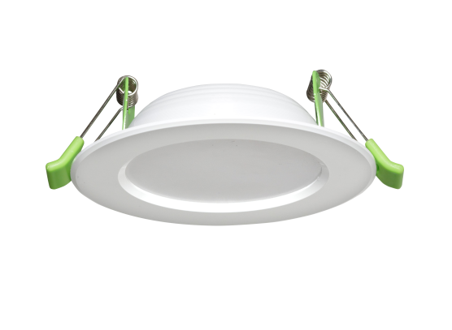
All in 1 fixed or gimbal downlight: cool white, daylight and warm white
Aval in white and satin chrome
Designer finish with slimline lip and recessed face
No harmful effects
Does not overheat
Power saving
Long lasting - low to no globe maintenance cost
Low heat – Dimmable
This fitting has a three-year warranty

LED OYSTER LIGHT

Energy-efficient and low maintenance
Plastic diffuser as opposed to glass diffuser reducing risk of breakage
Three-year warranty
Available dimmable

QUAD POWER POINT WITH USB CHARGING
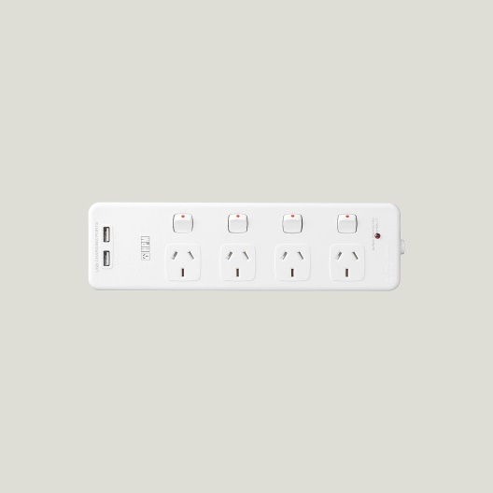
Four power points in one unit
Makes your home neater
Great for when you need to plug in multiple devices or appliances
USB option for convenient charging and even more space saving

SURGE PROTECTOR
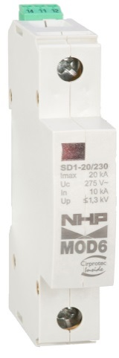
Your appliances are protected against unexpected power surges, lightning strikes and voltage spikes
Keep your TV, laptop, fridge, and other expensive investments safe
Fits easily into your existing switchboard

SAFETY SWITCHES
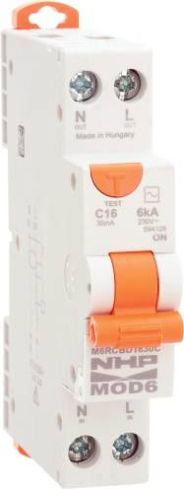

In the event of a fault this device protects you and your appliances
Safety switches are sensitive to minor faults which will prevent larger fault
Industry recommended devices

SECURITY LED TWIN SPOT FLOOD LIGHTS (WITH AND WITHOUT SENSOR)
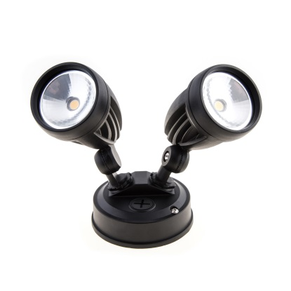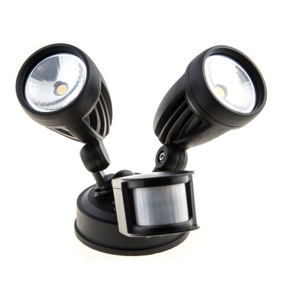
Low heat
Long lasting - low to no globe maintenance cost
Energy saving
Available in black or white
With Sensor: Detects motion and instantly turns on LED light
Timing, lux and distance adjustments

CEILING FANS (WITH AND WITHOUT LIGHT)
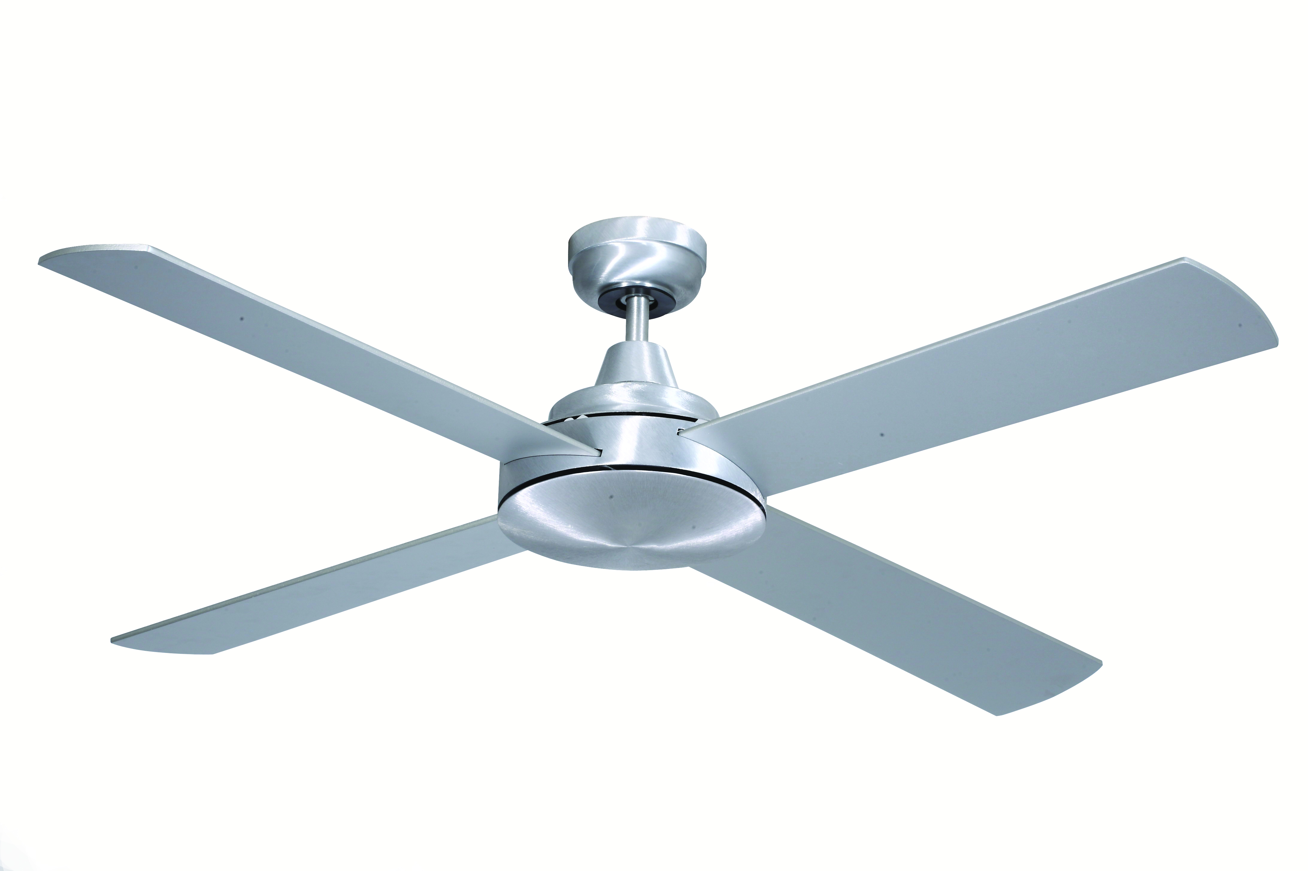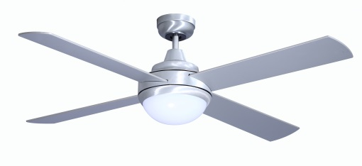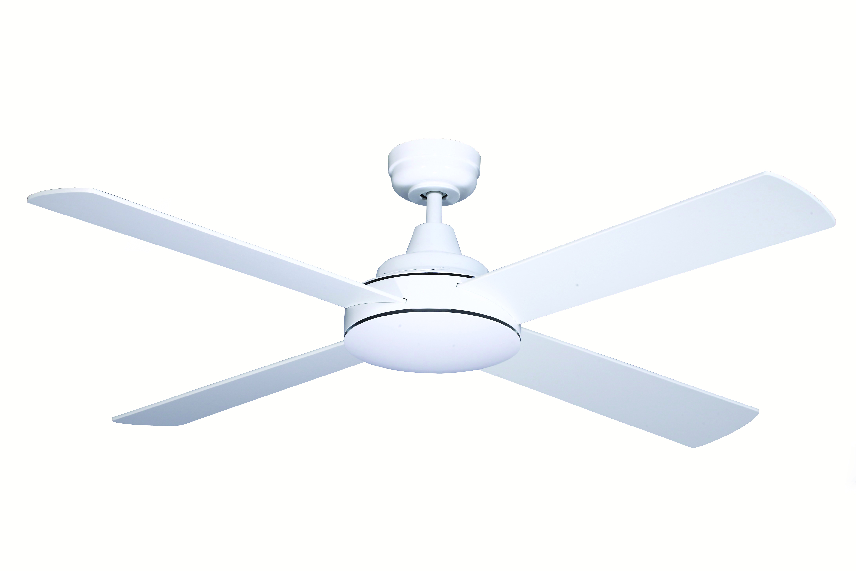
Energy efficient when compared with expensive air conditioning costs
Comes with or without a light
Available with remote control for convenience
Can replace an existing light fitting

UP/DOWN LIGHT
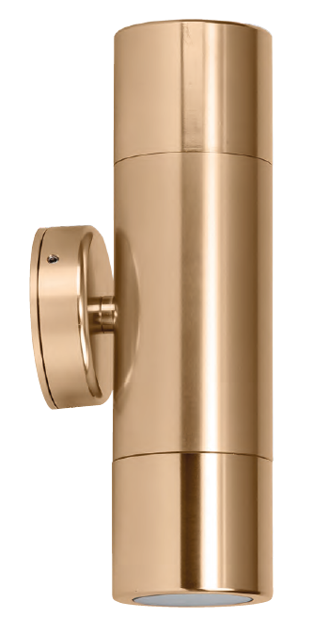
Up/Down wall pillar light
Available in stainless steel, solid copper, matt black, matt white, matt silver, gold, silver, titanium, and bronze
Attractive option for outdoor spaces
High output reflector to maximise light
LED optional

DOUBLE ADJUSTABLE SPOTLIGHTS
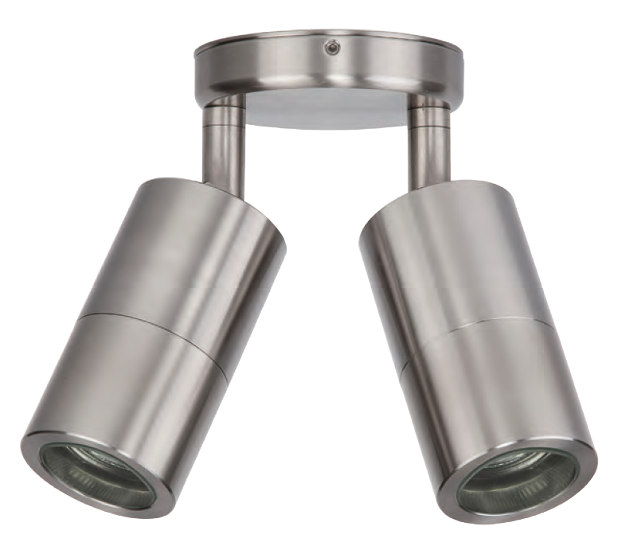
Double adjustable wall pillar lights
Available in stainless steel, solid copper, matt black, matt white, matt silver, gold, silver, titanium, and bronze
High output reflector to maximise light
Create light in the direction you desire
Attractive option for outdoor spaces

LED GARDEN SPIKE LIGHTS
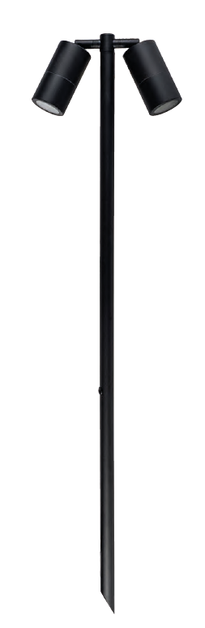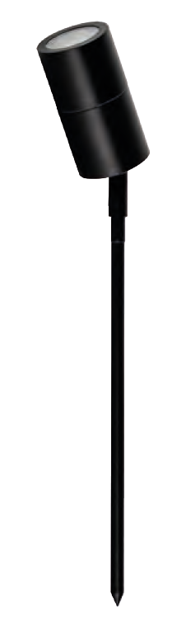
Single or double adjustable spike spot lights
Available in stainless steel, copper, matt black, gold, silver, titanium and bronze
LED optional
Can be used with a halogen globe
Great to light up garden spaces


Glenco Electrical Services
02 9700 9996
service@glenco.com.au
www.glenco.com.au
PO Box 7402, Alexandria NSW 2015

