Please change the words to say “The Wise Choice” and “Never Compromise Integrity”. I just want you to replace the wording with the wording in the white box. I don’t want you to create a white box.

THE WISE CHOICE
NEVER COMPROMISE INTEGRITY
Please combine the section below with the image above. You can change the colors to make it flow.

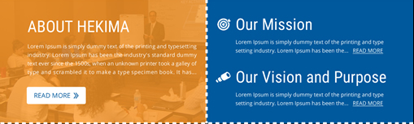
Please add the title “What we do” to this section. You can play with the colors here to make the design flow.

What we do



