THIS IS GOING TO BE 1 SHEET OF A4 SIZE, PRINTED ON 2 PAGES.
NEED TO HAVE COMPANY LOGO, COMPANY ADDRESS, PHONE WEBSITE ADDRESS, EMAILS.

PAGE 1
Smart PENDANT ADVANTAGES:- 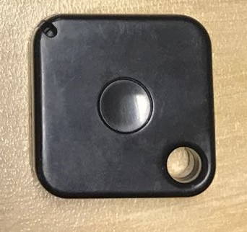
- ACTIVATE HANDS FREE LOCKING SYSTEM
- STAND ALONE SYSTEM ( NO COMPUTER INTERFACE REQUIRE )
- CONTROL RANGE ( 1-3 METRE )
- MULTIPLE USERS – ELDERLY , PHYSICALLY CHALLENGE, KEYLESS, NO NEED SPARE KEYS, provide entry to your home for others at your discretion; can also tell exactly when and how people attempted to access your home ; you can check the open door records through the lock record card
- UNIVERSAL CONTROL SYSTEM, CAN BE FITTED TO MOST ELECTRONIC LOCKING SYSTEMS
- LONG RANGE RFID TECHNOLOGY

Page 2
SMART PENDANT
A SIMPLE STAND ALONE ACCESS CONTROL SYSTEM THAT CAN BE FIT
TED TO MOST ELECTONIC LOCKING SYSTEMS THEN ACHIEVE HANDS FREE ACTIVATION
BASED ON RFID LONG RANGE TECHNOLOGY . SMART PENDANT CAN BE ATTACHED TO A KEY RING,OR LEFT IN YOUR POCKET OR BAG, AND ONCE YOU APPROACH THE SET PERIMETER AREA OF THE DOOR, SMART PENDANT WILL THEN ACTIVATE THE STAND ALONE RECEIVER , WHICH THEN GIVES A OPEN SIGNAL TO YOUR LOCKING SYSTEM.
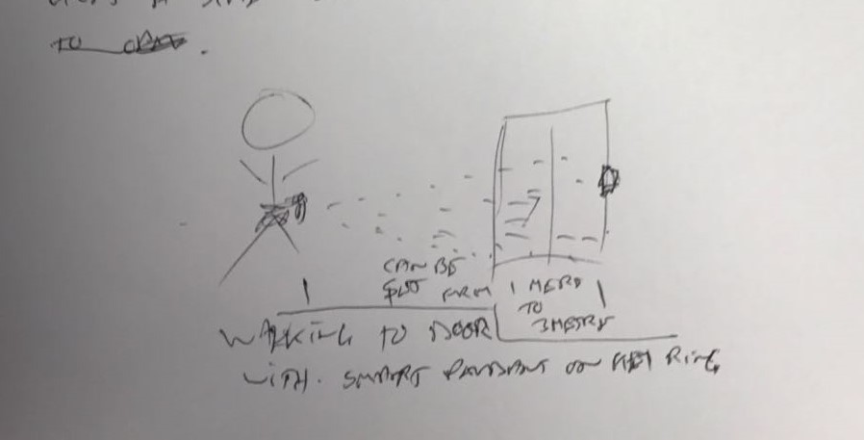
NEED YOUR TO FIND A GIRL WALKING TOWARDS A DOOR, HOLDING A KEY CHAIN, FITTED WITH THIS PENDANT, SHOW A SLIDING GLASS DOOR, AND ON THE DOOR FRAME SHOW A PENDANT RECEIVER ATTACHED TO IT. THEN FROM THE KEY , DRAW THE RADIO FREQUENCY SIGNAL TRANSMITTING IN BLUE COLOR.

The wordings in the picture above are .
Can be set from 1 to 3 metre
Walking to door with smart pendant attached to a key ring

COPY RIGHT, PLEASE COPY BELOW WORDS ON COPYRIGHT CLAUSE. CHANGE THE YEAR TO : 2016 – 2026

