Home Page
- 1200 sq ft home – newly remodeled
- Large yard - ¾ acre lot
- 3 bedrooms
- 1 ½ bathrooms
- Large workshop (approx. 500 sq ft)
- Brand new kitchen appliances
- Central Air / Heat
- Large laundry room
- Conveniently located on LA-1 approx 3 miles to Hwy-190
Home Page should look something like this, but modify to be visually pleasing.
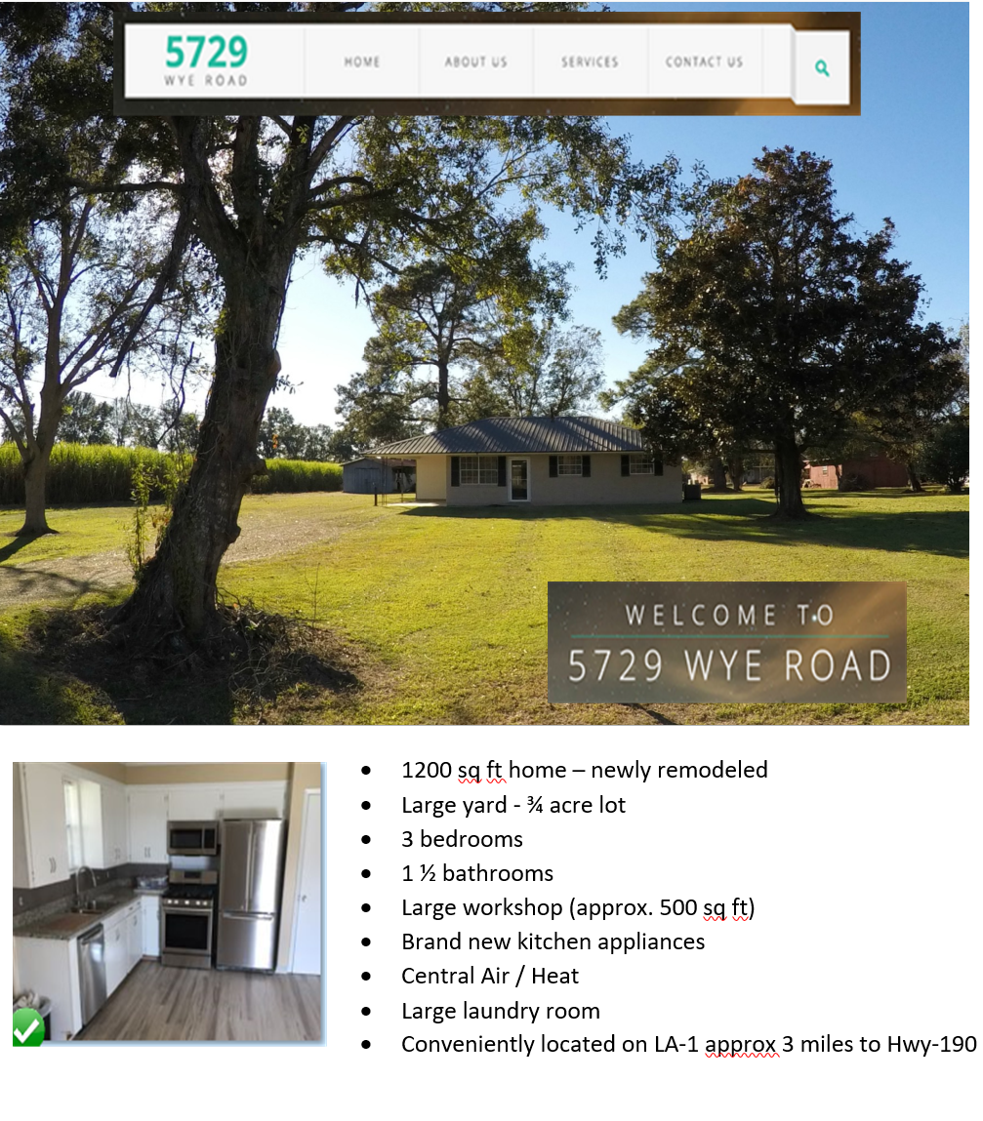
About Page
1200 sq ft home – newly remodeled
Large yard - ¾ acre lot
3 bedrooms
1 ½ bathrooms
Large workshop (approx. 500 sq ft)
Brand new kitchen appliances
Large laundry room
Conveniently located on LA-1 approx 3 miles to Hwy-190
Pets under 50 pounds allowed with non-refundable pet deposit (dogs/cats only)
No smoking inside the house

Rent
$1,000 per month – ACH deduction required
$1,000 deposit

Not included in rent:
- Utilities (Electricity/Gas/Water/Cable)
- Internet / Dish / DirectTV
- Lawn Care
- Renter’s insurance
- Washer / Dryer

Contact Page

Tammi Fabre
Phone: (225) 718-1654
Email: tammi_househunter@yahoo.com

[5StarDesigners – Is it possible to add the email as an image (rather than text) to prevent spam?
Also – please note there is an underscore after the Tammi and before the househunter.]
Photo Gallery Page

[Please add photo Gallery page and insert the photos I previously posted in the brief. Please leave space to add a caption below. I will write in a very short description (2-3 words) of the pictures once you’re done with the website. No more than one line is fine for the caption.]

Terms Page
[5StarDesigners – PDF “terms” to open in new window.]

Other miscellaneous things:
I don’t think I need the search tool at the top.
I don’t think I need the “Our Services” section either, unless it’s a duplicate way to access the other pages.
Remove testimonials
Remove the icons for LinkedIn, Facebook, Twitter, etc. Won’t use those.
Remove the credit card icons/ links at the very bottom – I will only use PayPal as noted in the “Apply Now” page

