Brand Guidelines

Table of Contents

Martek
Martek’s history 2
Martek’s values 7

Our Brand
Who is our customer? 8
Who is our brand identity? 9
Our company’s purpose 11
Our brand personality types 12

Our Look and Feel
Corporate logo 17
Corporate typefaces 18
Using type effectively 19
Talkboxes 21

Photography Guide
Photographic direction 24
Product 27

The Martek Tone & Voice
Our tone and voice 29
Caring 31
Real 32
Innovative 33
Straightforward 34
Positive 35

Internal Communication Resources
A4 letterhead 37
Internal posters 38
Email signature 39
Business card 40
Compliments slip 41
PowerPoint slides 42
History

2005 – Launched MariNOx
2005 – Winner of the 2 Queens Awards
2005 – Sales of £4.7m
2006 – Sales of £2.8m
2006 – Martek reaches 23 employees
2007 – Martek Relocated to Adwick Park
2007 – Sales of £3.9m
2007 – Martek reaches 30 employees
2008 – Sales of £5.5m
2008 – Martek reaches 45 employees
2009 – Sales of £6.5m

2000 – Martek Incorporated
2001 – Martek’s First Office
2001 – Awarded ISO9001
2001 – Launched MM5000
2001 – Launched SENTRY
2001 – Launched CENTURION
2001 – Sales of £160,000
2002 – Sales of £492,000
2003 – Launched BULKSAFE
2003 – Launched VECSAFE
2003 – Sales of £1.5m
2004 – Sales of 3.4m

Martek’s Timeline

History
2010 – Deployment of Epicor ERP system
2010 – Launched FASTCALGAS
2010 – Launched NAVGARD
2010 – Sales of £4.8m
2010 – Martek at 35 employees
2011 – Sales of £5.3m
2011 – Martek at 38 employees
2012 – Launched ABC
2012 – Sales of £6.9m
2012 – Martek at 46 employees
2013 – Sales of £7.1m
2013 – Martek at 52 employees
2013 – Awarded ICS ServiceMark accreditation
2013 – Awarded IIP Gold Standard
2013 – Launched Drinksafe
2014 – Launched iECDIS

The idea for Martek was born after a chance encounter between Mike Pringle and Paul Luen in 1993. Mike was selling gas detection systems for a new company based in Wakefield and Paul was working for a plastics company in Featherstone. Paul was working in process technology and asked Mike for a job in sales - 2 weeks later Paul resigned from the plastics company to join Mike. Steve Coulson came into the picture in 1994 after a career as a hydrographic surveyor, navigator, sales representative and medical purchasing manager and joined Mike and Paul in a marketing role.

After a few years all working together, the concept of Martek was born. Mike, Steve and Paul had become disillusioned by the lack of vision and drive and opportunity where they worked. In 2000, Martek was created and incorporated in Northumberland with an initial investment of just £6,000 between the three of them.

For the first six months, no-one earned a salary and all three worked every hour to put in the foundations of the business.

After accessing a grant, the first office was opened, a 3m x 3m unit in an old school. Too tight a space for the three to fit into, early days saw the office being shared as best as they could.

It was pursuit of this opportunity which was the original catalyst for Martek and what a success it turned out to be! BULKSAFE became the world market leader generating >£10million in sales and helping Martek win two Queens Awards for Enterprise in the Innovation and International Trade categories.

The revenues from BULKSAFE were re-invested in further research and development to deliver a pipeline of new product launches. The second significant product was MariNOx engine exhaust gas monitoring system - another massive success which became a world market leader and has delivered approaching £20million in revenue to date.

In the very early days the company earned revenue on supplying and servicing gas and temperature monitoring systems. Paul and Mike regularly worked in South Wales sharing a room in a £12.50 a night bed and breakfast - separate beds of course! Steve worked tirelessly to draft all of the marketing literature to support the products.

Steve, Paul and Mike spent months looking at what they could offer that would 100% differentiate them in preparation for the upcoming legislative water ingress alarms, needed for bulkers and BULKSAFE was launched to detect water ingress into bulk carrier ships.

As the years have passed, the increase in revenue for the company has led to many new faces joining the Martek team. The passion and determination that each and every individual has, as a member of the Martek ‘family’, is second to none.

The outlook for Martek looks really bright with a compelling new Vision and clear strategic objectives going forward.

The company has enjoyed many successes and like most businesses has been through some tough times. In January 2009 at the onset of the worldwide recession, Martek was forced to make a quarter of the workforce redundant, whilst those that retained their job reverted to a four day week. This was a particularly dark time in Martek’s history for obvious reasons, but despite all of this, the company and its employees managed to pull through. In fact the 5 day week was restored within 12 weeks and Martek began to invest for the future again.

Martek’s Values

- Taking ownership to delight customers, WOW at every opportunity and deliver a legendary customer experience
- Doing business with warmth and personality whilst having fun to stand out from the crowd
- Pioneering disruptive propositions to challenge current thinking
- Nurturing exceptional people into winners through continuous training and assessment
- Embracing ICT innovations to perfect customer experience and maximise operational efficiency

Our values and personality

Martek is known for its warm personality, strong culture and enthusiasm for providing Legendary Customer Service

These values are reflected in Martek’s identity

Who is Our Customer?

There is only one boss. The customer. And he can fire everybody in the company from the CEO on down, simply by spending his money somewhere else. Like every great business story, ours must start with the customer. What they want is most important.

Legendary Customer Experiences.

And though each person is different from the next, they all appreciate how we offer them new solutions to improve the safety and performance of their ships.

Effective communications? They’re just not possible unless you know who you’re talking to.

Our customers.
Our boss.
What is Our
Brand Identity?

We convey our brand identity through every form of communication and experience. Through the products we sell, how we look, how we act and what we say. Everything we do has a direct impact on how the world perceives us. It’s crucial that the experience our customers have with our brand, be the best possible.

Brands are built over time. And over time, we’ll measure our brand’s success by the alignment of the communications and experiences people have with our brand.

The Martek brand identity is like the Virgin of the marine industry: quality products offering value for money; innovation to offer competitive challenge; Fun and quirky communication via brilliant customer service.

Easy to do business with

Communication practices

Culture

Knowledgeable people

The Martek brand identity is the complete alignment of what customers see, hear, read, experience and think about Martek products and services

Brands exist
in the mind
Distribution channels

Safety policies

Public relations

Financial performance

Customer service

Quality products

Innovation

Unbeatable value propositions

To pioneer new solutions to improve the safety and performance of ships

Our Company’s Purpose

It drives all our business decisions and actions. It’s the guiding philosophy we communicate with pride, both internally and externally.

Our company’s purpose is our reason for being:

Our Brand Personality Traits

Caring
We’re helpful and very engaged. Our customers trust us and we work hard at never letting them down. We treat our customers as individuals so they feel comfortable and welcome – just as we’d treat our loved ones. We always assess a situation from the customer’s point of view and enjoy giving legendary customer service. We never argue with a customer.

It’s our job – all of us as keepers of the brand – to make sure that all of our communications are consistent with the following brand personality traits. At the very least, it’s up to each of us to ensure that our communications do not conflict with the traits.

Innovative
Real
We pioneer disruptive propositions to challenge current thinking. We innovate in smart ways to make our customers' lives easier. Staff have the authority to innovate make customers happy. We anticipate our customers' needs and deliver on them. We're not complacent.

We’re down to earth and friendly. We treat every customer like a regular. We’re unpretentious and human, doing business with warmth and personality whilst having fun. We take customer satisfaction seriously. Always.

Straightforward

We're straightforward and not complicated.
Simple, knowledgeable and upfront with customers, suppliers and employees.
We speak in plain English centred around customers' needs and what you see is what you get. We always tell the truth - no hidden agenda or ulterior motives.
We always sincerely say sorry like we REALLY mean it, explain what happened (no excuses) and say what we're doing to correct it and prevent it happening again. We always keep our promises.

Positive
We're flexible and exhaust every option to satisfy a customer before saying no.
We have a 'can-do' attitude and always under-promise & over-deliver.
We take ownership to delight customers and WOW at every opportunity.
We're reliable and consistently get the basics right.
We do it right, or not at all.


Our Look and Feel

The core design elements are the essential visual elements of our brand – the Martek logo, typefaces, colour palettes, imagery, and graphics – and are the starting point for any Martek communication.

A Comprehensive Visual System

In keeping with our updated brand approach, we’ve created a complete set of design guidelines. These guidelines are intended to ensure consistency over just about every instance of customer contact. How? By building a deeper and more emotional connection to our customer. It’s subtle, yet so tangible when executed properly.

That’s why it’s our duty as keepers of the brand to protect, support and communicate our brand clearly and consistently in everything we say and do. Do this and the strong, positive perceptions created will drive new customers to buy from us and existing customers to spend more with us.
Corporate Logo - Marine
The corporate colours shown are the only colours the Martek Marine brand should be reproduced in.

Where possible the Martek logo should be produced in its positive form as shown.

Exclusion Zone
The logo should always have clear space around it so it doesn’t look crowded. There is an absolute minimum amount of space that must be left clear at all times. This is the equivalent of the height of the letter ‘e’ in Martek as shown.

Secondary Colour Palette

Pantone 2995
CO83 M001 Y000 K000
RO8O G177 B234
HTML 05B1EA

Pantone 369
C073 M000 Y100 K000
R119 G172 B054
HTML 77AC36

Pantone 130
C000 MO35 Y100 K000
R229 G172 B000
HTML FOAB00

Primary Colour Palette

Dark Blue
Pantone 303
C100 M047 Y023 K079
R000 G031 B051
HTML 001F33

Light Blue
Pantone 2995
CO83 M001 Y000 K000
R080 G177 B234
HTML 05B1EA

Corporate Typefaces

When used correctly, typography can convey image and feeling every bit as much – and sometimes more – than simple graphics. We’ve selected a type family that gives Martek a friendly, warm and real voice: Calibri.

Calibri says approachable and “straightforward” and is easy to read. (You’re reading it now. Nice isn’t it?)

Compared to similar typefaces, Calibri is an easier read, conveys warmth, and aligns nicely with the Martek brand.

Internal Title
Option 1
Calibri, Size 16pt or Size 14pt, Centred, Pantone 303
a b c d e f g h i j k l m n o p q r s t u v w x y z 1 2 3 4 5 6 7 8 9
A B C D E F G H I J K L M N O P Q R S T U V W X Y Z

Subtitles
Option 1
Calibri Size 11pt, Left Justified, Pantone 303 / 2995
a b c d e f g h i j k l m n o p q r s t u v w x y z 1 2 3 4 5 6 7 8 9
A B C D E F G H I J K L M N O P Q R S T U V W X Y Z

Body Text
Calibri Size 11pt, Left Justified
a b c d e f g h i j k l m n o p q r s t u v w x y z 1 2 3 4 5 6 7 8 9
A B C D E F G H I J K L M N O P Q R S T U V W X Y Z

Think of the most powerful brands you know. Now think of how identifiable their typography and branding elements are. On a billboard? Glimpsed through the corner of your eye on someone’s desk? Seen on a sign as you walk past a display at your local supermarket? We see the brands even before we read the message.

Using Type Effectively
Dos and Don’ts of typeface usage:

- Do always set type in a combination of uppercase and lowercase
- Do use only approved colours, or colours that are easily read in type.
- Do use only the approved Martek typefaces.
- Do avoid using all uppercase; we don’t want to shout!

Using Type Effectively
Uppercase and lowercase styling in headlines and call outs support our brand warmth and friendliness. Please do not use Calibri in all uppercase. It’s a form of shouting. Always be consistent in the typographic style you use, it’s the best way to create, over time, a distinctive and recognizable voice for Martek.

Dos and Don’ts of typeface usage:

- Don’t use special effects, such as drop shadow, that compromise legibility.
- Don’t change kerning (space between letters) when setting headlines or body copy.
- Don’t distort the typefaces (e.g., expand, condense or modify the letterforms)
- Don’t substitute other typefaces

Talkboxes
Dos and Don’ts:

- Do make sure you use the correct colour for your talkbox outline. The interior of talkboxes should always be white.
- Do use talkboxes to communicate helpful information
- Do use talkboxes to convey special messaging
- Do use them as speech containers when Martek is talking directly to customers
- Do make the content of talkboxes highly conversational. Always read the copy to yourself and do the “real person” check: Would someone actually say this?

The talkbox lets us reach out in an even more personal way

Thanks for your order!
Customer Testimonial

We chose DRINKSAFE™ because it contained enough tests to daily water testing at
multiple outlets as per WHO + ILO guidelines offering the lowest cost per test of all kits.
DRINKSAFE™ was also easy to understand and the kit looks simplest and quickest to use.

Captain Jones
Talkboxes
Tried to call, you’re away from your desk, call me on 204!
Dos and Don’ts:

- Don’t put quotes around speech contained in a talkbox
- Don’t put pictures in talkboxes
- Don’t use any talkbox other than the approved talkbox pictured

Photography Guide
Caring
Photographic Direction
Knowing and understanding our brand personality traits and how to apply them to our photographic art direction is what separates our work from others. By applying these five basic traits to our creative direction we’ll succeed in defining the Martek brand.

Think about what type of photography conveys caring best. It usually includes some human element to it or shows that someone took the time to do their best.
We can elevate our work by caring for our subjects, lighting, styling, and every
aspect of our photographs. When we care enough to speak from the brand the customer will respond.

Real
Innovative
We’re innovative...not complacent. We can be aspirational but never out of the grasp of our core customer's imagination. Forward-thinking but never trendy. Inventive? Yes.
We innovate in smart ways. High style? No, it's not our style. Fun, clever, and refreshing ...it's what makes us innovative.

We’re real...we strive to be unpretentious and authentic. It's not about being slick.
We understand when a photograph feels staged or contrived and so do our customers.

Positive
Because we’re positive about our customers, business, and products, correctly selected imagery communicates the optimism of our brand. The lighting, smiles (natural smiles, of course – never forced), and a fresh feel are all elements that, when properly combined, are essential to capturing our upbeat nature.

Straightforward
We’re straightforward...not complicated. Simple. Up-front. We have an important role
in defining the brand to our customers. Our photography can reflect this by not taking
itself too seriously. If it takes a moment to understand it's not straightforward enough.

Product
Product is hero. All attention should be made to highlight product and have it support our brand personality.

Art Direction
If using a natural setting, add a human touch to it. It should feel real... Never too much seriousness

Selective focus can be used to focus on product letting the background and foreground become softer in focus

Locations
Real locations are preferred. There can be an aspirational aspect to the setting but never out of the realistic grasp of our customer’s imagination

Styling
Product should have a straightforward look. We’re neat and casual, never too slick.

Lighting
Natural lighting is preferred. When studio lighting is necessary it should look natural
The Martek Tone & Voice

Our Tone and Voice
Parents say it all the time: “Don’t use that tone with me!” Customers say it, too, in much less direct ways. Usually, it’s by buying from someone else. Learning to use the right tone and voice will help keep them coming back. Here’s how.

It’s how we speak to people. Through our advertising, through our e-mails, presentations, and more. Through the language we use, our tone and voice provides our customers with another way of recognizing our brand.

Knowing and understanding our brand personality traits and how to apply them in your writing is crucial to communicating to your customers.

A Guide to Writing in Martek Style

Caring
Real
Innovative
Straightforward
Positive
Caring
Think of someone you care about. Now think how you would convey a message to them. You’d be respectful. You’d think about how you can help them. You’d want them to trust you and know that you have their best interests at heart. Your message would exude warmth.

Write with empathy
Look at your communication in terms of the other person.

Make it obvious that we’ve done our homework
Always know what you’re talking about. It breeds trust and shows you care enough to
research.

Show that we’re there for them
Include our phone number or e-mail address when appropriate.

Be upbeat but never “cheeky”
Avoid being glib, flippant, apathetic, or pretentious.

Communicate with the utmost respect — always
Everyone deserves it.

Offer helpful suggestions
We all need tips on how best to use products or services.

Be passionate
If it matters to our customers, associates, and suppliers, it matters to you.

Ask questions
Even if they’re not meant to be answered. It engages the reader/listener.

Keep the volume down
Avoid uppercase and exclamation points!!!!

Family-friendly
Engaged
Reliable
Helpful
Trustworthy

Ethical
Welcoming
Passionate
Compassionate
Respectful

Real

Write conversationally
The way people talk. Real people.

Be friendly in your copy
Real people like other real people. Show it in your tone.

Never be phony
There’s no place for phoney’s at Martek, so don’t write like one. Be sincere.

Use words that people with English as a 2nd language understand
Using big words just to impress is pretentious.

Be humble
Being modest and self-effacing in addressing great achievements works best. Don’t
brag.

Sound approachable
Your words should have an undertone of “I’m glad to see you.”

Use humour – appropriately
Humour engages, so use it occasionally to get a point across, but never at the
expense of others.

We’re all just ordinary people serving people just like us. When you craft your message, you want it to mirror your audience. And our audience is everyday people. Think about how people speak. Your communications should accurately depict our personality trait with simple, everyday words. Speak in plain English.

Hometown
Local
Unpretentious
Self-effacing

Down-to-earth
Friendly
Genuine
Fun

Innovative
You’ve just found out that Martek is able to help save customer’s time and/or money to improve the safety and performance of their ships. If you’re innovative, you’re excited. You use words that paint pictures – “imagine being able to...” and “tell us what you think.” “New” is a staple of your vocabulary.

Reveal something new
New means change and change is born of innovation.

Share an idea
A suggestion on how to use a product, where to find the latest anything.

Don’t just be creative; be ultra-creative
Try a different approach. A new angle.

Know the latest and the greatest
Innovative communicators avoid dated thoughts and words.

Share your enthusiasm
Especially about change and the future. It’s infectious.

Brainstorm
Be open to all ideas, no matter the source. It'll show in what you write or say.

State-of-the-Art
Pioneering
Ground-breaking
Advanced
Leading edge

Forward-thinking
Inventive
Smart
Original
Creative

Straightforward

When you craft your messages to be straightforward, you’re sharing information or a point of view. Good writing is clever. Great writing is clear. The best writing is clever AND clear.

Make clarity king
Is your message crystal clear? If not, re-draft it.

Be brief
Say the most with the fewest words possible.

Get to the point
Be direct; don’t make people wait for what you really mean.

Say what you mean …
… And mean what you say. Honesty and candour in communications are crucial.

Use short sentences and brief paragraphs
Blocky text and run-on sentences hurt your message.

Don’t be wishy-washy
Take a point of view and have it run through your message.

No hidden agendas
Uncomplicated
Honest
Open

Clear
Simple
Upfront
To-the-point

Positive
When we talk about Martek, we want to reassure our customers that we can meet their needs.

Constructive
Upbeat
Affirmative
Optimistic

Encouraging
Generous
Reassuring
Cheerful
Spirited

Show your smile
Write when in a positive frame of mind, as the written expression of a smile.

Speak to provide benefits
Speak to provide benefits, and you speak to positive outcomes and effect of our products and services.

Avoid negative language.
Embrace positive language. Just like this.

More “dos” than “don’ts”
Do try to tip the scales in favour of “dos” and if a “don’t” can be written as a “do”, please do so.

Communicate optimism.
Always exhaust every option before saying no.

Internal Communication Resources

A4 Letterhead

Format
Typesetting

Address and telephone numbers:
Calibri 7pt on 10pt leading.

Internal Title Option 1:
Calibri Size 16pt or 14pt, Centred (in Dark Blue)

Subtitles Option 1:
Calibri Size 11pt, Left Justified (in Dark Blue)

Subtitles Option 2:
Calibri Size 11pt, Left Justified (in Light Blue)

Body Text:
Calibri Size 11pt, Left Justified
A4 (210mm X 297mm

Colours
DARK BLUE
PANTONE 303
C100 M047 Y023 K079
R000 G031 B051
HTML 001F33

LIGHT BLUE
PANTONE 2995
C083 M001 Y000 K000
R080 G177 B234
HTML 05B1EA

Secondary Colours
LIGHT BLUE
PANTONE 2995
C083 M001 Y000 K000
R080 G177 B234

LIGHT GREEN
PANTONE 369
C073 M000 Y100 K000
R119 G172 B054

ORANGE
PANTONE 130
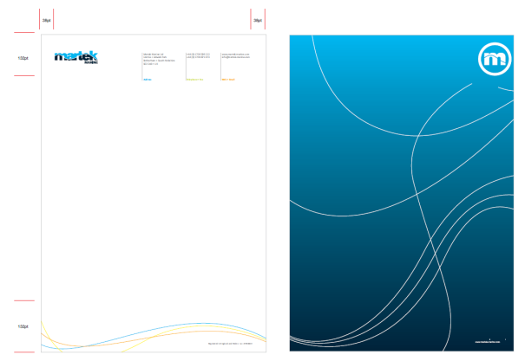
C000 M035 Y100 K000
R229 G172 B000

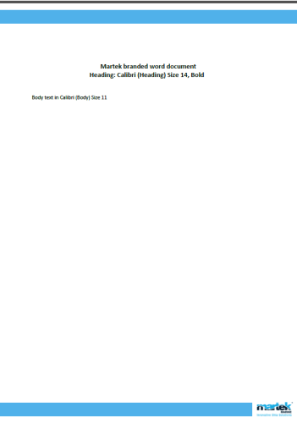
Internal Posters
Format
A4 (210mm x 297 mm)

Colours
DARK BLUE
PANTONE 303
C100 M047 Y023 K079
R000 G031 B051
HTML 001F33

LIGHT BLUE
PANTONE 2995
C083 M001 Y000 K000
R080 G177 B234
HTML 05B1EA

Typesetting
Internal Title Option 1:
Calibri Heading Size 14pt, Centred (in Dark Black)

Subtitles Option 1:
Calibri Body Bold Size 11pt, Left Justified (in Dark Blue)

Body Text:
Calibri Body Size 11pt, Left Justified

Email Signature
When writing on behalf of Martek, it's important to maintain professionalism — and that means using an approved, brand-consistent e-mail signature with all the right sign-off information. It's the brand champion thing to do.

- Only use marketing released signatures

- Only use marketing released logos

Business Card

Format
110mm x 85mm open
85mm x 55mm folded

Colours
DARK BLUE
PANTONE 303
C100 M047 Y023 K079
R000 G031 B051
HTML 001F33

LIGHT BLUE
PANTONE 2995
C083 M001 Y000 K000
R080 G177 B234
HTML 05B1EA
Secondary Colours

LIGHT BLUE
PANTONE 2995
C083 M001 Y000 K000
R080 G177 B234
LIGHT GREEN
PANTONE 369
C073 M000 Y100 K000
R119 G172 B054

ORANGE
PANTONE 130
C000 M035 Y100 K000
R229 G172 B000
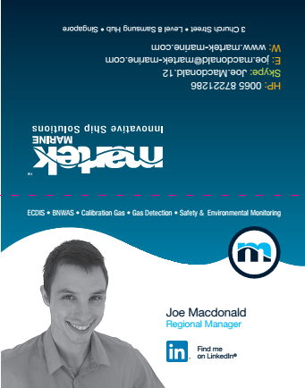
Compliments Slip

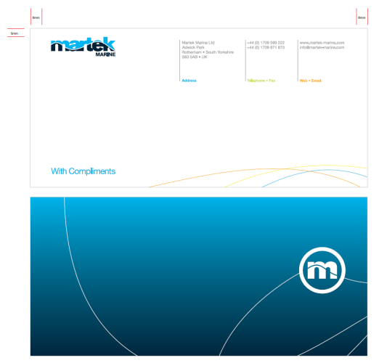
Format
1/3 A4 (210mm X 99mm)

Colours
DARK BLUE
PANTONE 303
C100 M047 Y023 K079
R000 G031 B051
HTML 001F33

LIGHT BLUE
PANTONE 2995
C083 M001 Y000 K000
R080 G177 B234
HTML 05B1EA
Secondary Colours

LIGHT BLUE
PANTONE 2995
C083 M001 Y000 K000
R080 G177 B234

LIGHT GREEN
PANTONE 369
C073 M000 Y100 K000
R119 G172 B054

ORANGE
PANTONE 130
C000 M035 Y100 K000
R229 G172 B000

PowerPoint Slides

Title Slide
Title to be in Calibri Headings
Size 36

Slide
Main title header to be in Calibri bold.
First header, second header

Colours
Martek Marine
DARK BLUE
PANTONE 303
C100 M047 Y023 K079
R000 G031 B051

Colours
LIGHT BLUE
PANTONE 2995
C083 M001 Y000 K000
R080 G177 B234

WHITE
PANTONE 196
C000 M000 Y000 K000
R255 G255 B255

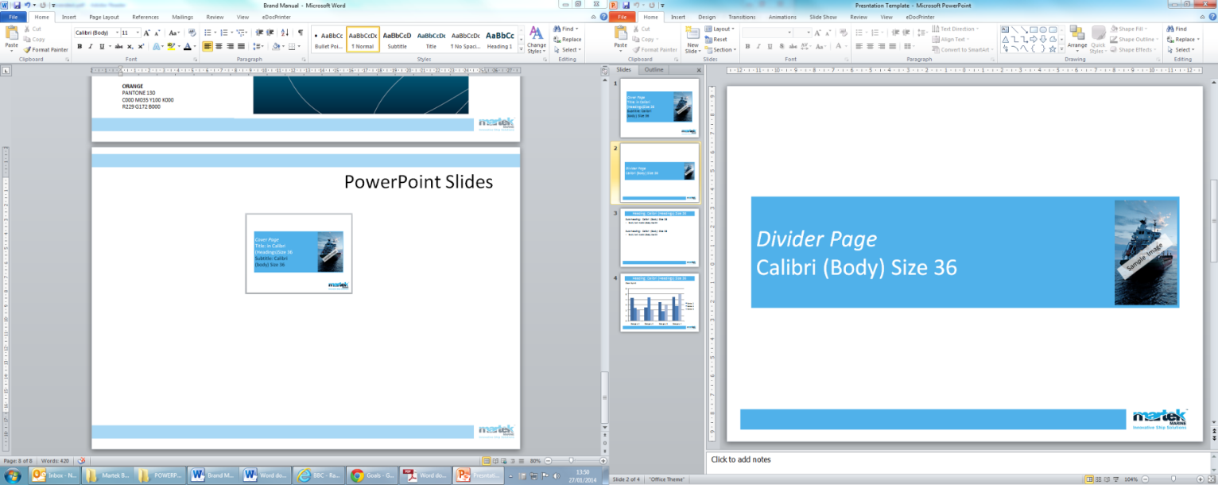
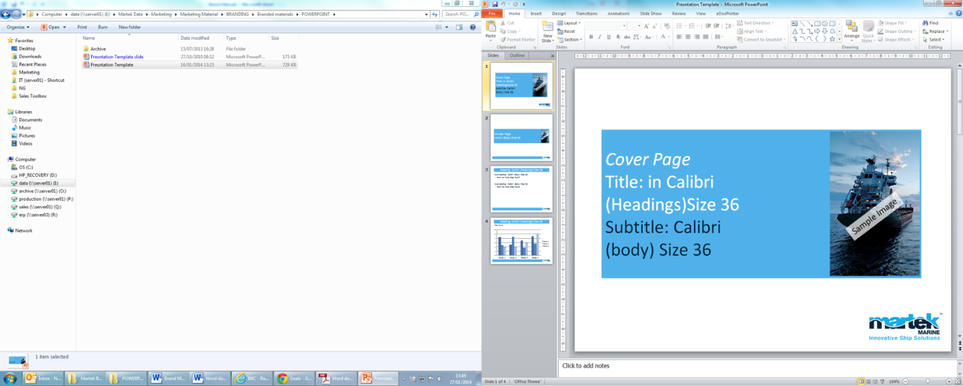
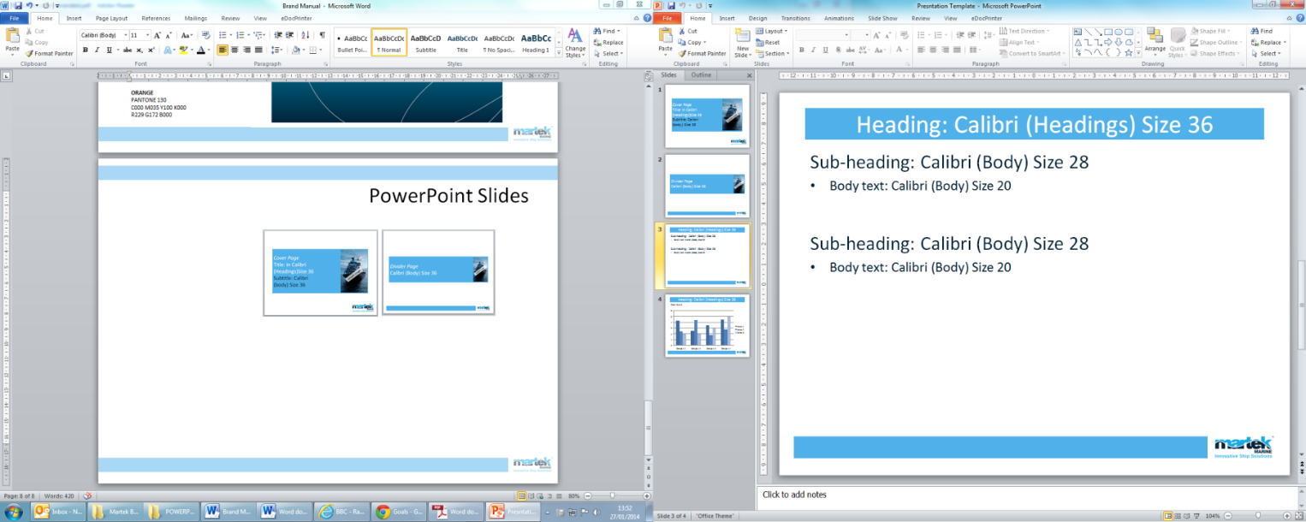
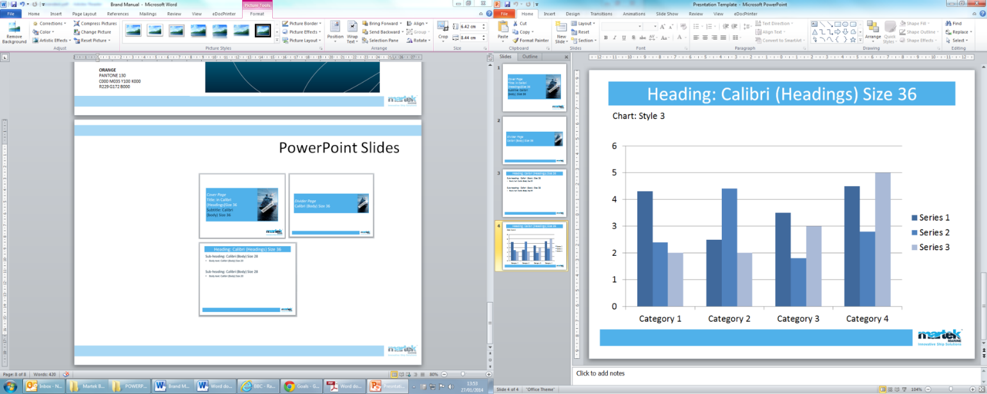
Chart Slide
Text Slide
Divider Slide
Title Slide

