Inside flap  Showers  Framing  Design  Mirrors | Back Panel  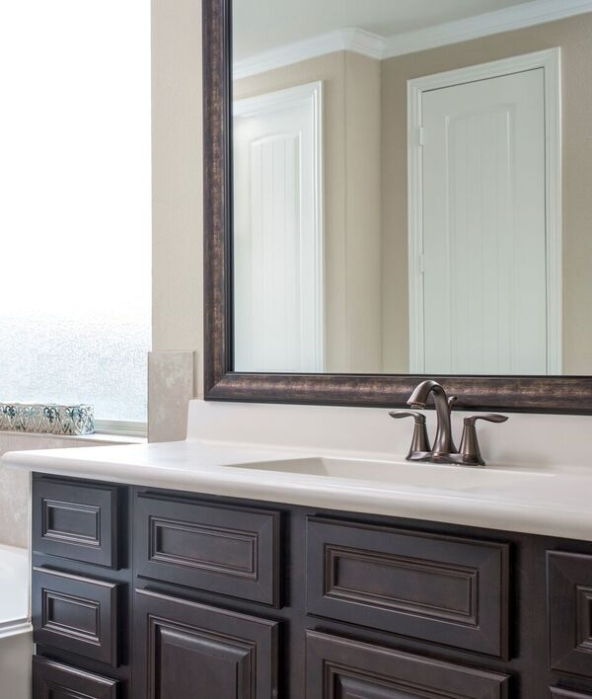  - Crop above pic as needed  - I like the symbols, but please remove the physical mailing address symbol, and replace with an email symbol.  - Email: Team@NewLuxeBathGlass.com  - Phone: 281-809-6625  - Web: www.NewLuxeBathGlass.com  Just the NewLuxe Logo, no Mirrorcle Frames logo | Front Panel  NewLuxe Logo  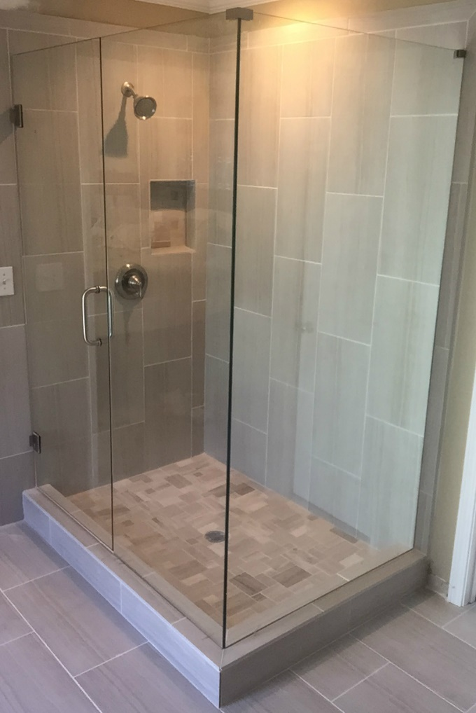  - Keep overall layout with the blue line, but remove the woman from the front  - Adjust the line blue curved line, if and as needed  - Change the tagline to:  QUICK & SIMPLE  BATHROOM MAKEOVERS

Front Panel Pic: https://www.dropbox.com/home/newluxe%20bath%20glass/Bath%20Glass/Shower%20Door%20Pics?preview=brushed+nickel+frameles.jpg

