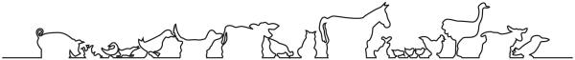
This is the logo from my old practice which I quite like, a variation on this including the tropical theme would be great

