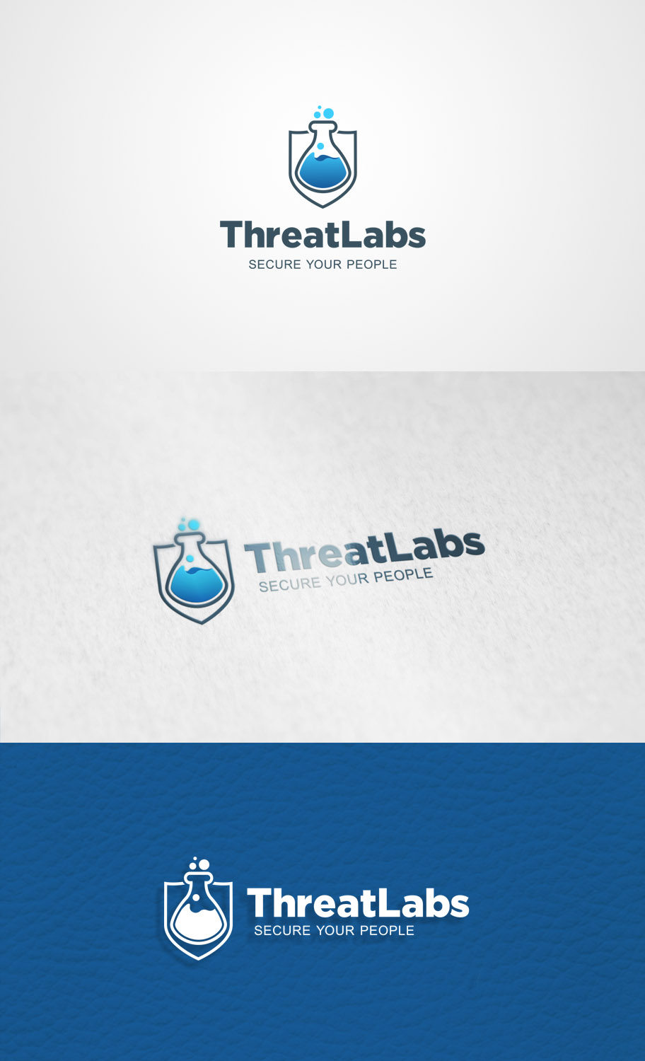
Figure 1 - logo designs

Pages: (This can be one long page if that works, or broken out). Really like avasecure the way it reads and the way the simply describe the service in a couple easy steps.
Home
Some type of image or splash page at the top. “Secure your people” is the company motto.
Services: ( This is really the main focus so could be near the top of a vertical layout)
1# Identify #2Analyze #3Educate
#1- Threat Labs has developed industry leading software that will intelligently build a profile of a company’s attack surface. This is the first step to identify and evaluate todays internet based risk and attacks. The attack surface includes people, data leakage, web servers, vpn devices, and all other TCP equipped devices that are prevalent in today’s modern business.
#2 One the attack surface has been realized, the threat labs analytics engine(s) is used to further identify relationships between employees and social media, along with other forums and websites. This data is fed into passive and/or active testing procedures to get a real-world assessment of employees security awareness and adherence to company programs and policies. We can perform assessments via email, text, phone, social media, or mail. After each assessment has been completed, data is instantly updated to the threat dashboard.
#3 After the attack surface has been mapped out, and security assessments have been performed, ThreatLabs provides an in-depth series of online training material. This material is custom designed for each client and relevant to their respective industry and/or relevant regulations. The portal tracks user progress, and can be used by HR and/or auditors to ensure training has been delivered effectively.

About us:
ThreatLabs is a leader in Social Engineering and Security awareness education. Our cutting-edge analytics software is a first of its kind to truly identify an organizations attack surface to provide realistic assessments that identify users overall security awareness level. This is follow-up with custom tailored training material that not only has been designed for individual markets, but also specific regulations. This ensures that all users have been trained to help limit risk and exposure for an organization.
Contact us:
Basic Contact Form (Drop down for more info, sales, schedule a call, etc)

