“What if we did something on the theme of bringing sound to life and the left side of the chalkboard mural was in black-and-white (representing the world of hearing loss) and then the right side of the mural was full of bright, vibrant colors (representing life w/ hearing restored)? Not sure exactly what the images/scene might be but thought the idea of a scene straddling both worlds could be impactful."
"Building on this idea [refer to image attachments], what if we used an ear instead of a brain and made that the center of the design on each side? Then we could add images around each ear to depict isolation (black and white side) and full, beautiful, engaged life on the color side?"
Image 1:
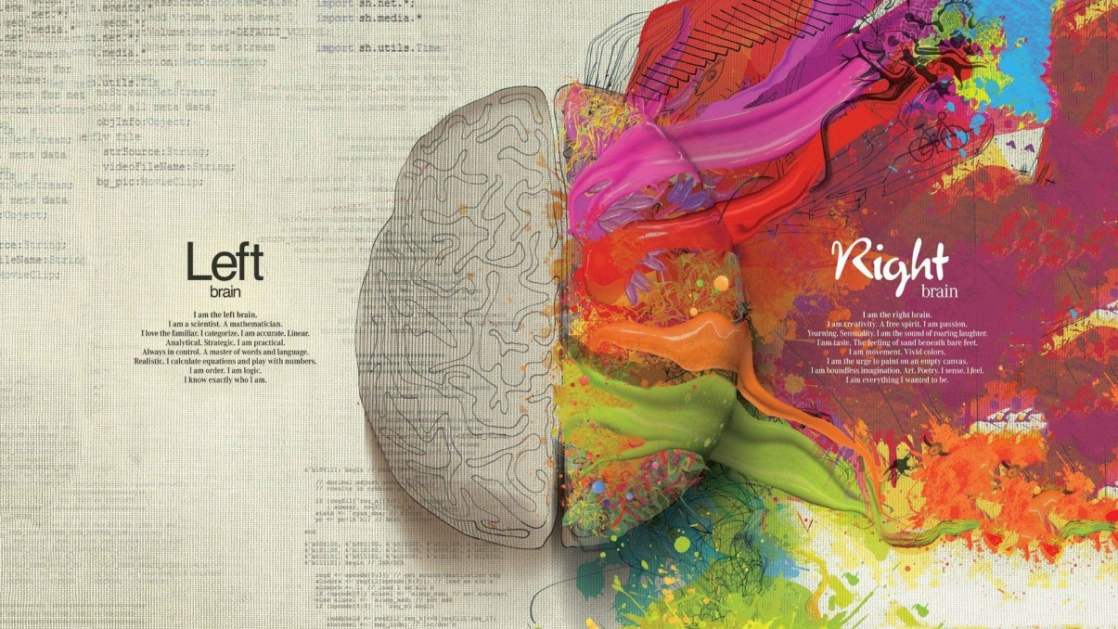
Image 2:
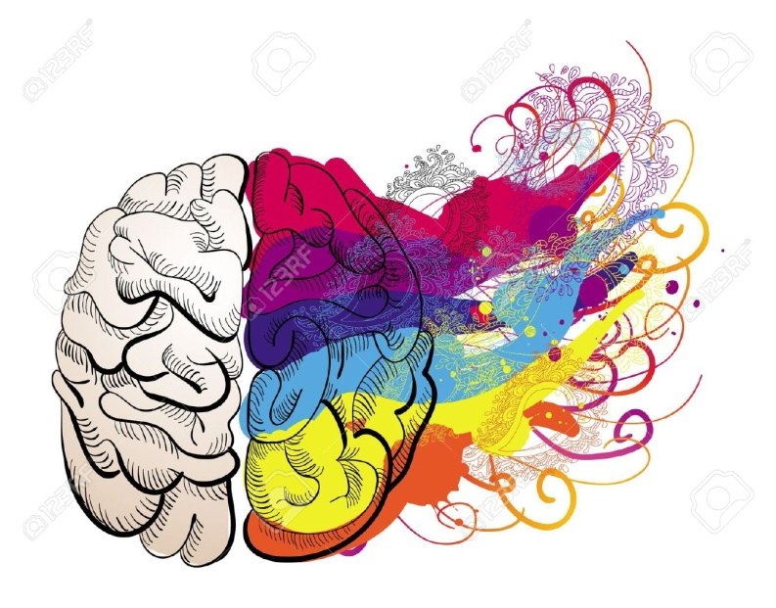

Other image ideas:
