Coffee Fundraising Label: RE-design

We are looking for a new label for our coffee bags. We are a coffee fundraising company (www.globalcoffeefundraising.ca).

I have included a sample of what we have been using…
- The size of the label is: 3.25 x 4.75 (should remain the same)
- The grey/white block area we need to keep as we custom print the coffee name, size, roast of the coffee. As you can see from the second label example. This information always changes so we need this blank space. However, you can place the block where you feel looks good. The height of the block is approx.. 1 ¼”. It cannot be smaller, maybe even a little bigger.
- Our logo has changed… it is included in a separate file and I can email a source file or high resolution for you.
- Text on the label should include:
www.globalcoffeefundraising.ca
Ethically Sourced Coffee
Custom Roasted in Maple Ridge, BC
Thank you for your support!
- We place these labels on black shiny coffee bags. Would like to keep the background color black.

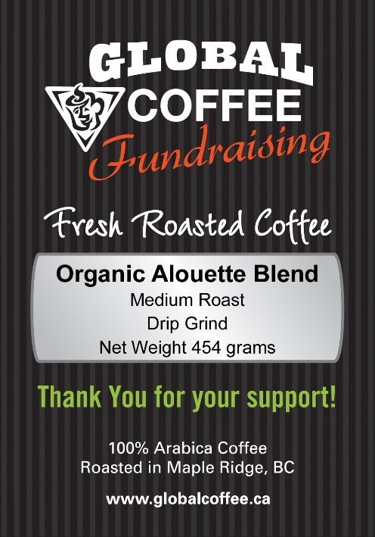
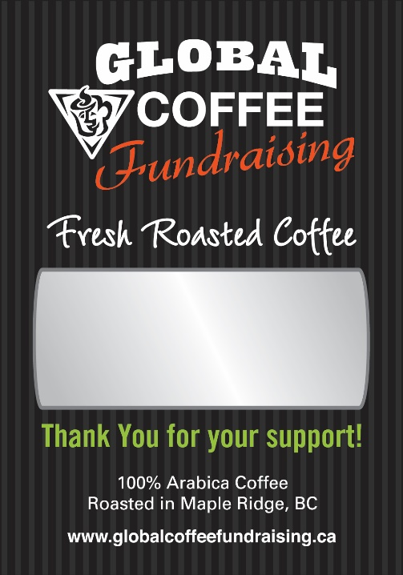

Our current Logo is included in a separate file. The fonts used in our new logo are Bebas Neue and Kenyan Coffee.

I have also included a file that shows some stickers we recently had printed.
Also a sample of what the bags look like for our fundraising labels

