The Fleur de Lis society was created in 2015 by Bruce A. Barron, MD, to recognize past and present members of the New Orleans Academy of Ophthalmology (NOAO). With a gift of $10,000 or more, supporters are recognized as philanthropic leaders in the NOAO.

All gifts benefit the NOAO and perpetuates the mission for current and future ophthalmologists: promoting ophthalmic education through instructional courses, workshops, lectures, and seminars. Your gift becomes a permanent endowment of the New Orleans Academy of Ophthalmology. Membership in the Fleur de Lis society is for life.

The Fleur de Lis Society has different levels of giving. These gifts can be made at the following levels:

Level | Amount of gift
Bronze | $10,000 - $24,999
Silver | $25,000 - $49,999
Gold | $50,000 - $99,999
Platinum | $100,000 or greater

There are a number of ways in which you may give to the Fleur de Lis society. Pledges may be paid in full or over a five-year period. Bequests are also accepted. Contributions may be made through a New Orleans Academy member, or a non-member in honor of a present member or in memoriam of a past member. These gifts will exist in perpetuity.

Why give? – Over the years there has been an increase in the costs of producing quality continuing medical education while keeping registration fees and membership dues at an affordable rate for all. The Fleur de Lis society minimizes the impact of the high production costs and decreasing corporate support.

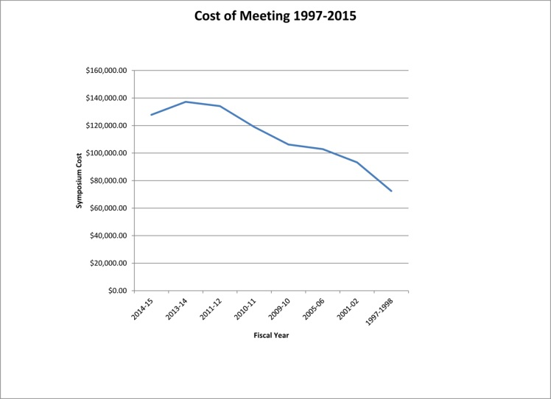

Your generosity is critical to securing the future of the New Orleans Academy of Ophthalmology. Thank you for giving this cause your every consideration. Gifts to the Fleur de Lis society are tax-deductible to the full extent of the law. For more information or to make a gift to the NOAO, please contact Amber Howell, Executive Director at amber@noao.org or 504.861-2550.

New Orleans Academy of Ophthalmology
8131 Oak Street, Suite 300
New Orleans, LA 70118
504.861.2550
www.noao.org

