Page for Consulting

[The information below in a slightly larger font, top of the page]
Fonebone Services provides on-site training, method optimization and development, instrument support, software support, and quality system support. Consultants are available with a wide range of experience including pharmaceutical, environmental, food and beverage and industrial laboratories. We can provide short term and on-going expertise with new lab start-up, sample preparation automation, business optimization, quality system implementation, and CALA and Health Canada audit preparation. If you have a problem in a laboratory environment, call or e-mail us!

[Eventually, when the main labservice page is built, it will have a series of people and their capabilities. So if there is a common format for how these are arranged, we can migrate that to the future website. For right now, it will be just this picture and the details below]
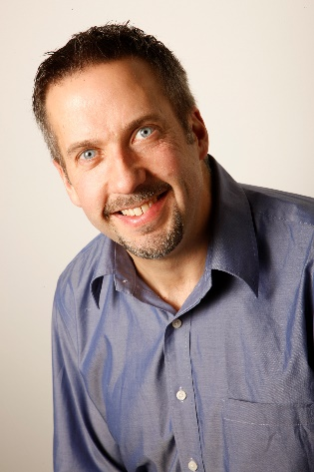
Patrick Steffes has 23 years of experience in the analytical instrumentation business, including service, sales, and management. He has formal training on a variety of analytical instrument and software platforms, qualification delivery and custom software.
He has consulted at laboratories across North and South America. He has delivered hundreds of technical courses and presentations on laboratory instrumentation and software. He has provided method optimization and method development services on LC, GC, LCMS, GCMS, CE and IC in a diverse range of laboratories. He has provided qualification document review services for the pharmaceutical industry.
Patrick is a Professional Chemist registered with ACPA.

[Maintain the same top bar as you had on the main page, but add in a “HOME” button. Maintain the same lower bar (contact information) that you have on the main page]

