
I thought I have for this image is for the red person to be holding a resume that glows.


Possibly standing on the mountain top with resume in hand with other people trying to climb up the mountain for the job.

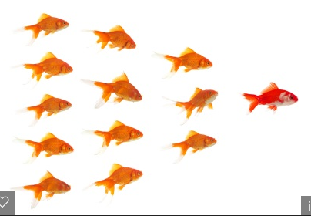
Possibly something like this, but with sharks.

