Claire Louise – Empowering Growth and Personal Change

Business Name: Name of practitioner: Claire Louise

Logo:
Primary: Fresh, represent growth, energy, sun, light, evolution
Secondary: Success, spirituality, health, vitality

Concepts around: sacred geometry (star Tetrahedron) flowers, butterflies – or other forms from nature to represent evolution (not trees or lotus flower)

Will use PSYCH-K logo as a certified practitioner on the website and on web page, emails etc
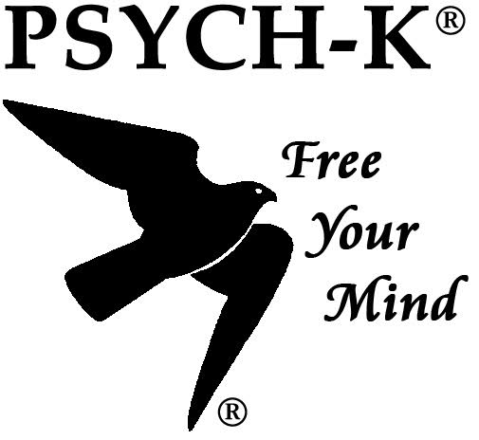

Branding Colours: Primary
Teal, + Purples (as below)

Secondary Palette: - as accents to highlight and offset

Claire Louise the Brand:
Initiative, Helpful, Supportive, spiritual, career, patient, adaptable, knowledgeable, creative

Who is CL the brand:
A listener, A guide, A collaborator, A healer, A Clairvoyant, A medium, a facilitator

Why Claire Louise: (USP)
To remove blockers to achieve goals
20 yrs of healing experience
Skilled in Reiki, Pyranic Healing, PSYCH-K, Energy cleansing

Services:
Change practitioner and healer
To assist with the removal of blocks and hidden barriers to achieve our goals
To support the personal evolution to meet our goals

Problem worth solving (offering)
Goal setting is important to drive personal change. You have probably tried many methods; you may have attended some manifestation courses, taken on a life coach or been disciplined to write journals for your achievements. But you may still be alluded by the goal and are lost as for how to solve this.
It could be perfect health or a mutually loving relationship or financial success. Let's face it we want them all. This is where we can assist with looking at your beliefs.
No goal is possible if deep in your subconscious you believe you cannot achieve.
How – the solution
Understanding the frustration in being blocked to achieving your goals is something I have worked with for years. Working with clients to help uncover the barriers and blocks to these goals is part of the key to achievement. You have already been working hard to achieve, and it's this effort you bring to the sessions that enable us to discover and literally reprogram the brain, so your efforts can be realised.
I love all the manifestation rituals, techniques, and methodologies available today. There are thousands of references out there which is just fabulous. However, if you haven't achieved your dream as yet, it is highly likely that you have a belief that is contrary to seeing it manifest.
You may not be worthy of it? You may have had this behaviour for so long it's part of who you are and losing it means losing your identity. Whatever the situation if your efforts have fallen short. This is where we can assist.
‘Short version”
By transforming subconscious​ limiting beliefs into empowering and supportive beliefs this empowers your efforts to success. Using PSYCH-K and Pranic Healing to reprogram and release the blockages to bring goals from distance dream to reality

Who is the client? Target
- People who are drawn to the words, that have tried many methods but yet to fully understand the blocks
- Those that are ready for change
- Those that are driven for the desire for change
- Believe in manifestation but struggling to achieve and succeed
- Are becoming more self-aware to uncovering the blockers

Clients say statements:
- Why am I not there yet?
- I have noticed this block
- Or my goal is sooo strong but not yet here

Another healer site using own sacred geometry

