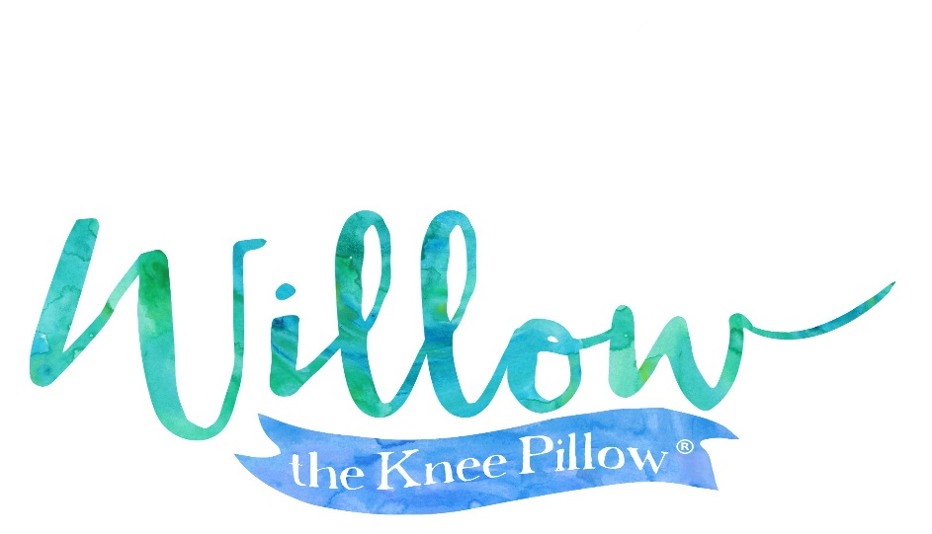

Business Profile

Company Information
Willow the Knee Pillow, LLC.
1063 Clark Way, Palo Alto, CA
408-469-0366
www.willowthekneepillow.com
willowthekneepillow@yahoo.com
Contact/Owner: Monica Zavala

Business Details
Product: Bathtub kneeling cushion. A comfortable, high-quality, waterproof cushion that is not intended for the use of children.
Customer population: People giving children or pets a bath
Manufactured by: Ningbo Da Feng Plastic Container Co Ltd.
Xin Jie Development Park, Zong Han, Cixi City.
Ningbo. Zhejiang Province. China
Retailers anticipated: Amazon.com, Walmart.com, big box retailers, boutiques, baby and pet stores.

In January 2016, Willow the Knee Pillow™ became a Limited Liability Company. We pride ourselves in being a business of high integrity and one that offers a high quality kneeling product. As a new company in our final stages of production, we are preparing to launch as early as October, 2016.

