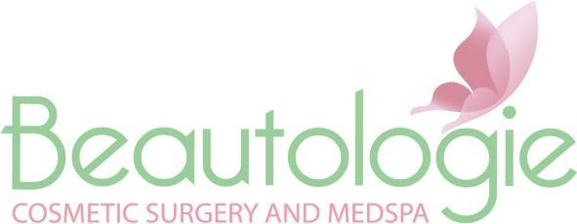
Beautologie Be-Line Skin Care Products

Be-Nourished- Facial Cleanser containing 12% Vitamin C helps brighten and nourish the skin. Removes impurities, oil, dirt and make-up. This facial Cleanser is ideal for dry, sun damaged or sensitive skin.
Be-Refreshed- 12% Glycolic acid facial cleanser removing any impurities, oil, dirt and makeup thoroughly while maintaining your skin's natural pH balance. Gently exfoliates for more smoother skin. Not for sensitive or reactive skin.
Be-Pure- Gentle facial cleanser removes dirt, oil and makeup while leaving the skin properly pH balanced. This low foaming cleanser will skin hydrated and soft with a natural clean feeling.
Be-Balanced- Invigorating facial toner helps refine pores, improves skins tone, texture and clarity. This toner rejuvenates environmentally stressed skin with this pore perfecting formula.
Be-Clear- 5% Benzoyl Peroxide cleansing medicated acne scrub. This cleanser kills harmful bacteria and removes pore-clogging oils leaving the skin looking and feeling refreshed.
Be-Blocked- Oil free, water based SPF 30 Sun Protectant provides protection against environmental factors that lead to premature aging.
Be-Rejuvenated- An anti-aging serum is a blend of hydroxy acids and antioxidants to refresh and nourish skin cells to reveal the most luminous skin.
Be-Hydrated- 9% vitamin C lotion is an ultra rich hydrator with antioxidants A, C and E to combat damage and dehydration from stress and other environmental factors . This product has moisture binding properties such as hyaluronic acid to help strengthen and refresh the skin.
Be-Radiant- Bio-Peptide lotion is a performance blend of cutting edge nutrients, antioxidants and soothing botanicals to nourish, protect and hydrate for the most healthiest skin.
Be-Flawless- Medicated acne lotion containing 7% bacteria killing benzoyl peroxide and 3% salicylic acid. While soothing Aloe vera and tea tree oil help heal and soothe the skin.

Be-Revitalized- A Hyaluronic Acid serum which penetrates deeply into the skin, hydrating cells , restoring collagen and elastin and destroying free radicals from the sun. Ideal for all skin types providing intense moisture, prevent excess oil production, giving the skin balance and moisture without shine. Eliminates redness, dryness, irritation and pain while instantly producing healthier younger looking skin.

Be-Renewed- A Retinol A lotion that rejuvenates and repairs aging and acne prone skin with a synergistic blend of retinol and polypeptides.
Be-Complete- An intense moisturizing eye cream containing vitamin K and caffeine to combat under eye puffiness and dark circles. Aloe vera and Vitamin E to ultra hydrate the eye area to soften fine lines and wrinkles.
Be-Caressed- A rich soothing hand cream that provides maximum hydration, nourishment and protection to extremely dry, overworked hands. Deeply penetrating through the skins barrier to strengthen, repair and fortify the skin. With repeated use this cream will help improve the skins tone and texture.

