We are now the Isle of Man’s only approved installers of Tynetec Care Call Systems
Who are Tynetec
With over 35 years’ experience in the design and manufacture of Warden Call Systems, Telecare & Telehealth Solutions, Access Control Systems and Wireles Nurse Call Systems, it’s no wonder that more and more people are turning to Tynetec as their no.1 choice. Tynetec’s range of hardware and software is all designed in house by a dedicated research and development team and all manufacturing is carried out at the company’s headquarters in Blyth, Northumberland. The company supplies equipment to hundreds of Local Authorities and Housing Associations across the UK and beyond. Through it’s Aid Call division, the organisation continues to increase its sales of Wireless Nurse Call Systems into the Hospital and Care Home Markets.
Tynetec focus on delivering outstanding, innovative products that clearly set the standards for others to follow. Through consumer insight, customer research and cutting edge design, Tynetec are able to deliver tomorrow’s technology today. Tynetec is truly committed to providing customers with the choice and flexibility through the supply of future proofed products that work on open protocols and deliver the most effective long term cost of ownership.
Tynetec offers full UK supply, installation, service and maintenance through its national network of Approved Partners. All companies are able to provide customers with a local, efficient and reliable service together with a comprehensive and cost effective service & maintenance programme.

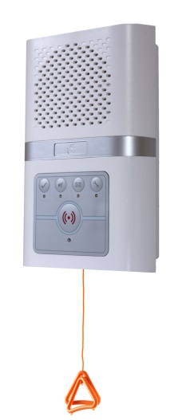
Sheltered Housing / Warden Call
Advent xt
When it comes to assisted living, you really need to ensure you have the most appropriate technology to support your residents and that’s where Tynetec can help. The Advent xt is now clearly established as the market leader in warden call systems. Offering true telecare capabilities as standard, it’s so flexible and suited to all types of core & cluster housing, managed schemes and extra care developments.

Live At Home
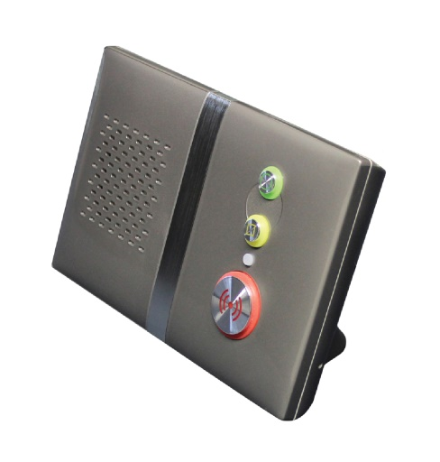
The Reach
What is a Reach? The Reach ‘at home alarm unit’ provides the user the security and confidence to live independently for longer by providing a reliable means to call for assistance in an emergency. The Reach series of our at home alarm units bring together the most sophisticated electronics with cutting edge design and customer flexibility. The Reach offers fantastic features and benefits such as compatibility with up to 32 telecare devices as standard

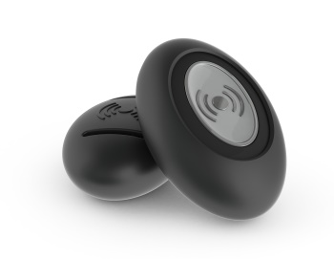
Touch Personal Pendant
From concept to industrialisation, the Touch personal pendant has been designed with the user in mind. Total flexibility is delivered via multiple wearing options which are simple to switch between and for those who are concerned about being labelled as vulnerable or at risk; the new sleek black and silver design eliminates the red button stigma.

Wrist Worn Fall Detector
Tynetec’s wrist worn fall detector was the latest product to undergo the Tynetec Innovation Centre treatment. Building on the advanced technical capabilities of Tynetec’s body worn fall detection system, this latest product provides a reactive solution with the added bonus of being able to be worn on the wrist.
For further details and information on the entire range of products available please contact us today.

To Design and Development –
Please see the attached Tynetec Full brochure. Can you please take the following additional pictures from within the brochure and add them into the pages:
Front Page – the butterfly picture and please also incorporate the Tynetec logo
Page 10 – the picture of the lady using the system
Page 17 – the picture of the 2 ladies
Page 25 – please add the picture of the ladies wrist to the section “wrist worn fall detector.

