Classic Images of Joseph Smith
A rare daguerrotype (early photograph):
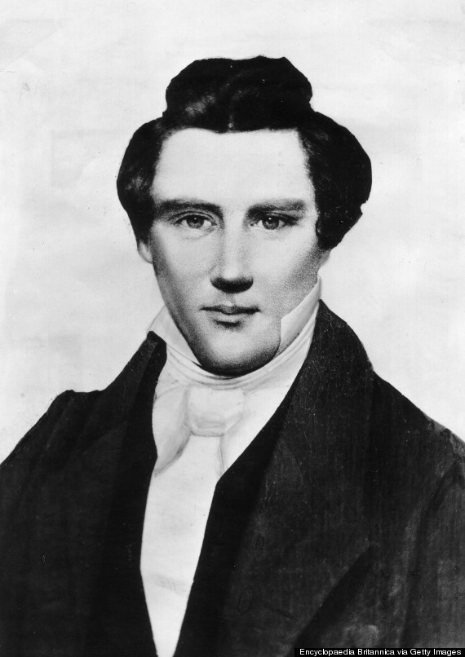
Joseph Smith’s plaster death mask (i.e. a mold of his face)
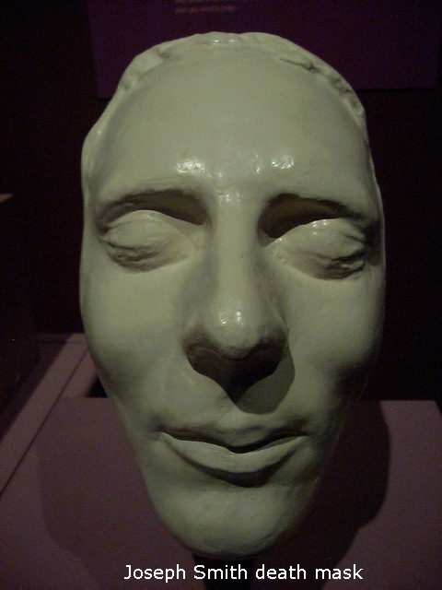

Early sketches and paintings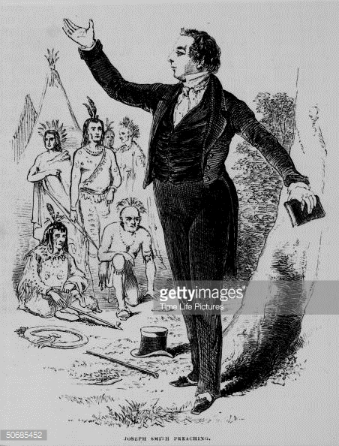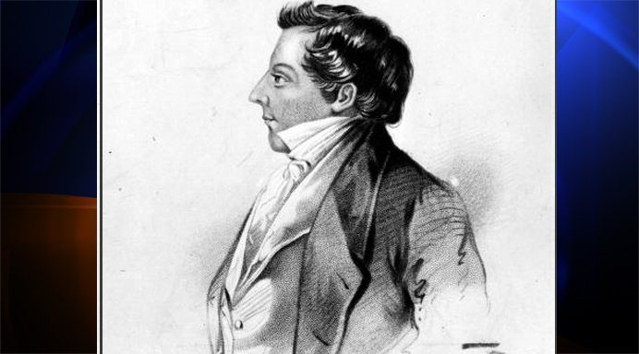
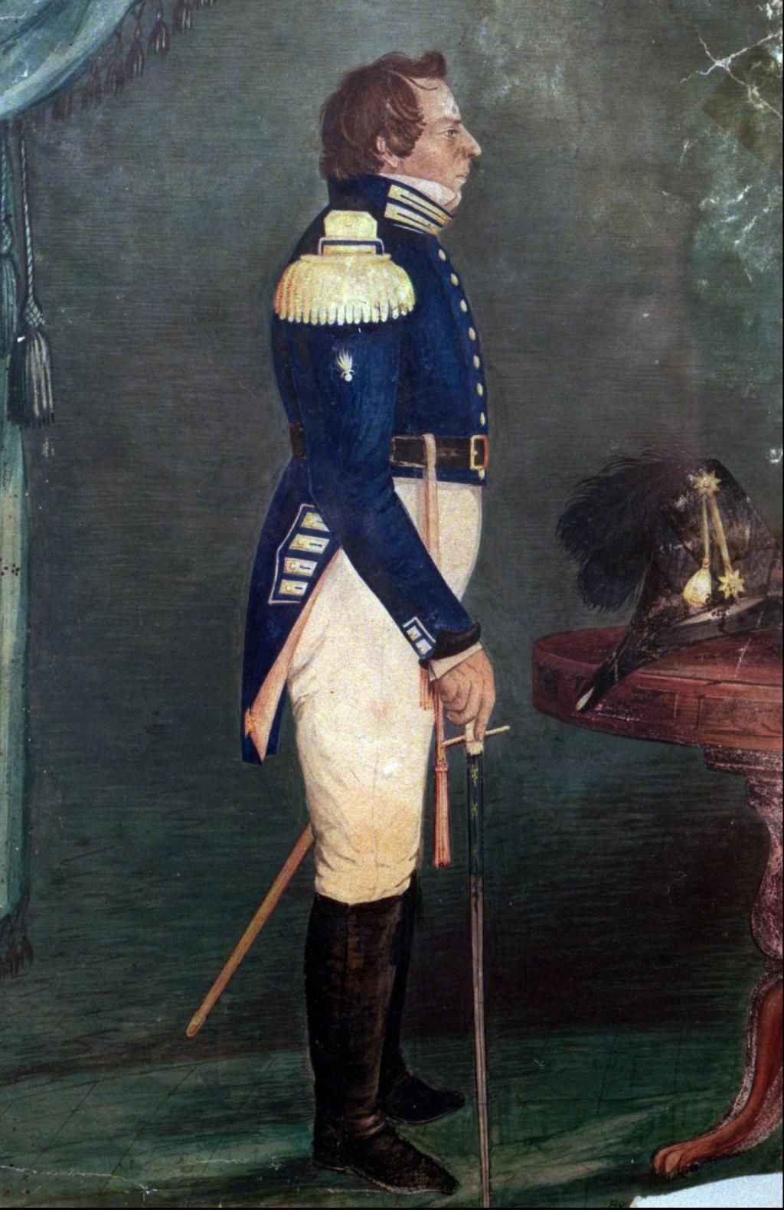
Modern (romanticized) paintings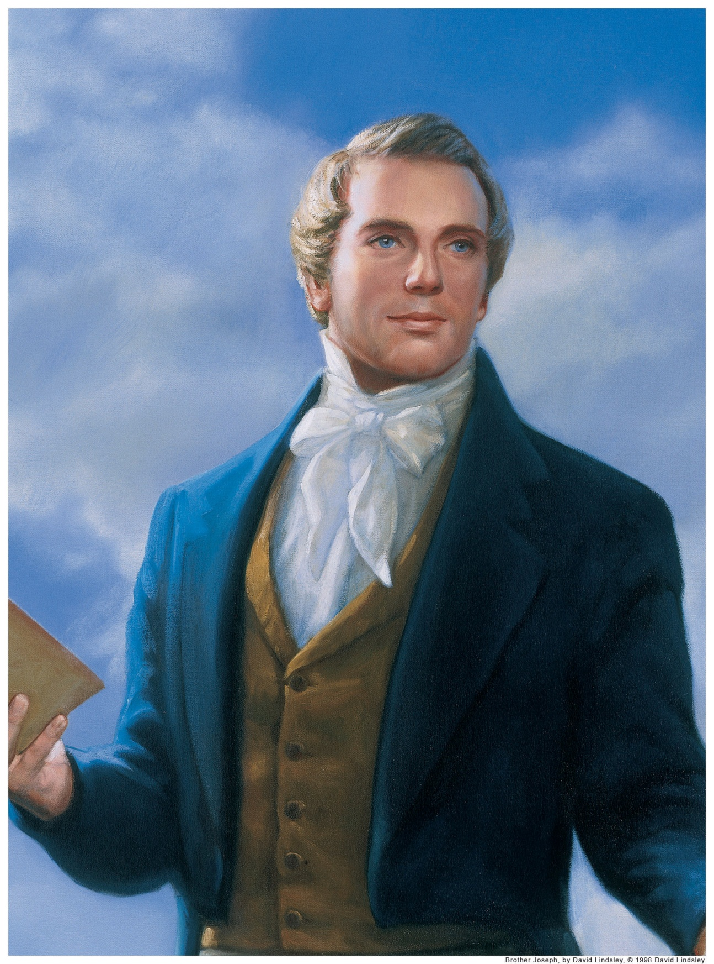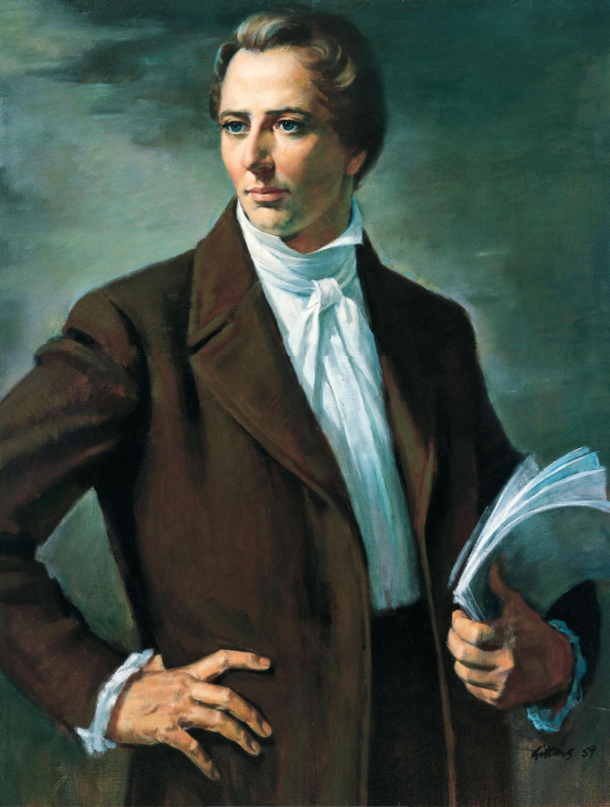

Examples of Medieval Icons
St. Andrew
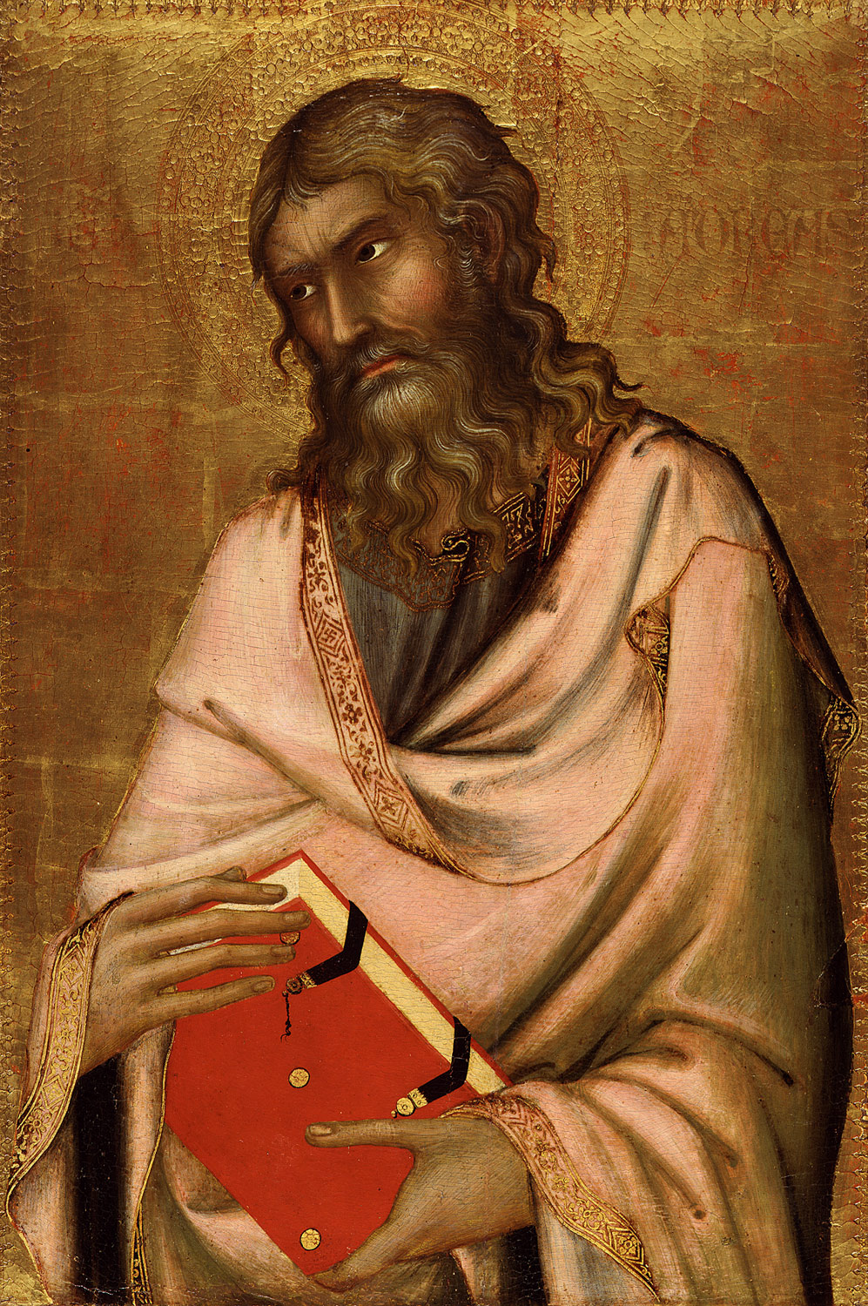
St. Cuthbert the Incorruptible
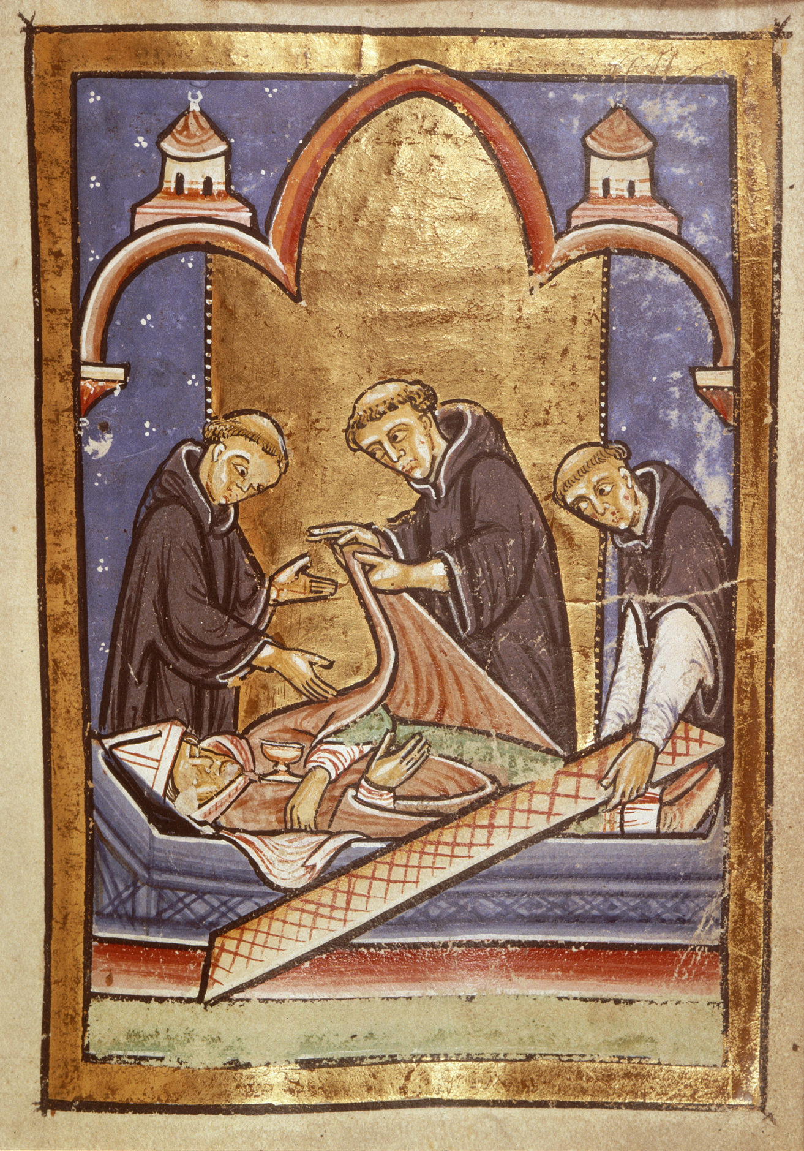
A modern rendering of St. Matthew in medieval style
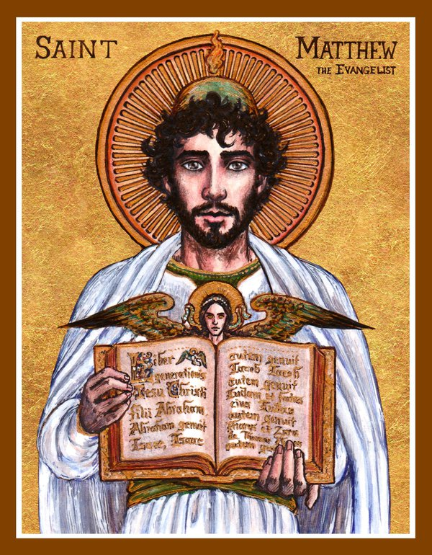
A modern rendering of St. Gregory in medieval style
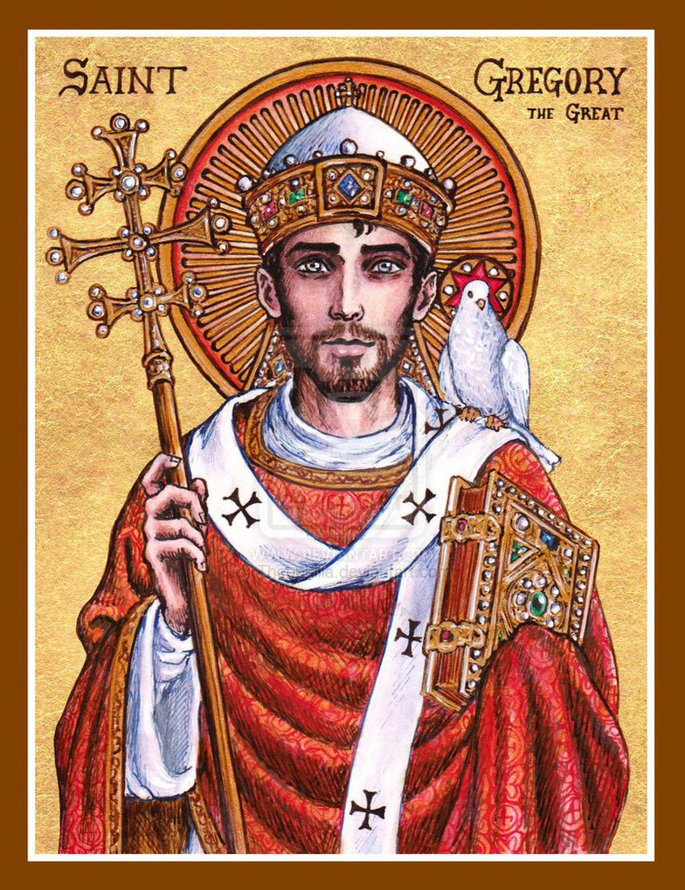
Suggestions
Catholic and Orthodox iconography should be replaced with Mormon symbols.
Classic Mormon symbols include:
the Nauvoo Temple (http://www.templehousegallery.com/images/Nauvoo%20Temple%20Blue%20Prints2.png)
Sunstones (http://www.utlm.org/images/masonictemplearticle/nomanknowsmyhistory_p298b.jpg)
The seer stone (http://4.bp.blogspot.com/-q_T1WSq3FCs/VcImBnqjY6I/AAAAAAAATSs/8t_EjAWKYLg/s1600/Joseph%2BSmith%2BSeer%2BStone%2Bc.jpg)
The 1830 Book of Mormon (https://static1.squarespace.com/static/516e0b56e4b08095006dd426/t/51bc138ee4b0510af19f4ad0/1371280271346/BofM+Replica+5.jpg)
The angel Moroni (http://ldsonward.com/wp-content/uploads/2015/04/AM.jpg)
Joseph Smith’s serpent cane (http://culturalmormoncafeteria.blogspot.com/2009/09/joseph-smiths-cane-thing-of-nature.html)
Joseph Smith’s name in Greek characters is Ιωσήφ
The word “YTFIF” (“FIFTY” spelled backwards) could also be substituted for Latin or Greek text that appears in an icon.

