Main page

Get the health and lifestyle you want now!

About HealthStyles for Wellness
Good health is everything! I’m passionate about getting you back there and beyond. Why? It impacts every aspect of your life from sleep to work to family. I want to help you improve all of the above!

I am a lifestyle change coach that focuses on the prevention and improvement of chronic lifestyle diseases. My Lifestyle Coaching practice utilizes the 5 core aspects of health to create lifelong change to daily habits and mindsets. Change is tough, but I partner with you every step of the way to develop a plan that works for you.
Ask yourself, what would it be like to feel great again? 

Pre-Diabetes and Chronic Disease

Is your health out of control? Get it back!

If you have received a diagnosis of pre-diabetes or diabetes type II, don’t let it overwhelm you. It’s tough and can be difficult to comprehend at first, but it is completely manageable and even reversible. Yes, diabetes type II can be reversible!
Does ditching diabetes interest you?

Understanding the underlying causes and conditions of diabetes and chronic disease is the first step to managing and reversing the damage. Education is an important aspect in this process and I approach the disease from a whole person perspective. Utilizing the 5 core aspects to health; Emotional, Physical, Environmental, Nutritional and Spiritual, I will develop a customized approach to bring improved health and well being from an integrated body system perspective.

Think of what it would feel like to lose weight, gain energy and feel great again!

As a CDC Diabetes Lifestyle Coach and Chronic Care Educator, I use the most recent, scientifically proven methods developed to:

- Need less medications
- Get more energy
- Stop blood sugar swings
- Lose weight
- Build more muscles
- Decrease stress
- Stop feeling bloated and miserable
- Stop wasting money on medications

Why do I need a Health Coach, Isn’t my doctor helping me?

If you have been seeing a doctor, he/she may or may not be educated in controlling the disease holistically. Physicians are trained to prescribe drugs for medical conditions and rarely have an understanding of nutrition or lifestyle changes. These kinds of changes not only have a monumental effect on controlling the disease, but they can eventually reverse the disease. It may sound strange that a doctor would not offer you this valuable information, but they are trained to treat acute symptoms and this kind of treatment can be detrimental when used as long-term solution.

They may have even provided you with medications to control your blood sugar, but over the long term those same drugs have a very deleterious effect on your health. Actually, they have the opposite effect of progressing the disease!

I know it’s a lot to take in, so if you still have questions, let’s talk! 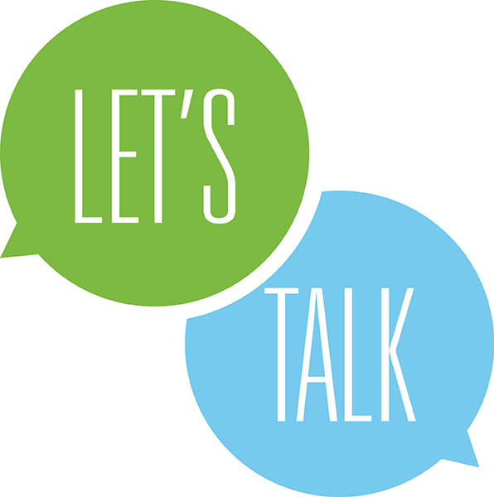

A new life is waiting for you! Don’t delay, contact us for a free 30 mins. consultation.
(Call to action button)

Nutrition and Weight Management

Our culture pushes us towards unhealthy eating everywhere you look. Calories are cheap. Fast foods restaurants are on every corner. Convenience stores have premade, prepackaged food with little nutritional value. We’ve got bad work habits of over-scheduling and over-committing. This drives our stress up, our sleep down and creates an unhealthy lifestyle that is literally killing us.

It’s time to stop the insanity!

It’s time to make health priority #1! We partner with you to reduce stress, create a nutritionally based diet and structure a physically active lifestyle. Seems easy, huh? It’s a big job, but you are worth it!. When you commit to a mindset of change and combine it with a new healthStyle, it becomes part of your daily life, not daily struggle.

Our HealthStyle programs are individually structured to uncover what road blocks have prevented a healthy lifestyle in the past and develop new approaches to creating healthy habits for the future. Our scientifically proven approaches will motivate and inspire you to create the life you’ve always imagined.

You will:

- Lose weight
- Decrease cravings and stabilize your blood sugar
- Increase your energy
- Build more muscle
- Decrease stress
- Stop feeling bloated and miserable

Don’t delay, you’re new HealthStyle is waiting! Contact us for a free 30 mins. consultation.
(Call to action button)

About Me

Hey there! Thanks for checking out the website. I’m very excited for you because you are starting a new life. It’s the path to a healthstyle that you may have only dreamed about, but want to experience.

I’ve witnessed many people change their habits, renew their energy, lose the extra weight, and live the best life possible.

To be clear, I’ve never been diabetic and never plan to be in the future. But I have had similar experiences of taking prescription drugs to circumvent pain and inflammation and felt the ugly side effects those drugs produce. After years of this, I found out the damage those drugs can, and did do to my health. It stinks!

Fortunately, you don’t have to experience what I did. Once you commit to a healthstyle of wellness, your changes will occur rapidly. Many times, these happen so quickly you will need to see your doctor to have your medications reduced. How great would it be to not spend all that money on expensive prescriptions while feeling great?

As a certified Lifestyle Coach from the ADA and a certified Chronic Care Educator from the National Institute of Whole Health, I have the knowledge and background to make this happen. I am also a Certified Occupational Therapy Assistant and have a B.S. in Computer Science from Northern Illinois University.

I look forward to making your wellness journey dreams come true!

