Hi Moataz,
Here are the updates/changes we need to make. If the words are in RED below please make corrections or additions:

HOME page:
The links on top of the page - LEARN MORE and REQUEST A QUOTE are still not directed anywhere. Nothing happens when we click on those.
Also, the pictures/video on the home page do not show up on this browser. The pictures at the top are all black:


ABOUT PROTOMED page:
We see that now you made a one column, instead of 2 columns. We would rather have the two columns like it was before. There is no way to center them below the icon? See lines below. Please let us know what you are able to do:
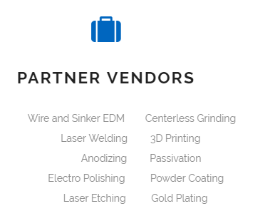

Also, please add this to the last sentence WHO WE ARE paragraph (only what is in RED):

“Steve Olson is the founder and President of ProtoMed Engineering. Prior to starting ProtoMed, Steve held manufacturing and R&D positions at Applied Medical Resources Corp., Medtronic AneuRx, Ventrica, Inc. and XTent, Inc. Steve has also consulted for Abbott Vascular, Medtronic Ardian, Avantis, Inc., Boston Scientific Corporation, Guided Delivery Systems, Inc., nVision Medical Corporation and Spinal Kinetics, Inc.
Steve has been machining since his apprenticeship in 1987. While working for medical device start-ups, he developed and manufactured hand held devices, miniature mechanisms and assembly fixturing for minimally invasive surgery. He setup in-house injection molding capabilities at three of his last companies and is experienced in injection molded part design, mold design and mold manufacturing.
Steve holds 8 patents relating to delivery devices for stent grafting of abdominal aortic aneurisms, coronary arterial bypass grafting and customizable coronary stent delivery, among others. Steve graduated from Cal Poly San Luis Obispo in 1994 with a degree in Industrial Technology.”

QUALITY STATEMENT: title “STATEMENT” is still cut off the page on the iphone. The writing is fine now.

FIXTURE DESIGN Page:
Please correct the testimonial to this one:
“ProtoMed has worked with me in designing several custom medical device manufacturing fixtures and they are always very thoughtful and thorough. Their price and lead times have been extremely fair and because of their open-door, easy to work with style and can-do attitude, I find myself looking forward to working with them. It’s very evident that ProtoMed employees enjoy working there and that is not only reflected in the shop atmosphere, but also in the quality of the work.”
Dwayne Bell - Principal Engineer - Veniti Endovenous Therapies

HANDHELD DESIGN Page:
There there are two CUSTOMER FEEDBACK in the flow chart. Please look at the flow chart one more time. Step 3 and step 5, please fix this.

PROTOTYPE AND PRODUCTION PAGES:
The font color of the accepted file types is different. PROTOTYPE has a light gray and PRODUCTION has a darker gray for the models and light gray for the drawings. Please make them all the SAME, we like the darker gray.

EQUIPMENT LIST:
The spacing is still not quite correct here:

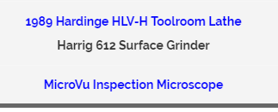

REQUEST A QUOTE:
Please remove the “.” at the end of the top sentence.

We are seeing many issues with this page and it also behaves differently with different browsers.
We still need to make some changes in the format, so here are the changes and then we can work on the problems with the browser:
After the files are uploaded it should ask to SUBMIT. Then, if the customer wants to upload more files, then there should be another button below asking UPLOAD MORE FILES? If this button is clicked, the CURSOR should move up to the CHOOSE FILE, but the information at the top should NOT be erased (so they don’t have to enter it again). In this way, the customer can enter more files with different quantities, materials and dates and not re-enter their name and all that.

Browser problems:
In IE11 – Version: 11.447.14393.0 or version IE10 – (Version listed above):
- The calendar for the desired delivery date is not available and it doesn’t show what the date format should be (mm/dd/yyyy). So, it will reject it.
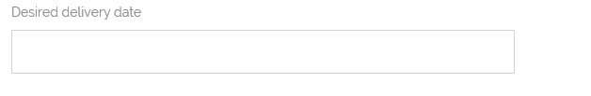

- Then we tried loading the files (they had the correct extension). Put the rest of the information and clicked SUBMIT. Once we clicked on SUBMIT, nothing happened (one could not tell if something had been submitted). After a minute or so (long time), this is what showed up:
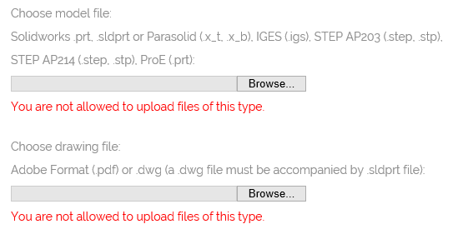
But the files were correct. Why? This is also a problem in Chrome now, it was not giving me the error on Chrome earlier. I just tried it now.

For the quantity field, we should allow multiple boxes (maybe 3) so the customer can choose more than 1 quantity to get a quote. Or we can allow a “,” after each quantity?

I tried to enter the information earlier (now if won’t accept the files). The information is not coming through in the email. This is what the email shows:

From: [your-name] <[your-email]>
Subject: [your-subject]

Message Body:
[your-message]

--
This e-mail was sent from a contact form on ProtoMed Engineering (http://www.freelance-studio.net/protomedengineering)

Why is this?
Thank you.

