Move website to our host

Moataz, once you log into network solutions, please CLICK on the following: MY HOSTING PACKAGES (see this screen capture)

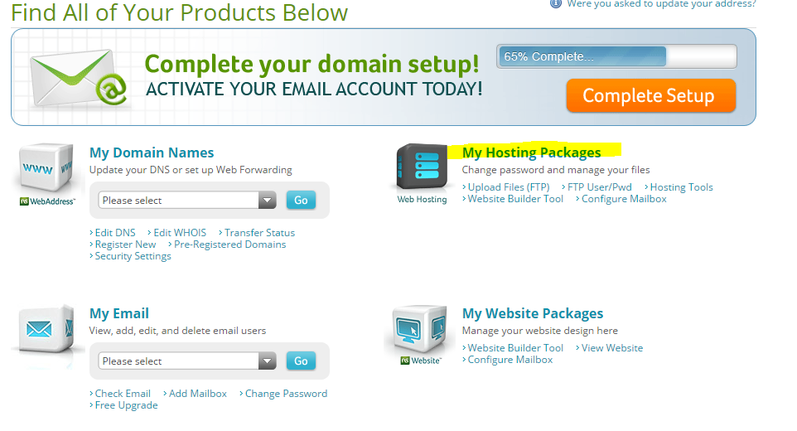

Then click on this:
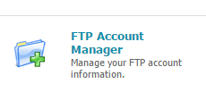

FTP – Host address is 205.178.145.65

Then it will take you to this page:
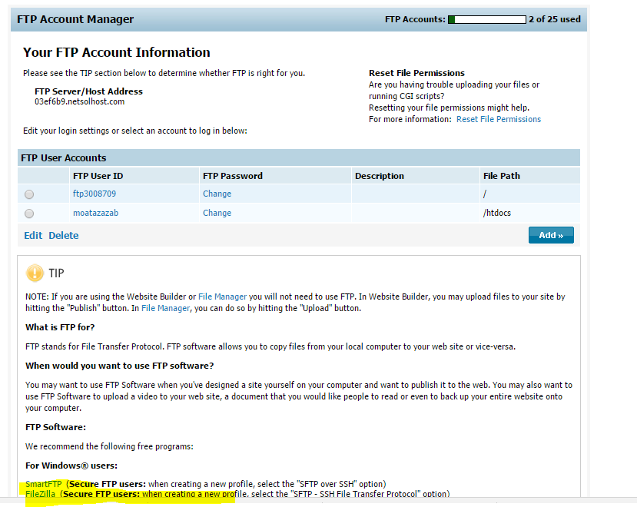

DO NOT create your own account (we see that you created one there, it needs to be deleted). We created one for you and that is the one to use:
FTP user name: ftp3008709
Password: mltJpyn6

If you need a file program you can use Filezilla, it should work on all platforms, MAC or Windows PC.
ONE MORE IMPORTANT ITEM: When connecting to ftp account use port 21

Database
User name: protomeddb
Password: mltJpyn6DB

Database name = protomeddb
Database host = mysqlcluster8

Database admin page = https://mysqlcluster8.registeredsite.com

