Hi Moataz,
Here are the updates we need to make:

HOME page:
The links on the top scrolling pictures/video are not directed anywhere:
The link LEARN MORE on the video should go to the ABOUT US page
The link LEARN MORE with the picture of the gentleman should also go to the ABOUT US page
The link CONTACT US on the next picture should be REQUEST A QUOTE and link to that page.
The SITE MAP at the bottom has DESIGN SERVICES and PRECISION MACHINING. Those links should not be available there or on the top menu. If one of those links (such as DESIGN SERVICES) is selected another menu should be offered to go to DESIGN FOR MANUFACTURING…. etc. or PROTOTYPE… etc. if the PRECISION MACHINING is selected.
The map at the bottom of the page is not working. This is what it shows (this is also a problem on other pages, could you please fix it on all pages):
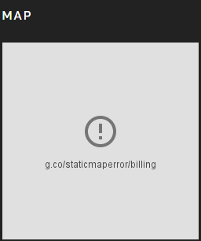

Does the SEARCH HERE field work?
The website looks great on the iphone. However, on the iPad, there is a large white space at the top of the page and the menu at the top is not visible, because of the white writing on a white background. The only menu item that is visible is the REQUEST A QUOTE because it wraps around to the second line and then it is on top of the picture. Also, it looks as if the website doesn’t start until the middle of the screen (it’s all white above). Can you please fix this? We see that the video does not show up on mobile devices?

ABOUT US page:
The partner vendor section is still looking a little off. Here is what we see now:
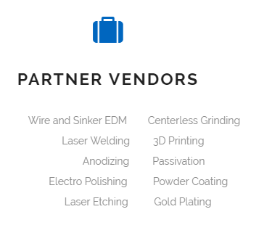

We would like the gap to be centered under the icon and PARTNER VENDORS. Move all the writing to the left. It looks fine on mobile devices.

The title STATEMENT (in the section QUALITY STATEMENT) is cut off the page on the iphone. Also on the iphone, some of the writing under QUALITY STATEMENT is not visible, because there is a white part on the picture and the writing is also white.

FIXTURE DESIGN Page:
Please change the testimonial to this one:
“ProtoMed has worked with me in designing several custom medical device manufacturing fixtures and they are always very thoughtful and thorough. Their price and lead times have been extremely fair and because of his open-door, easy to work with style and can-do attitude, I find myself looking forward to working with them. It’s very evident that ProtoMed employees enjoy working there and that is not only reflected in the shop atmosphere, but also in the quality of the work.”
Dwayne Bell - Principal Engineer - Veniti Endovenous Therapies

HANDHELD DESIGN Page:
We just noticed that the flow chart is missing a step between #2 and #3. There should be CUSTOMER FEEDBACK inserted after step #2.
On the iphone, the flow chart is cut at the bottom left hand side.

PROTOTYPE page:
Please move the testimonial above the scrolling pictures.

PRODUCTION page:
Under PRODUCTION MACHINING, please add a “-“ in the first sentence between “one” and “off”, so it should read …one-off…

Add the following testimonial to this page:
“ProtoMed Engineering was instrumental in supporting the development of our ocular implant by providing exceptionally high quality parts with turnaround times that rivaled even that of an in-house machining expert. Communications and relationship management with ProtoMed was intuitive and ProtoMed never missed delivery deadlines and was often able to react on a moment’s notice to make changes. I highly recommend ProtoMed Engineering for any low to mid-range volume production of machined parts.“
Randy Campbell - Chief Technical Officer - ForSight Vision4

On the iphone, there is a lot of white space on this page and the picture with the yellow container is cut off on the bottom left hand side.

EQUIPMENT LIST:
The last two items on the list do not follow the same spacing as the ones above. To be consistent, the last one MICROVU would need to be blue. Please change the spacing, so it is clear they are separate machines.

REQUEST A QUOTE:
The changes here are under a separate document called REQUEST A QUOTE 11-19-16

