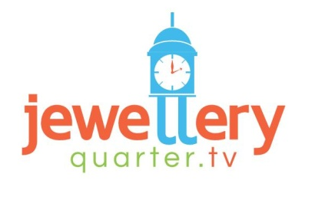

Introduction

Jewellery Quarter TV - requires a brochure to promote an Event Street market that will be used to drive tourism and local trade to the area.

Please watch the video below to understand the history of the Jewellery Quarter

https://www.youtube.com/watch?v=-lvoA5S2Dog

https://www.youtube.com/watch?v=yCKu7ps13fU

The Jewellery Quarter is Europe's largest concentration of businesses involved in the jewellery trade, which produces 40% of all the jewellery made in the UK. It is also home to the world's largest Assay Office, which hallmarks around 12 million items a year. Historically the Jewellery Quarter has been the birthplace of many pioneering advancements in industrial technology.

Brochure Brief

Layout is at designer’s discretion the following is for direction and material only – Images can be sourced by designer.

Front Page
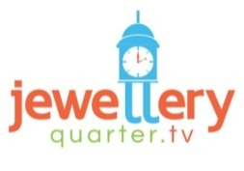

Sunday Fair

Antiques Fair - Area Tours - Art Fair - Clothes Market - Craft Beer Tent
Jewellery Fair - Jewellery Quarter Street Feast - Shakespeare Live Performances

First Sunday of every Month

10.00am – 7.00pm

The Golden Square, Warstone Lane, Birmingham B18 6NP

Celebrating 250 Years of Trade – In circle

The biggest Jewellery District in Europe – In circle
Find us at



Example
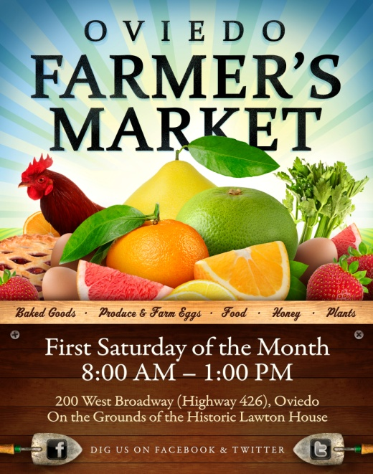

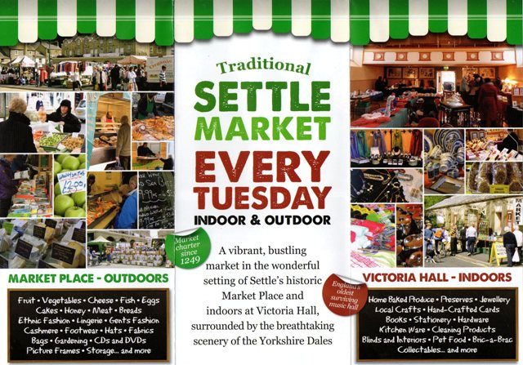

Circles

Inner Pages

We would like a middle spread that explains the market activities with graphical image to describe each area with a small amount of text to state what is contained within that area.

Antiques Fair

Antique & Collectors Fair with antiques, collectables, fine and vintage jewellery, linens, silver, metalware, militia memorabilia and lots lots more

Area Tours

Let the experts show you the real Jewellery Quarter with these guided tours that delve into the area’s history, landmarks, emerging culture and much more

Art Fair

Visitors can view and buy art from an assortment of galleries and artists presenting collections of visual art, photography, sculpture, glass work and ceramics

Clothes Market

If you're looking for designer brands at discount prices, on a budget, or looking for something different to the usual high street fashions, a trip to our clothes markets is sure to provide you with inspiration. Shop for unique and unusual clothes, plus vintage threads and second-hand treasures at our clothes market.

Craft Beer Tent

An extraordinary experience featuring specialty craft beers from craft breweries from throughout the midlands and UK

Jewellery Fair

Browse a stunning collection and unrivalled choice of contemporary jewellery and stylish silverware. Visitors can purchase from an exciting range by local, emerging British talent as well as the latest designs from more established makers.

Jewellery Quarter Street Feast

Brings together a wide variety of street food cultures from around the globe creating a unique dining experience that will leave attendees licking their lips and fingers for more.

Featuring:

Tacos, Jerk, Curries, Burgers, Burritos, Brownies, Fries, Stews, Pizzas, Sausages, Slow Roasts, Pulled Meats, Wraps, Noodles, Desserts, Shakes…

Shakespeare Street Performers

Come and enjoy a variety of Shakespeare plays either on our Shakespeare stage or specially adapted performances adapted by our team of Street Performers who will perform to large circles of people. They are capable of entertaining crowds hundreds strong for 45 minutes with a combination of adapted scripts and comedy inserts.

**If you would like to get involved with any of the above areas as a trader then please email with a brief of your area of profession: marketstalls@jewelleryquarter.tv

Example
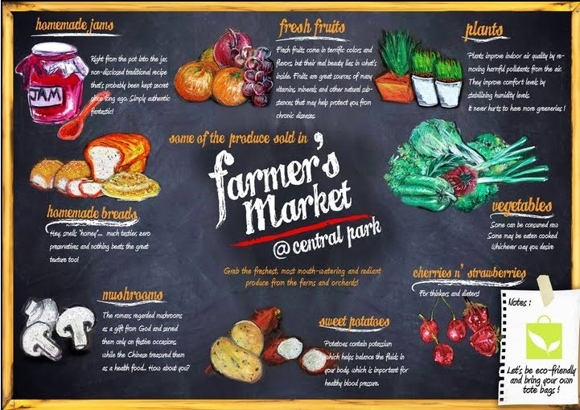

Back Page

Use the following map to place the different areas of interaction to the key and onto the map for the attendees so they know where to find the different fairs.

The map can be found at the following web address:

http://jewelleryquarter.net/wp-content/uploads/2013/02/61-getting-here-jq-map.pdf#page=1&zoom=auto,-201,839

Map

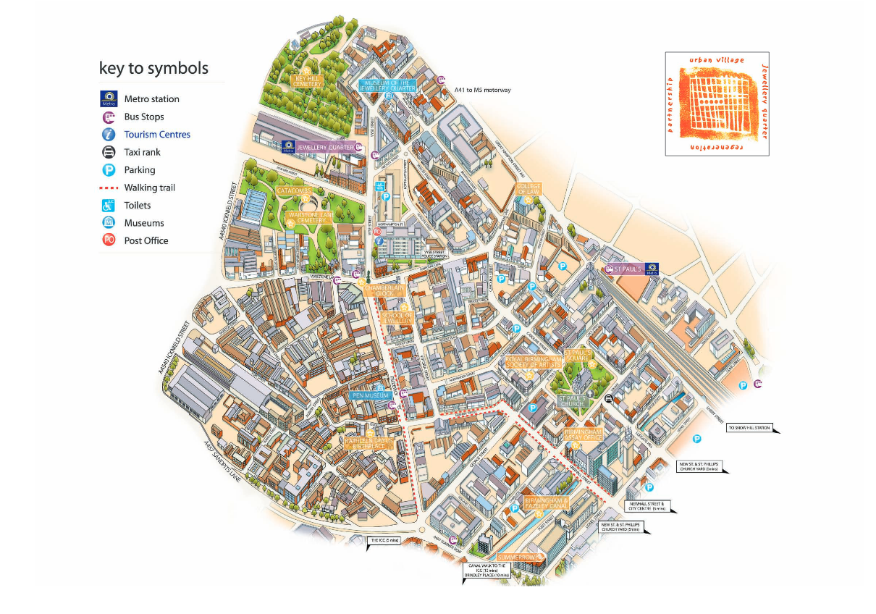
- Jewellery Fair

Frederick St, Birmingham B1 3HN
- Craft Beer Stalls
- Street Feast Stalls

Regent Place Car Park
B1 3NJ
- Street Feast Stalls

Vittoria St, Birmingham B1 3PE
- Antiques Fair
- Art Fair

St Pauls Square
Birmingham B3 1QU
- Area Tours
- Clothes Market
- Shakespeare Street Tent

The Golden Square, B18 6NP

Targeted Partners

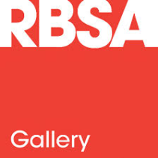
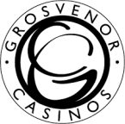
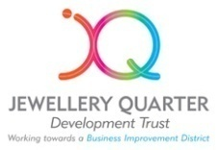



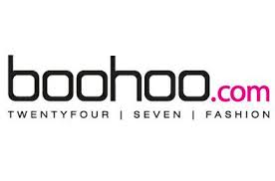




Example

