Enable A Push Or Pull Content Distribution Strategy

There are no development costs or lead times to get started. We can help you brand your own custom portal in minutes and you can begin to upload your content today.
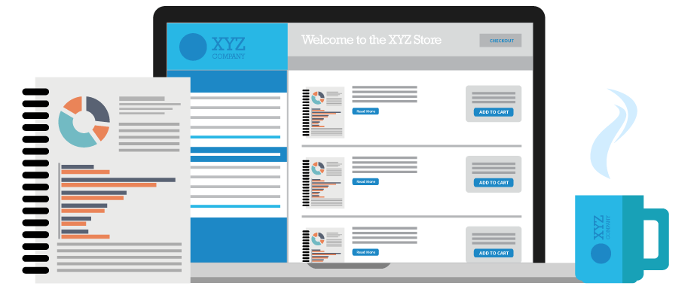

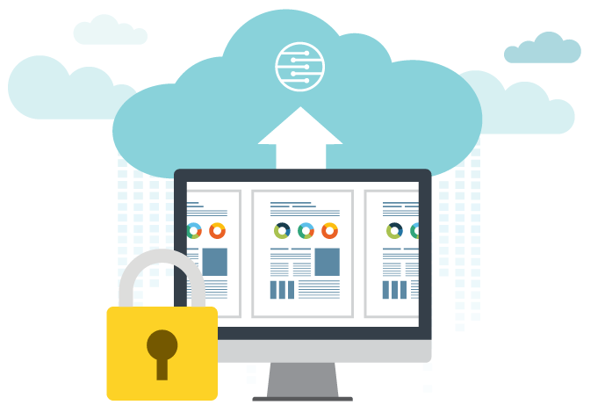
Centralized Content Management
Make United Connect the central Hub for all your printed and digital content. Push or pull to internal teams or external partner networks. Measure engagement with advanced reporting.

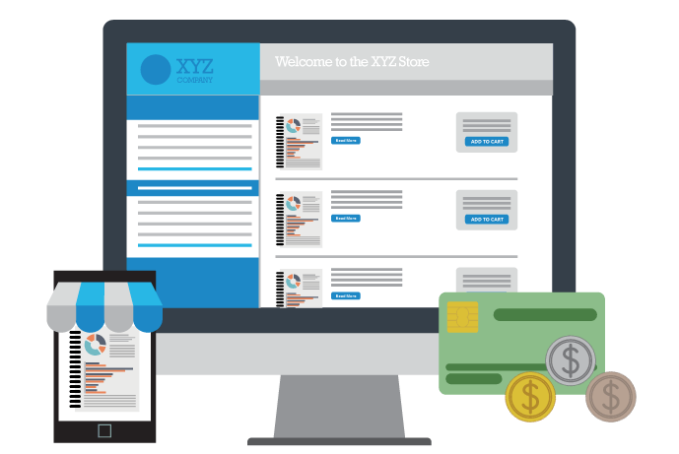
Instantly Increase Effectiveness
United Connect puts the buyer in control making systems that were cumbersome immediately easier to manage and more cost effective.

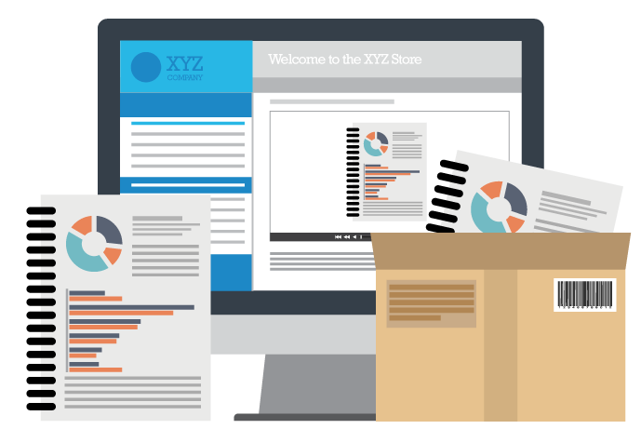
Focus On Core Responsibilities
United Connect platform handles every aspect of production, distribution and administration. This enables your team to put more focus on their core responsibilities and improves productivity.

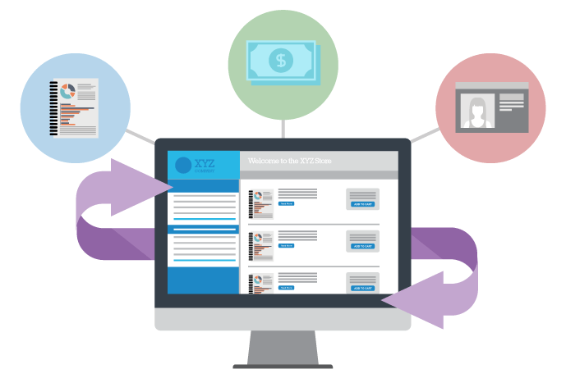
Your Content Can Work For You
Publish your content to your custom portal for purchase by your clients. You set the pricing and permission levels for access to materials. The platform handles the backend including payments.

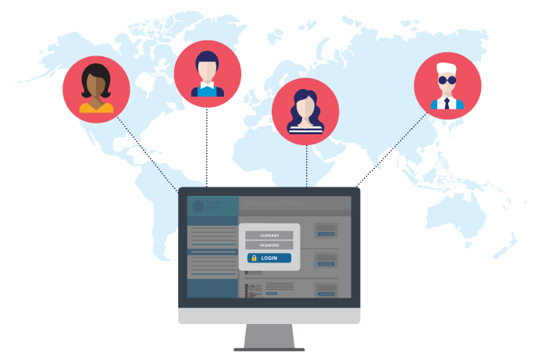
Network Support
Support partner network and franchise owners with the United Connect platform. Permissions can be set so each partner will access only what they need, and our variable data tool will let them customize materials to fit their end needs.

For questions and answers regarding the United Connect Application, click here.

Let us show you how you can create your own custom portal today

Speak to one our content experts to learn how:

First Name
Last Name
Company Email
Company
Phone
Comments
Submit

