Job Description:

Logo development for Glanco Carbon.

What we need: A Logo Mark and word combination.

How we want the logo: Mary Heath inspired (instructions below)

What it needs to say: Glanco Carbon (as below)

What we want:

Something very, very similar to the lion (below) expect for one difference…We want our company represented by a real life hero. This is Mary Heath:
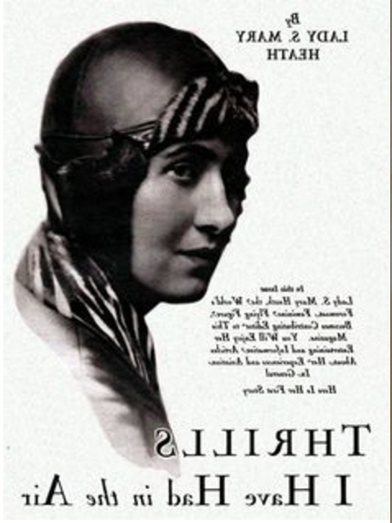

Mary (Irish, a hero, and under celebrated) was the first pilot, male or female, to fly a small open-cockpit aircraft from Cape Town to London. Mary was fucking badass. Look at her, chin down, head tilted forward –ready to go. We want to associate our brand with her. Make a badass flat representation of this lady. We need you to invent some kind of mane/contrail/mass of something behind her head, as in the lion head below, because it screams ‘STRENGTH’. Make the face recognisably feminine but not petite or delicate. Look at how a simple head tilt make this Hawaiian airlines logo look more ferocious (focus on the brow furrow, eye squint and head tilt):

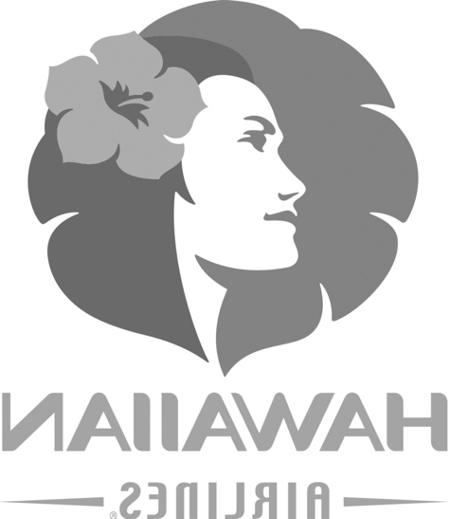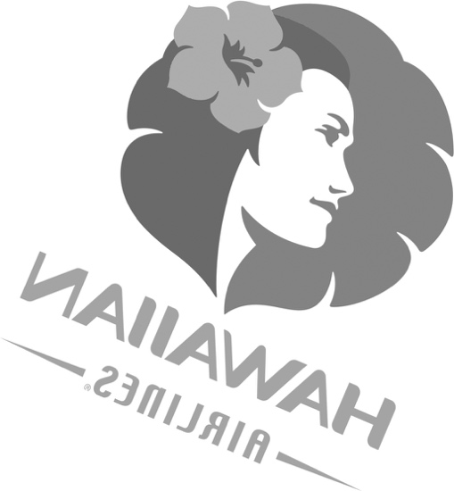

N.B. Mary Heath did not have a flower in her hair. She had goggles and a leather, head hugging, hat. If her hair was long it was likely messy and blowing in the wind at an almighty rate. Maybe that can be the mane/contrail we’re looking for?

Where we’re at:

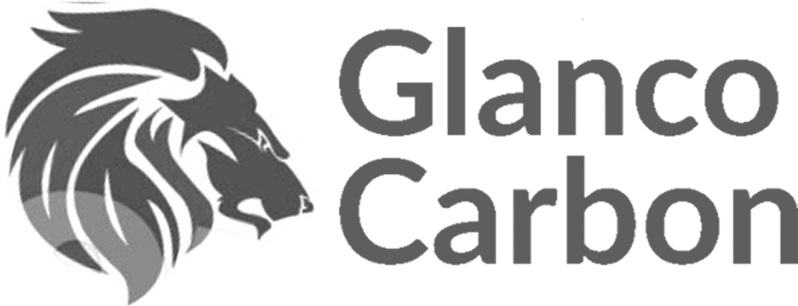

This captures the style we want – clean, minimal and using negative space to define all of the features. It is strong and purposeful i.e. the lion is moving forward as indicated by the forward head tilt and the furrowed brow. His mane is big a thick. This fucker means business. So do we.

Some design fluff to think about -
This lion has obvious geometry i.e. it has been constructed, with proportion in mind (hence the inherent beauty of the image) We want the proportions of our logo to be considered equally as important. Obviously we don’t want to see the construction lines but you can imagine how that lion was made. It was certainly measured. Examples of proportion works in progress below.

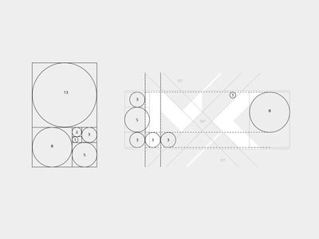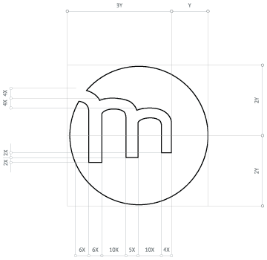

Other notes…don’t be afraid to be abstract…at the end of the day we need a recognisable mark…we don’t need people to be able to come along and identify the woman’s face.

“Oh yeah Ted, that’s Mary Heath alright.” I don’t know Jim, is that not yer wan from the telly?” …and so on

No, we want to capture the soul, heroism and sense of adventure she represents.

We don’t want a random lion to represent our brand. We want Mary – a lioness.

Looking forward to seeing your concepts – Have a fucking awesome day.

Ray

