Kyle willett
CEO/Head Trainer

Education and Certifications
- Vanguard University
- BS in Exercise Science
- Sports Performance Specialist (SPS)
- CPR, & AED certified
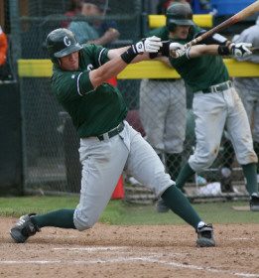
Athletic Achievements
- NWAACC South Championship in 2010
- CIF Champion as a coach in 2014 with SMCHS
- Over 100 stolen bases during college career
- Signed Professionally with Raton Osos
Personal Bio
Kyle Willett is a 2007 graduate of Santa Margarita where he was a dual sport athlete playing both baseball and football. After SMCHS, he went on to play baseball at Chemeketa Community College in Salem, Oregon. In 2010, he helped lead his team to a NWAACC South championship. Kyle continued his baseball career at Vanguard University while obtaining his degree in Exercise Science. He then went on to coach at SMCHS under coach Dave Bacani from 2012 through 2014. As an outfield coach, hitting coach, and speed coach, Kyle helped the Eagles win a CIF championship in 2014. In that time, he turned down a professional contract from the Raton Osos to begin his career with Redline Athletics. Kyle has been a part of the Redline Family since 2007, first as a client, then intern, and now as the Head Trainer.

