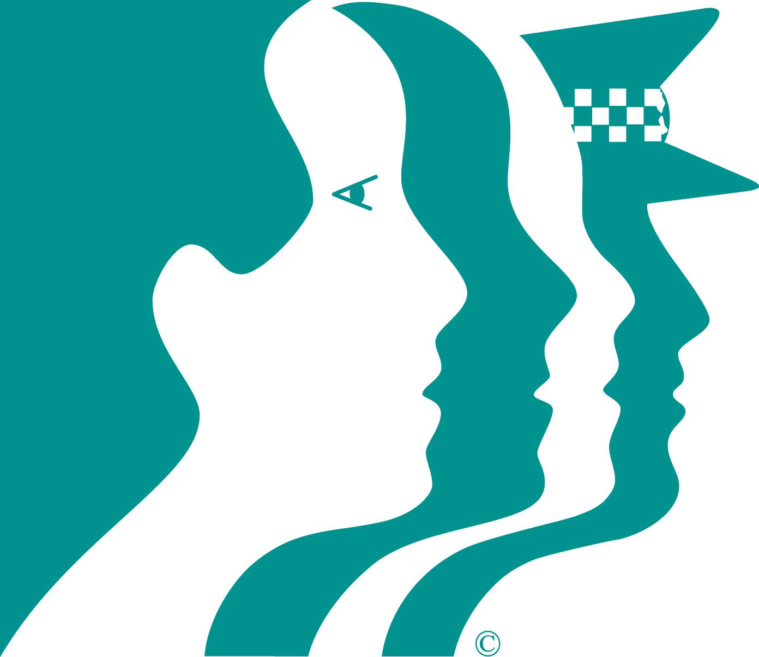

CREATING SAFER COMMUNITIES
crime prevention is everyone’s business

