EN3 Skin Clinic - Website Specification

General
We need a web design for new wellbeing website. At the moment, I would like to focus on selling wellbeing products and so need an ecommerce solution also. I have attached some photos of natural beauty faces. On the home page I would like these faces to dissolve into each other on a loop.
You will need the option of being able to log into an account, either through facebook, google, twitter or create an account. For created accounts, obviously need the facility to be able to reset passwords, see previous orders, track current order, and maintain favourites.
It should be PC, mobile and tablet friendly.

Home/Landing Page

Logo is below.

There should be a search field.
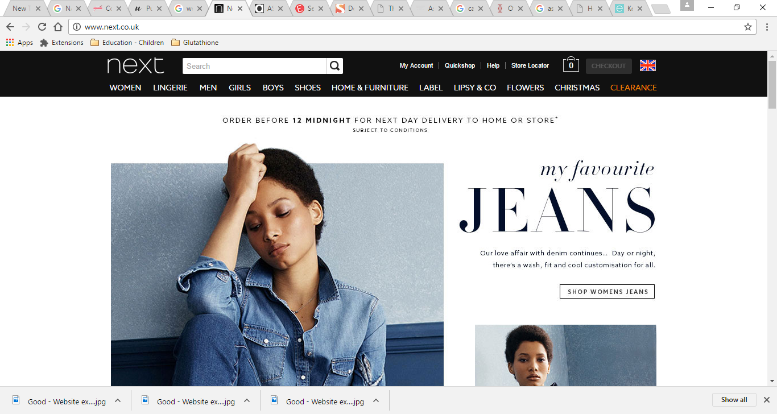
And cart
I particularly like the sign-in and cart logos on front page of this site. https://www.justvitamins.co.uk/
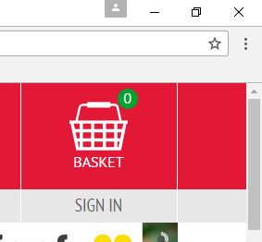
navigation bar should with menu for following categories;
- Skin Lightening Tablets
- Skin Lightening Creams
- Skin Lightening Soaps
- Skin Lightening Vials
- Contact
- About Us

I would like a body of the home page to have a slider(i think thats what it is called), basically an image that transitions exactly as show in the attached presentation. I would also like the images i have used in the presentation to be used. If you can just keep the faces and white out the background. I would like the images to dissolve into one another like in the attached presentation, or alternatively to transition in a honeycomb effect.

Shop
Should allow customers to add to cart from shop landing page and should be able to click on more detail and pop-out of more detail should appear where they can also add to cart. The shopping functionality as seen this site is exactly what I want, including the review functionality. http://www.pureclinica.com/health-supplements.html

Shop should have a “sort by” drop down, and this should have options of;
- Name
- Top Sellers
- Highest review score
- Price high to low
- Price low to high
There should be ability to refine on left hand side, similar to that shown on following link http://www.asos.com/women/new-in-clothing/cat/?cid=2623

It should have the following refine categories down the left side;
Categories;
- Skin Lightening tablets
- Skin Lightening Creams
- Skin Lightening Soaps
- Skin Lightening Vials
- Skin Lightening Systems

Contact

This page should have a send a message tab as seen on this page - https://www.justvitamins.co.uk/contact-us.aspx
Please can you create page that gives the following message;
Get in touch for expert confidential supplement advice, or for customer services.
Calling from the UK
0844 357 8005
Calling from Overseas
+44 844 357 8005
To contact us by email, please click the send us a message tab on the right.
Our team is available
Monday - Friday: 8am until 18:00pm
Answerphone out of hours

About Us
Lorem ipsum dolor sit amet, consectetur adipiscing elit. Phasellus non sodales ipsum. Pellentesque ac nisi eu sem suscipit luctus. Duis commodo aliquam mi, non pellentesque est finibus vitae. Maecenas ut faucibus magna, eget volutpat lorem. Nunc vestibulum ut nunc ut tincidunt. Curabitur non ante porttitor lectus volutpat imperdiet interdum sit amet erat. Maecenas convallis erat massa, sit amet faucibus purus imperdiet sed. Sed tellus odio, ullamcorper sed elit consequat, pretium dictum dui.
Morbi a euismod sapien, ac porttitor sem. Suspendisse molestie at urna quis accumsan. Suspendisse potenti. Integer id dui elementum, feugiat erat quis, ultricies dolor. Quisque in ullamcorper purus, efficitur ultrices leo. Nullam non gravida nunc, eget interdum mi. Suspendisse ac nisi aliquet, tempus urna vitae, venenatis nibh. Vestibulum aliquet in tellus et aliquet. Praesent consequat arcu et mauris porttitor, ut lacinia dui lobortis. Praesent hendrerit dolor eu faucibus venenatis. Mauris porta auctor ex lacinia mollis. Morbi euismod massa a lacinia porttitor.

Target Market
Middle aged women are our most common client, however, younger patients, both male and female, will often visit the site. In summary, I would like the site to appeal to all age brackets.

Look and Feel
It should be an elegant, modern, professional, trendy, unisex website. It should look clean and calm. Am happy to try interesting and slightly unusual designs. I would also like to have chat functionality, either powered by zopIMchat or by
Websites I like are
https://www.elite-aesthetics.co.uk/
https://www.justvitamins.co.uk/
http://www.pureclinica.com/

PLEASE DO USE YOUR KNOWELDGE OF WHAT WORKS FOR WEB DESIGN. YOU’RE THE EXPERT AND NEED YOUR EXPERTISE. CARTE BLANCHE TO DESIGN AS YOU SEE FIT. Please be creative, I need my site to stand out from the crowd.

