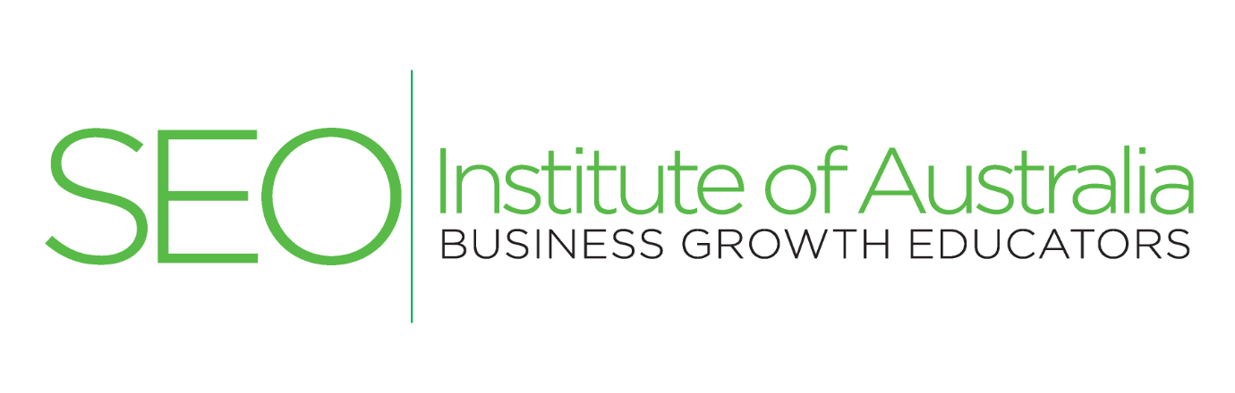

SEO Institute of Australia work with organisations to design, implement and oversee an online marketing Search Engine Optimisation (SEO), Social Media optimisation (SMO) and Search Engine Marketing (SEM) strategy. Integral to the strategy is getting your website ranking high on Google, Yahoo! and Bing to increase site visitors and then boost conversions into leads and sales.
We aim to give your business the tools to hit your competition hard and take from them market share across each product and service offering.
Comprehensive Small Business SEO package fees from $1,800.00 per month plus GST.
SEARCH ENGINE OPTIMISATION (SEO)

We create great and unique content on your website pages that focus upon what your customer needs to know and wants to find:
- SEO friendly URL's;
- Integrate key words as identified from a key word planner (Google Planner);
- Anchor text, Meta Tags, Meta Description;
- Blogs for business;
- Question and answer;
- Live chat;
- Cross linking;
- URL normalisation;
- Copywriting;
- 301 redirects;
- Multiple URL's;
- Multiple ISP's.

SOCIAL MEDIA OPTIMISATION (SMO)

We create and coach you how to maintain exciting and useful social media:

- Facebook for business site;
- Instagram for business site;
- LinkedIn site;
- Twitter for business account;
- E-Marketing newsletters.

ONLINE MARKETING

Online marketing is often referred to as digital marketing, internet or web marketing. Online marketing activities include, but are not limited to:

- Search Engine Optimisation (SEO)
- Search Engine Marketing (SEM)
- Social Media Marketing
- Direct marketing
- Display advertising
- Email direct marketing
- Social Media Optimisation (SMO).

The fundamental concept with online marketing is the focus on the customer and building comprehensive solutions to meet their search needs.

SEO Institute of Australia incorporate each of these activities into the development of a robust and nimble online marketing - business growth strategy to enable you to compete within an aggressive and competitive environment so you can break into, grow and then maintain SEO and SMO rankings for each of your products and services.

SEO Institute online marketing staff work on each of these activities and implement, tinker, arrange and then re-arrange a myriad of SEO, SMO and SEM below listed techniques to broadcast your organisations products and services within your region of business.

SMALL BUSINESS PACK

SEO Institute of Australia will implement an online marketing growth strategy that seeks to get your website ranking high on search engines allowing you to take from the competition market share for each product and service your small business offers. Products and services you receive include:
- Branding (stationery, newsletter templates);
- Domain name registration and hosting (3 URL annually);
- Website design and creation/recreate (1 website and 2 sub website annually);
- Search Engine Optimisation (SEO techniques applied weekly to each site);
- Social Media sites (Facebook, Twitter, Linked-In, Instagram);
- Social Media Optimisation (SMO techniques applied weekly to each site);
- Online advertising (Newsletter templates, banners, photos, Pay Per Click (budget limited);
- Broadcast marketing monthly (Fax, Mail, SMS);
- Conversion Rate Optimisation (Copywriting, site analysis reports);
- Coaching and overseeing blogs, question and answer, social media, key word and identifying industry updates.

Fixed monthly fee
The standard fee charged for the aforementioned services is $1,800.00 per month plus GST. We require that you commit to a 12 month campaign but our recommendation is that you commit to at least a 24 month campaign to achieve the best long term sustained results.

We understand this is a serious investment but we are about producing serious results and if your business is ready to grow then our proven techniques will see that you will grow.

What you receive
- An online marketing - business growth strategy plan
- A logo, stationery, websites, social media sites, advertising template, banner template, databases, blog, marketing techniques, broadcast gateways and associated intellectual property (IP);
- A monthly site report that includes ranking statistics and conversion analysis with the view to ongoing improvement of increasing sales or leads as per the online marketing strategy.

What’s expected from you and your staff?
We will require that you or another designated person/s within your organisation:
- To be trained in and then maintain online enquiries, blogs, social media uploads, web page unique content creation and content for Fax, Email, SMS and Newsletter Broadcasts;
- Liaise with our SEO Institute studio technicians regarding your business products, services and industry updates;
- An openness from the small business to allow the website to integrate and become part of your business practice;
- Learn to plan for and think about business operations in terms of the online marketing strategy to enable the business to continue to achieve long term sustained SEO and SMO results.

Will this work for my business?
In short, yes. But you need to be able to afford it, commit to the journey AND be ready to handle the sales activity that comes your way. An E-commerce (online sales) website needs to handle increases in orders. Lead generation websites need to be able to process an increase in the number of new leads. But, growth in business does come with challenges and if you have read this far then you are ready to take the next step.

BROADCAST MARKETING

Building a successful marketing strategy should also incorporate technologies that are not solely online strategies. The addition of database marketing to support an online marketing strategy can time efficiently and cost effectively grow business leads and support existing clients, via:

- Mail
- SMS Broadcasts
- Email marketing
- Bulk Facsimile Broadcasts

SEO Institute advisors will assess your organisations existing databases and suggest how the creation or variance to existing practices can help generate new and repeat business for your organisation.



FOR MORE INFORMATION

SEO Institute of Australia was established on 18 November 2015 to assist business around Australia integrate proven internet marketing techniques and help them grow inbound enquiries, online sales and provide greater solutions to existing and future clients.

SEO Institute has an intimate understanding of Search Engine Optimisation (SEO), Pay per Click (PPC), Social Media Optimisation (SMO), online advertising and building business brands across Australia that compete with large organisations and take from them market share.

SEO Institute of Australia
Level 14, 330 Collins Street
Melbourne VIC 3000

Level 9, 55 Hunter Street
Sydney NSW 2000

Email: info@seoinstitute.com.au
Web: www.seoinstitute.com.au

Call 1300 61 61 91

Search Engine Optimisation Australia Pty Ltd ACN: 609 302 043 trading as SEO Institute of Australia

