LOGO
(replace the design&construction with word `maintaince`)

WE PROVIDE THE COMPREHENSIVE PROPERTY MAINTAINCE & BUILDING SERVICE YOU NEED!
No matter how BIG or SMALL the job …
We have the SKILLS & EXPERTISE to HELP!
CALL US NOW FOR A FREE QUATATION
800-LUXEN
800-58936
QUALITY GUARANTEED

(Similar image but photoshopped with our logos and european peoples)
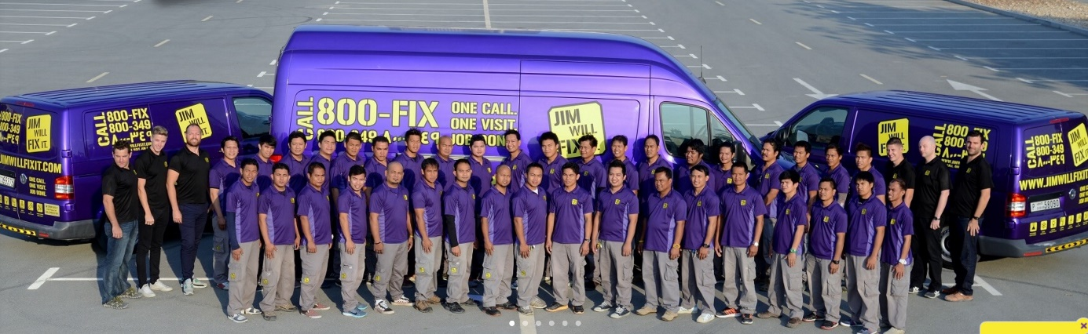

SERVICES
- AC Repair
- Plumber Services
- Electric Repair
- Carpentry Work
- Gypsum Ceiling
- Painting Services
- Cleaning Services
- Emergency Services

www.luxen.ae
Luxen LLC, Clover Bay Building, Office 1304, Business Bay, Dubai

