Balance your body with Biomagnetism!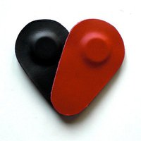
Sandra Mortada
050 748 30 73
Sandra.mortada@gmail.com

