Hi
I am truly happy to be doing all of this. I know that these are registered Icons but I took them so that I can give you an idea of what I would like.
So the final name is Quantum Bioenergetic Healing, as it was available, So these are the images and information you need for the Logo. In the meant time I am working on the template for the Banner and the Leaflet and I am also getting the email account so that it can go on the business card,. I put a little information on what Quantum Healing is so you can use it for your inspiration.
Tank you
Name: Quantum Bioenergetic Healing
Colors: Healing Colors are normally around the Green, Blue, Purple
Font: 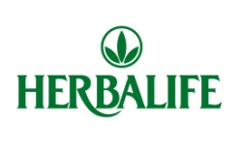I think this is simple but nice So For Example it Could say Quantum in the Top and Bioenergetic Healig as a second Line with logo in the middle? By the way this is just to give you an idea so that you know where srtar. We could also use QBH in the Logo? I don’t know My love you do your magic, Ido mine( hehehehe).
Images: I love the “Q” below (I think the first Q better than the second one? Or a combination of both, I like the softness of the first Q and the oval around the second Q. with something like the other icons inside it. Or it could have healing hands with the earth inside the hands.
The Images: repressent Quantum Energy, Healing, Well being.
Quatum Healing: Your body is composed of more than just its physical state of muscle, bone, and organs. It is also a complex system of subtle planes of matter that vibrate on a subatomic level. These vibrations act accordingly based on what the body is exposed to physically and subconsciously.
Treatment sessions consist of accessing the body on higher levels of vibration and intensity. The dynamic of the sessions help the body optimally recognize itself and its imbalances so it can heal much more efficiently. When higher vibratory frequencies are addressed, the body can fix itself faster and stay fixed for longer periods of time, and with less effort. The goal is to allow your body to adapt to its external environment and express a higher state of health without having to rely on medicine, supplementation or rehabilitation.
The new theory, or Quantum Kinesiology (QK) utilizes quantum mechanics, Eastern medicine, Homeopathy, Applied Kinesiology, Chiropractic and supplementation, while identifying six realms of the body: physical, chemical, structural, emotional, electromagnetic, and spiritual.

“ Q’s” IMAGES
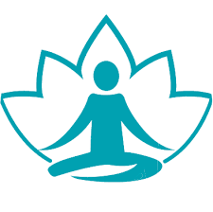
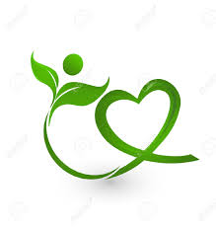
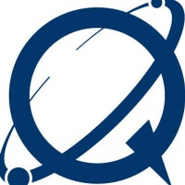
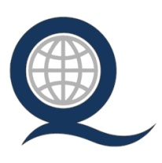
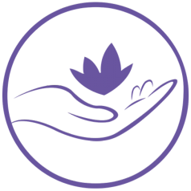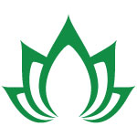
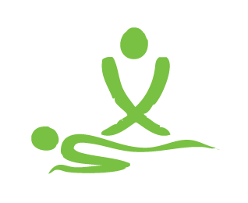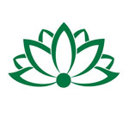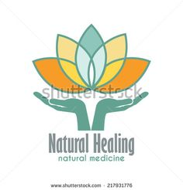

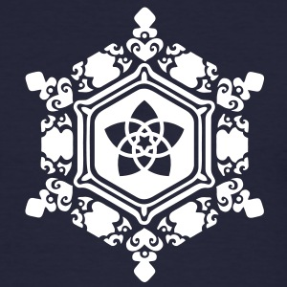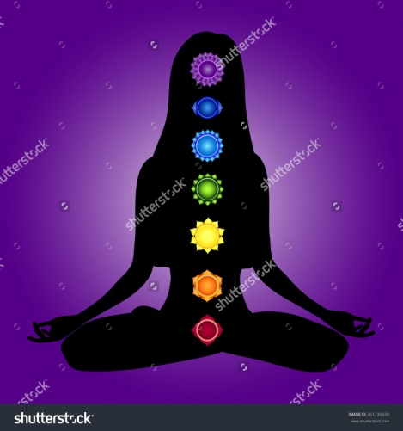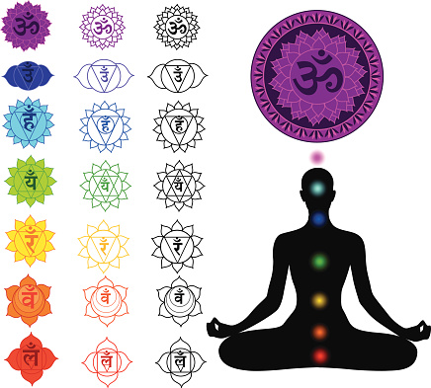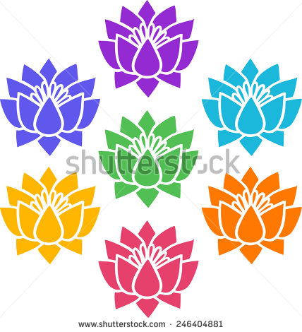
Gratitude Full Chacra system Simbols Of Chacras Quatum Energy: Lotus Flowers

