Mount Pleasant Website Requirements

General

- The target audience ranges from youth to elderly people, so the font needs to be easily readable.
- The design needs to be classical and lean toward conservative with a white background preferred.
- Colour scheme needs to be conservative but colourful, inviting and warm.
- The design needs to feature photos to support text boxes on each page to create a balance between text and images.

Logos
- Both Mount Pleasant Uniting Church and Uniting Church logos need to be used, With MPUC logo the more prominent.

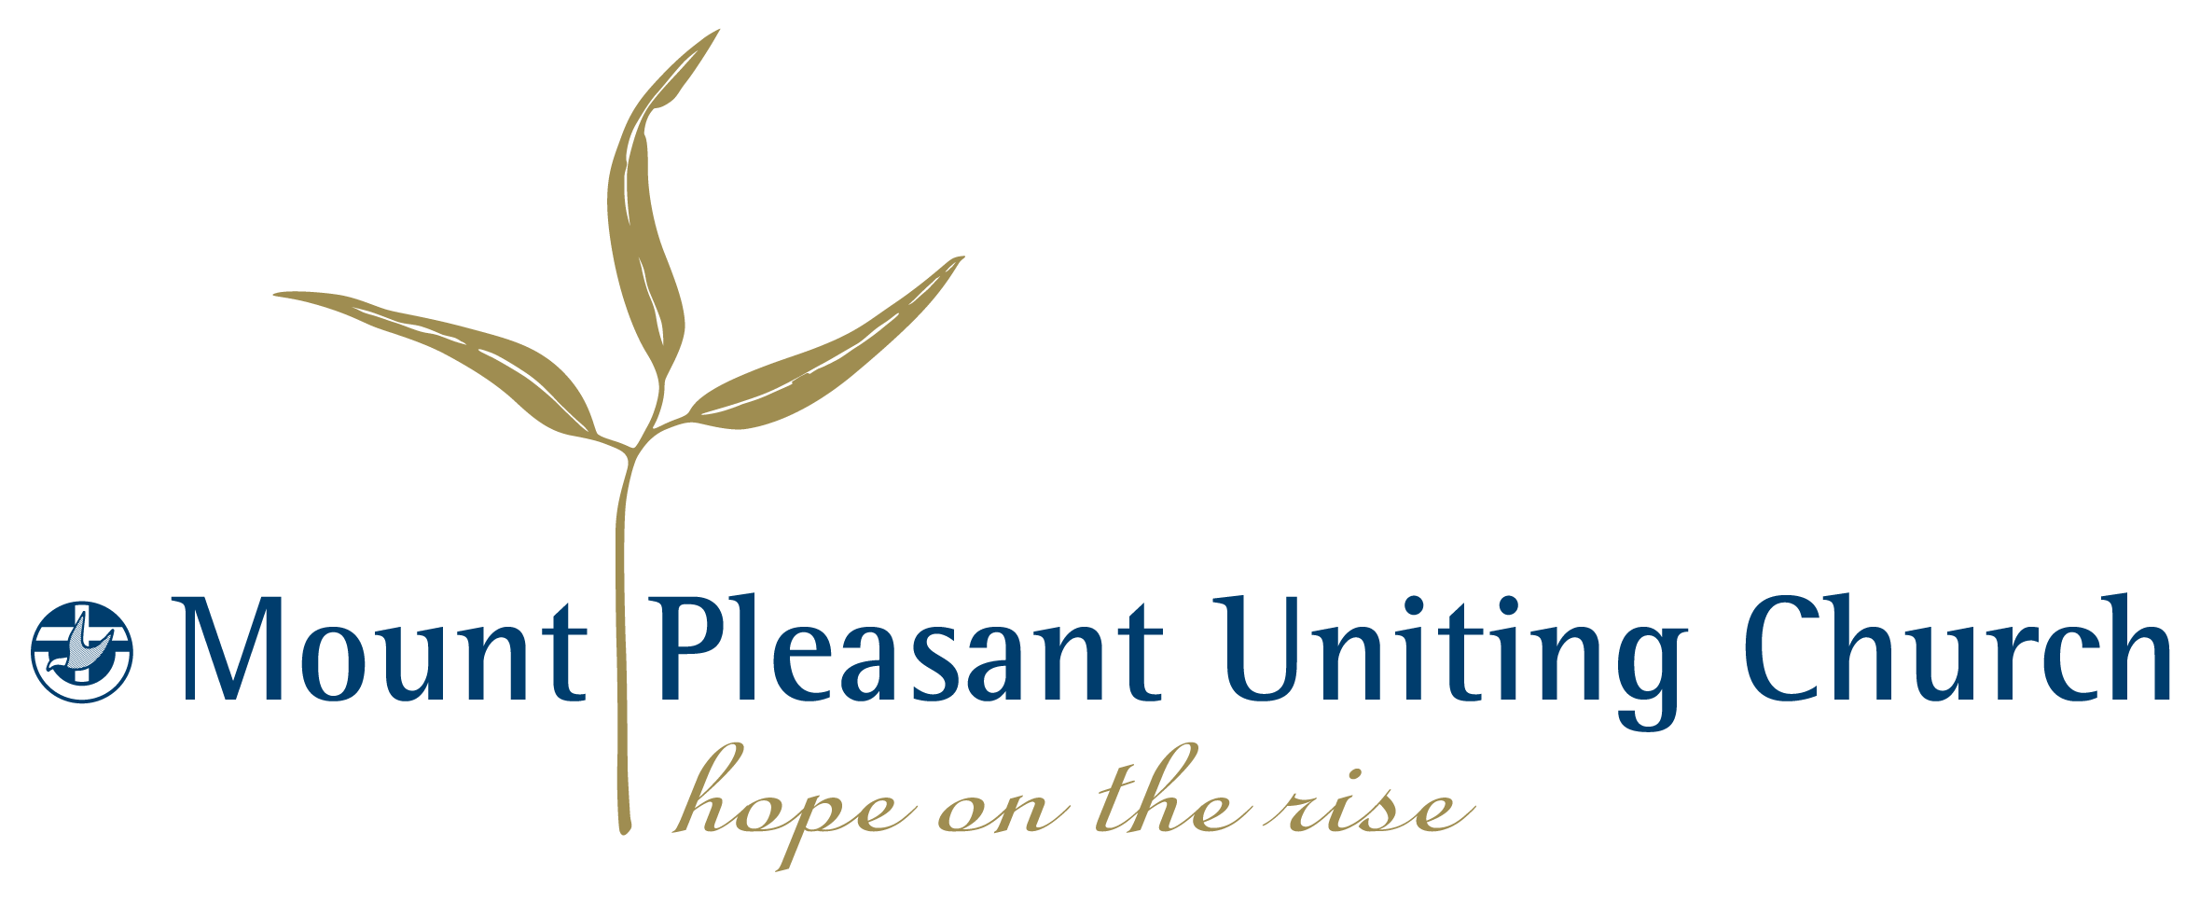

Mount Pleasant Uniting Church Logo



Uniting Church logo

Page structure
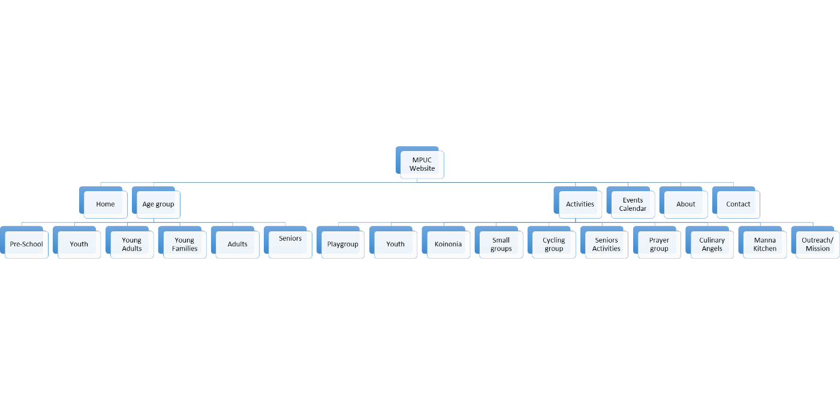

Home Page

The home page needs to be the central landing page for the website.

It needs to contain a welcoming first impression and contain the most important information of the church as listed below.

The home page needs to include the following:
Invite/Welcome | Paragraph of invitation/ welcome | Text | None
Scrolling photos of activity areas | Photo and tagline of each activity area | Photo with text tagline | Linked to activity page
Message | Minister's weekly message | Text | None
News | News summaries | Text/photos | News page
Prayer request | Area to enter prayer request | Text | E-mail address
Contact detail | Contact detail | Text | None
Email form | Form to email Church | E-mail form | Send email
Service times | Service times | Text | None
Facebook link | Link to Facebook page | Link | Facebook page
Theme/mission | Theme of Church | Text | None

Age Group Page

The objective of this page is to list the activities available to each age group.

This page needs to have a pull down menu to select the age group as listed. Each age group will list a number of the activities areas from the activities page, with links to each of those sections. E.g. The Young adults page will include links to the Small groups, Koinonia, Prayer group and Manna kitchen pages.

- Activites Pages
This page needs to list each of the activity areas. For each activity it needs to have a text box where information can be listed as well as a photo area where applicable photos can be added.

- Events Calendar
The events calendar need to have a table where Day, Date, Time, Event, Short description and contact detail can be listed. This will be updated weekly with future events.

- About MPUC
This page will explain the origins and objectives of the Church and needs to following areas:

Heading | Content | Format
Who we are | Description of MPUC/history | Text with photo
We believe | Paragraph on our beliefs | Text
Welcome | Invitation | Text

- Contact
The contact page needs the following information listed:

Heading | Content | Format | Links
Address | Address including Google maps image | Text/ Google insert | Google maps
Contact numbers | Telephone/ email/ fax contact detail | Text | None
E-mail form | Form to contact via email | E-mail template | E-mail
Bank account detail | Bank account detail | Text | None
Office hours | List | Text | None

