Rules Twist Poker Cards
For: Designer
Overview:
- Card Size: 63mm x 88mm (standard playing cards)
- Files must be print-ready
Card Back  - Use similar card back you already created as shown on the right, but black border and silver background.  - Provide the back in its own image file. No need to combine front and back images for all cards.  - Include small letters at the bottom  ©KC Entertainment LLC | 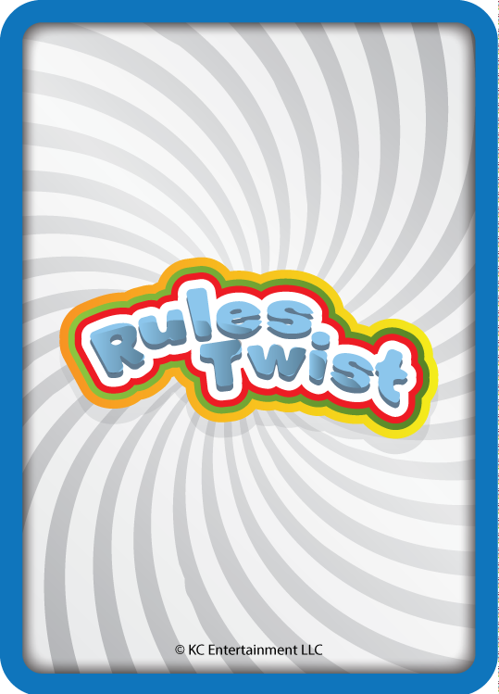

Card Fronts
Text in the middle of the card is only needed where shown. If the text area is blank then just the name is sufficient in the design.
Item # | Name | Action
1 | CHIP LEADER FOLD ‘EM | Player with highest chip stack must fold
2 | WILD HEARTS
3 | WILD SPADES
4 | WILD CLUBS
5 | WILD DIAMONDS
6 | PEEK | Peek at 1 card from any player
7 | 6TH STREET | Add 1 more community card
8 | BONUS | Each player receives 1 bonus card
9 | PASS RIGHT | Pass 1 card to the player on your right
10 | PASS LEFT | Pass 1 card to the player on your left
11 | LADY LUCK | If you’re a lady, receive a bonus card
12 | MAN LUCK | If you’re a man, receive a bonus card
13 | TILT | If you lost the last pot, you must crazy call any bet
14 | FAMILY POT | Everyone wins. Split pot between remaining players
15 | UNDER DOG | Worst hand wins
16 | JACK POT | Player with fewest chips wins the pot
17 | BETS OFF | No more bets. Best hand wins.
18 | WILD 2’S
19 | WILD 3’s
20 | WILD 4’s
21 | WILD 5’s
22 | WILD 6’s
23 | WILD 7’s
24 | WILD 8’s
25 | WILD 9’s
26 | WILD 10’s
27 | WILD JACKS
28 | WILD QUEENS
29 | WILD KINGS
30 | WILD ACES
31 | NO TWIST
32 | NO TWIST
33 | NO TWIST
34 | NO TWIST
35 | NO TWIST
36 | NO TWIST
37 | NO TWIST
38 | NO TWIST
39 | NO TWIST
40 | NO TWIST
41-52 | HOUSE RULES | <leave text area in middle blank so players can add their own rules>
53-54 | JOKERS

