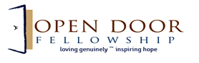

Colors – Gold, Orange, blue, green purple
Suggestions – Silowette of a city in the background; Use letters of ODF in some way

