You are invited to Liver Day 2015
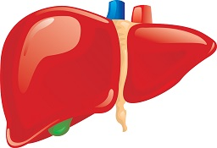
Purpose: to celebrate Jon's gift of a healthy liver to Von Welch in 2006

November 25th 6-9pm
LDS Church
11162 Alpine Hwy, Highland, UT

6pm Meet/greet and set up tables
6:30pm Eat (provided)
7pm Concert
-Donovan Welch
-Sidney Terry
-Bluegrass
8pm Dodgeball

You are invited to Liver Day 2015
Purpose: to celebrate Jon's gift of a healthy liver to Von Welch in 2006

November 25th 6-9pm
LDS Church
11162 Alpine Hwy, Highland, UT

6pm Meet/greet and set up tables
6:30pm Eat (provided)
7pm Concert
-Donovan Welch
-Sidney Terry
-Bluegrass
8pm Dodgeball

