 image for address399. W Boundary St.
image for phone 419-931-8786
image for fax 419-931-8785
image for email Info@perrysburgpetlodgeandspa.com
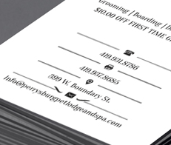

All of this info should be up in the top right corner

