VICTORY URBAN SOCCER – Its Football But Not As You Know It

EXECUTIVE SUMMARY

Victory Urban Soccer is a California Corporation that owns and operates boutique indoor soccer facilities focused on quality across all facets of the player experience, innovative soccer technology and being a unique social hub of the communities of which they service.

Our vision is to be the leading indoor soccer facility brand across the country. We aim to achieve this through our innovative approaches to the game and building a loyal and interconnected player network, culminating in a respected lifestyle brand.

INTRODUCTION

Indoor soccer in the U.S. is a near $1bn industry with no market leader and no clear identity on the broader sporting landscape. This lack of identity has led to a cookie cutter approach to facilities nationwide and a distinct lack of atmosphere at venues.

THE OPPORTUNITY

Victory Urban Soccer is much a lifestyle brand as it is an indoor soccer facility in that it understands and engages its patrons rather than perform the basic duties of a transactional entity that refuses to be flexible in a changing economy. Our research has shown that the market is ripe for a new type of indoor soccer facility, one that provides more personalization, connectivity and value to players and transforms venues into unique soccer hubs that players, supporters, friends, and families can come together and enjoy.

Did You Know? The current indoor format was created due to North Americans’ familiarity with hockey and the existence of hockey arenas, which then adapted their game for these facilities.

Victory Urban Soccer’s focus on combining an enhanced player experience with personalized technology (including an app, in-game video and packaged highlights) is a key differentiator in this market and will drive future growth.

Services | Current Indoor Soccer | Victory Urban Soccer
Organized leagues | X | X
App to connect with team and see latest live stats |  | X
Team personalization – logos & kits |  | X
Video highlight packages |  | X
Community engagement |  | X
Weekend Finals & Tournaments |  | X

Flexibility and innovation is a necessity for success and carving out a niche in the market. Many indoor soccer venues are limited with their services due to the necessity of maximizing league participation in the evenings and leaving little time to appeal to larger (and more lucrative) junior markets. The fields are also often oversized and cannot serve multiple functions because they are contained within rigid, purpose-built walls.

PHOTO OF VIDEO, COOKIE CUTTER COLLAGE & LOGO’S

THE FACILITY (show photo of facility and map)

- 5 minutes from downtown San Diego.
- 15,670 sq. ft.
- Field is within regulation futsal dimensions
- 2 story building with urban theme
- Electronic advertising hoarding
- Full video & sound system

Business Model

Core Revenue (80%)

- Competitive Soccer Leagues
- Youth Instructional programs
- Tournaments
- School programs
- Private Rentals
- Sponsorship & advertising

Ancillary Revenue (20%)

- Retail & equipment sales
- Memberships
- Niche partnerships
- Concessions
- Games zone/Classroom
- Community Events

Sales Forecast

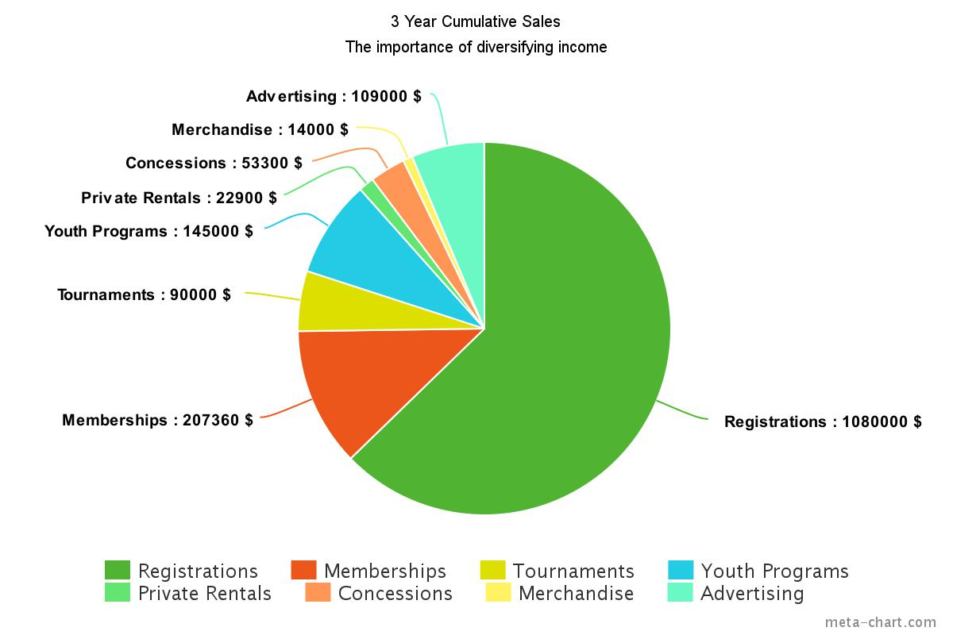

PROJECTIONS

Physical

- Approximately 600,000 impressions to I-5 northbound visitors weekly
- 124 teams & 1000+ players
- 75,000 visitors per year and over 3500 unique visitors

Financial

 | 2017 (60%) | 2018 (75%) | 2019 (90%) | 2019  (2 fields) | 2020 (95%) | 2021  (100%)
Revenue | $481,846 | $577,520 | $683,194 | $1,112,990 | $725,302 | $769,260
Expenses | $390,066 | $378,775 | $387,361 | $618,574 | $396,204 | $405,282
Net Profit | $91,780 | $198,745 | $295,833 | $494,416 | $329,098 | $363,978

Who Are We?

The strengths of Victory Urban Soccer are intrinsically linked with the skills and experiences of its two founders. Having both played numerous forms of indoor soccer across different continents, running FIFA affiliated clubs and tournaments and participating in international soccer tournaments, Ryan Ginard and Felipe Greven have spent the past year researching and predicting the future trends of the indoor market. Together with over 30 years combined experience in fundraising, sales, civic engagement and event management from Federal Government through Fortune 500 companies, their partnership and innovative approach to the recreational side of the game are a strong value proposition for future investors.

WHAT WE NEED – HOW WE’LL USE IT

Victory Urban Soccer is currently seeking seed funding of $250,000 - $350,000 for stage 1 (launch phase) of their proposed National City facility.

These funds will be spent on start-up expenses associated with site development including permitting, consultancy fees, building design and renovation, playing surface installation, off-field and online infrastructure, marketing and customer acquisition.

The seed capital will be used over the first year of operations to reach the following business goals;

- Develop National City site and launch competitions
- Grow team patronage to 60% capacity
- Continue rolling out new features to build out from minimum viable product
- Build a unique brand and loyal following through key milestones and metrics
- Diversify income streams and increase ancillary income to 15%
- Test, tweak, and launch beta version of Victory App
- Finalize a feasibility study into site purchase, a second field, and Series A funding found

INVESTOR ROI

Quarterly investor updates and dividends will be distributed and paid to all investors with the annual return forecast to be between $1,500 - $3,500. Investors will be making a profit on their investment midway through year 4. Those that purchase a 5% stake will also serve on an advisory board. Based on our five-year projections of operating via a minimum viable product, we anticipate an internal rate of return of 16% based on a 1% equity investment of $10,000.

