Sheesh Catering Catalog
PAGE 2
HOW TO ORDER

INSIDE COVER
INTRO

PAGE 3
BLANK

PAGE 4
TABLE OF CONTENTS

MAIN PAGE

PAGE 5
PARTY PLATTERS
DIPS

PAGE 8
STARTERS

PAGE 6
PARTY PLATTERS
STARTERS

PAGE 7
DIPS AND
SALADS

PAGE 9
MEATS –
SHAWARMA

PAGE 11
TRADITIONAL
DISHES

PAGE 12
WRAPS

PAGE 10
MEATS –
SKEWERS

BACK PAGE
PAGE 13
DESSERTS

PAGE 14
SIDES
AND EXTRAS

OTHER INSTRUCTIONS:
Each Page with food should have on the bottom: All platters serve 10 people unless otherwise stated
Wraps Page should have on the bottom: Wholemeal available upon request
Wraps Page should have on the bottom: All platters serve 10 people and consists of 21 pieces. Each piece is approximately 1/3 of a wrap

INSIDE COVER
Sheesh Grill is where you bring your friends or family to enjoy quality traditional Lebanese cuisine. Being the first of it’s kind we pride ourselves in creating a unique dining experience with excellent quality food at affordable prices.

The Lebanese love to gather regularly with friends and family to enjoy a banquet of lovingly prepared traditional food, such as dips and salads, bite sized pastries, marinated barbequed meats and much more.

Our catering is like no other; we will provide your next event with a feast that will impress all your guests. There are options to suit all your needs from a small get together to large family gatherings and corporate events. We also cater to all dietary requirements.

Your next event deserves a memorable feast worthy of the occasion. Something your guests will talk about for years to come!

customise your catering experience

1. Baked not fried.
We can bake our usually fried menu items for those who are health conscious.

2. Vegan.
Many of our menu items are vegan or can be made vegan to order.

3. Wider range.
Enjoy the freedom of choice of our exclusive catering menu options.

4. Mix it up.
Choose, mix and match our salads, dips, and starters to cater for ten, fifty or one
hundred people.

HOW TO ORDER

By Telephone
03 9330 3050

By Email
Send us an email to info@sheeshgrill.com.au, emailed orders must be sent 72 hours in advance. If placed in less than 72 hours, please contact us directly.

Come in and see us
255 Mickleham Rd., Tullamarine, Victoria, 3043
We are open from 11am until 12 Midnight Sunday – Thursday and until 2am Friday and Saturday.

TERMS & CONDITIONS

Delivery
We offer free delivery for orders over $150 within our delivery area. You can alternatively pick up the order from 255 Mickleham rd. in Tullamarine. Weekend and Public holidays may incur a delivery fee.

Pricing
Sheesh Grill reserves the right to amend the pricing at any time. Dietary requirements such as wholemeal, gluten free, baked, etc., may incur an additional fee. All pricing is current at time of printing.

Payment
All orders are to be paid in full 24 hours before delivery or pickup. Payments by eftpos, credit card or direct debit will incur a 5% administration fee.

Deposits
A 10% deposit is required on the date of order. The deposit is non-refundable if the order is cancelled within 7 days of the delivery/pick up date.

Cancellation
Deposits are non-refundable if the order is cancelled within 7 days of the delivery/pick up date.

CONTENTS

How to order
Terms and Conditions

Choose from a selection of:

Party Platters p3-4
Dips p5
Salads p4
Starters p5
Meats p6
Traditional Dishes p7
Wraps p8
Desserts p9

PARTY PLATTERS – 2 PAGES

DIP PLATTERS

Our fresh dip platters are perfect for any party where good food is welcome.

Choose from 2 different Sizes:
Regular - 15 People - $25
Large - 30 People - $50

Each platter has Hummus, Eggplant, Garlicky Yogurt and Cucumber, Spicy Salsa, and Capsicum and Walnut Dip and your choice of crispy herb pita bread or sliced carrots and celery.
Make your next event memorable with our delicious homemade dip platters.

STARTERS PLATTER

Our starters platters are sure to make any event even more memorable. Great for Christmas parties, birthdays, office meetings, casual get-togethers, family BBQs, or any other occasion.

10 Falafel with Mixed Pickles and Tahini Sauce
10 Sambousek Pastries
10 Kibbie
10 Stuffed Vine Leave Rolls
10 Sheesh Stuffed Pastries (Choose either Spicy Sausage, Garlicky Chicken, or 3 Cheeses)

$50

DIPS AND SALADS

DIPS

Our dips are made using fresh ingredients and imported Lebanese spices.

Hummus / Eggplant (Baba Ghanoush) / Yogurt and Cucumber / Spicy Salsa / Capsicum and
Walnut

$25

OPTIONS:

Add Bread and Olives - $7.50
Add Shawarma Meat to top - $10

SALADS

We use only the freshest vegetables and ingredients for all our salads such as Grade A farm tomatoes, Fresh Lemon Juice, and Hand chopped parsley

Tabouli
Traditional Lebanese salad with parsley, onions, tomato, lemon juice and cracked wheat

Coleslaw
Our take on this popular classic – crunchy cabbage and carrot with a home-made mayo dressing

$30

Fatoush
Mediterranean salad drizzled with pomegranate dressing and topped with baked Pita Crisps

Potato Salad
Our jazzed-up version which includes pickles and dill.

$25

STARTERS

Kibbie
Lightly-fried cracked wheat shells stuffed with lamb and pine nuts

Shawarma Sambousek
Tiny turnovers of buttery flaky dough enveloping a flavour burst of shawarma filling on the inside

Minced Lamb Sambousek
Filled with lamb and pine nuts

Sheesh Pastries
Filo pastry rolls stuffed with your choice of:

• Three cheeses with capsicum & onion
• Garlicky chicken & vegetables
• Spicy sausage, potato & cheese

Chicken Wings
Tender marinated char-grilled chicken wings topped with garlic and coriander

$20 (15 Pieces)

Falafel
Lightly-fried vegetarian chickpea patties served with Tahini sauce for dipping

Stuffed Vine Leaf Rolls
Seasoned rice and vegetables rolled in a tangy vine leaf

$15 (15 Pieces)

OPTIONS:

Add Dipping Sauces – Tahini or Garlic $5

MEATS

Shawarma
Our Shawarma meat is whole seasoned slices of lamb or chicken roasted on a spit and sliced to order

Chicken or Lamb
Tender pieces of shawarma cooked with fresh tomatoes, sliced onions, and served on a bed of rice.

$42

OPTIONS:
Add Dipping Sauces $5
Add Pita Bread: $5
Add Pickles and Olives $7.50

Sheesh Skewers

Bite-sized cubes of marinated lamb or chicken on skewers chargrilled to order. We also offer kafta which is Tasty minced lamb skewers infused with onions, parsley and Mediterranean spices.

Choice of either MINI COCKTAIL SKEWERS or FULL SKEWERS

- Lamb Skewers with Grilled Capsicum and Onion
- Chicken Skewers basted with our garlic sauce
- Chargrilled Kafta

$30 MINI COCKTAIL SKEWERS $48 FULL SKEWERS

OPTIONS:
Add Dipping Sauces $5
Add Pita Bread: $5
Add Pickles and Olives $7.50

TRADITIONAL DISHES

Mujaddara
A traditional lentil dish cooked together with rice and garnished with sautéed onions
$35

Riz a Djaj
A traditional Lebanese dish typically served for special occasions. Delicately spiced lamb and rice is topped with tender chicken, golden almonds and pine nuts.
$42

Mousaka’a Batenjen
Sliced grilled eggplant topped with a homemade salsa of chick peas, spices, onions and tomatoes.
$40

Kafta Batata a Riz
Kafta meatballs and diced potatoes slowly cooked in our traditional Lebanese tomato sauce with a mix of spices and served on a bed of rice
$42

Batata Harra
Pieces of spicy potato sautéed with coriander and garlic, then grilled with onions.
$35

Soujuk
Chopped spicy Lebanese sausages grilled with tomato and onions
$40

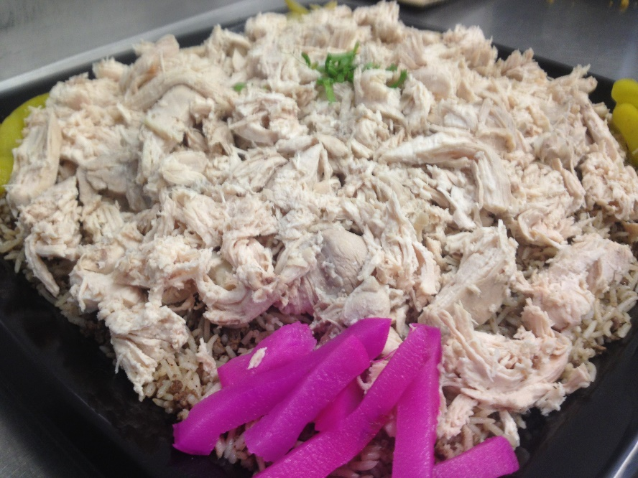

WRAPS

Chargrilled Skewered Meats
Bite-sized cubes of marinated lamb or chicken on skewers chargrilled to order.

Sheesh Lamb
Chargrilled lamb and vegetables with lettuce, tomato, a dollop of hummus dip and a splash of our secret-recipe Sheesh BBQ sauce.

Sheesh Chicken
Chargrilled chicken with lettuce, tomato, onions, mixed pickles and a dash of our tangy Sheesh garlic sauce.

$65

Shawarma Wraps
Our Shawarma meat is whole seasoned slices of lamb or chicken roasted on a spit and sliced to order

Chicken Shawarma
Tender pieces of chicken shawarma cooked with fresh tomatoes and sliced onions then put in a wrap with lettuce, tomatoes, onions, chips, pickled cucumbers, and garlic sauce.

Lamb Shawarma
Tender pieces of Lamb shawarma cooked with fresh tomatoes and sliced onions then put in a wrap with lettuce, tomatoes, onions, parsley, pickled turnips, and tahini sauce.

$65

Vegetarian Wraps

Falafel Wraps
Golden brown falafel with Lettuce, tomato, onion, parsley, mixed pickles & tahini sauce

Grilled Veg Wrap
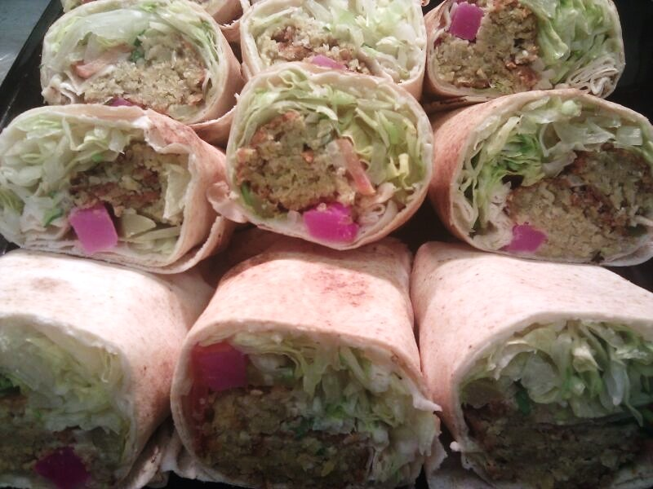
Lettuce, tomato, grilled onion, grilled zucchini, grilled capsicum, grilled eggplant and our Lemon Herb Mayo or Tahini sauce

$60

DESSERTS

Traditional walnut baklava
A sweet pastry made of layers of filo filled with chopped walnuts and sweetened and held together with our rosewater syrup.
$20

Baklava Fingers
Filo rolled and filled with chopped cashews and sweetened and held together with our rosewater syrup
$18

Ma’amoul
Shortbread pastries either plain and filled with dates or topped with icing sugar and filled with pistachio.
$20

Namoura
Rich and dense semolina cake that crumbles in your mouth.
$12

Turkish Delights (Rahat Lakum)
Small cubes of fragrant jelly flavoured with Rosewater or lemon.
$15 (12 Pieces)

Lebanese Nights (Layali Libnan)
An amazingly aromatic dessert that is quite refreshing. It has a rich complex taste stemming from subtle hints of mastic, orange blossom water and rose water. The bottom layer is made of pudding, topped with a layer of homemade cream and a layer of coarsely ground fresh pistachios and sugar syrup

Available in a tray $28 or individual servings $4

Lebanese Custard
A layer of plain custard topped with Lebanese biscuit then topped with a layer of chocolate custard. We then put a biscuit on top.

Available in a tray $28 or individual servings $4

Almonds Biscuits
Our oval almond shortbread biscuits are dusted with an icing sugar
$12

Coconut and Chocolate Chip Cookies
Soft and delicious. No further explanation needed
$15

SIDES

PITA BREAD $5
Wholemeal option available with at least 48hours notice

CRISPY HERB PITA BREAD $15
Crispy pita bread seasoned with our middle eastern herb and spices. Great for dipping

FRIES - $25
Seasoned with our special in house seasoning

LOADED FRIES $35
Different loaded options available – please ask for options

RICE - $25
Basmati rice cooked with a thin egg noodle

OLIVES AND PICKLES PLATTER - $25
An assortment of mixed peppers, pickled turnips, pickled cucumbers, and olives

SAUCES $10 (355ML) – ALL MADE IN HOUSE

LEMON HERB MAYO
A zesty Mediterranean mayo that’s great for dipping

TAHINI
A sesame sauce that goes great with Lamb Shawarma and Falafel

SHEESH GARLIC (TOUM)
A traditional Lebanese garlic sauce that complements our meats. Also great to dip our seasoned fries.

SHEESH BBQ
A tangy BBQ sauce that’s been a family recipe for over 35 years.

BACK PAGE

SHEESH GRILL GAURANTEE

At Sheesh Grill we aim for the highest standards in catering for our customers.

Our menu is full of different items that can accommodate any kind of catering requirement, whether you need to cater a lunch, conference, finger food event, BBQ, or a private party.

Our menu is prepared fresh for each catering order using only the highest quality ingredients.

We will make your next event or function memorable!

