Current site
www.vibeproject.org (will be changed to www.vibelife.org)

Description
A website consisting of podcasts dealing with unconventional/esoteric ideas for creating personal fulfillment and success.

Color Scheme

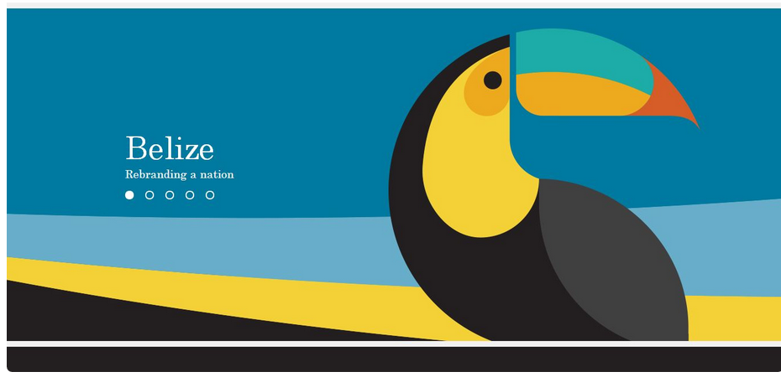
#1d5476 Blue (dark)
#5aa7d6 Blue (light)
#388E8E Blue-Green
#ffbd44 Yellow-Orange
#ff6500 Orange
#292929 Black-dark brown
#333333 Gray-brown

Note: The above hex colors are may not be an exact match to the artwork above.

Concept

- Based on Kokopelli. For examples see: https://www.google.com/search?q=kokopelli&tbm=isch&tbo=u&source=univ&sa=X&ved=0ahUKEwjA5Yjbi9PPAhWHix4KHXs6DEYQsAQINA&biw=1536&bih=794

Move away from the “traditional” Kokopelli images, which is a little overplayed. Needs to have unique playful (but NOT cartoonish) character/personality/identity Also, here’s an example (only a reference):

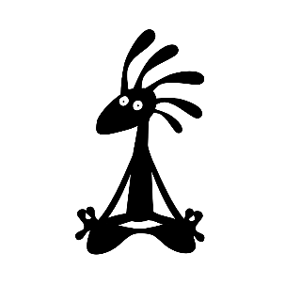

For website, currently thinking character (incorporating color scheme of toucan image above) speaking dynamically/expressively into a studio microphone. For ideas, see website header image (www.vibeproject.org) and below images as reference ideas only. Character would be standing vs. seated.

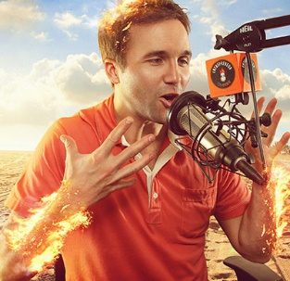
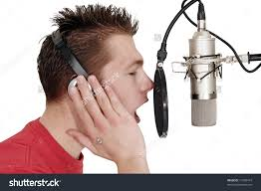
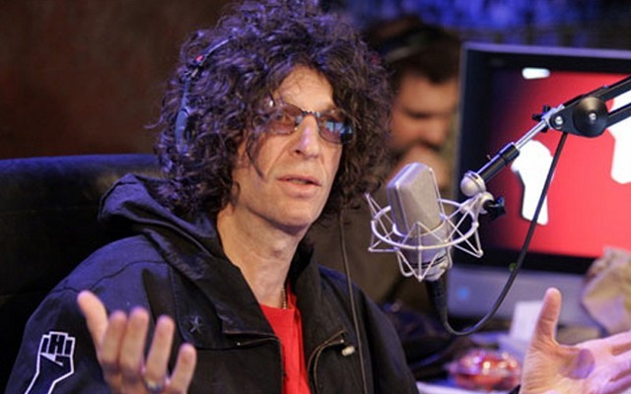
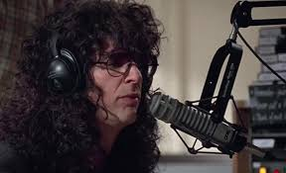
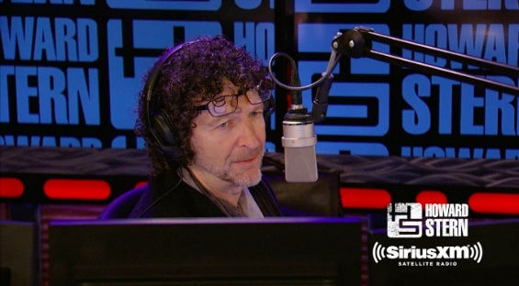

- Open to other concepts.

Final logo needs to be clean and to pop.

