Here are some methamphetamine chemical symbols you may want to incorpate into the logo design….

This is the preferred one below:

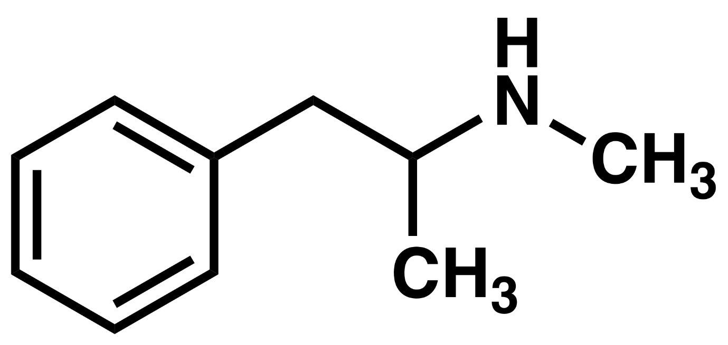

The other example (below on second page)…. However, another meth company uses a stylised version of this one (here http://www.methxpert.co.nz/) so it is really important that should you use this design we do not look similar to Meth Expert.

It is not life or death that a meth chemical symbol be incorporated into the logo… we are just providing some ideas and are open to having a completely different stylised design incorporated into our logo.
