See below some websites that I like certain things about:-

- http://www.johannamontgomerydesigns.co.uk/
I like the header of the opening page
- http://www.careercontessa.com/index/
I like the overall look of this opening page – the font, the inclusion of the blue colour, the menu titles in grey and the boxes with lines around them defining the picture

- http://femaleentrepreneurassociation.com/
If you scroll down this opening page there are 4 boxes again I like the idea of boxes that people press to find out more information.

- A picture of what I think I would like – but pls need creative input!

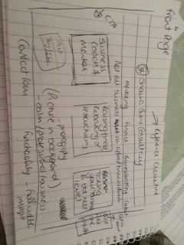

- I love the fresh and fun feel of this website

http://www.magicbeans.online/

- I have my own domain name www.shaunaburns.co.uk I want to use

