Shauna Burns Consulting
Here are some of the fonts and headings I like in some of the designs so far:-

I like the following font for the word “Consulting”

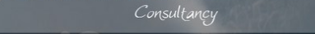

I like the following logo
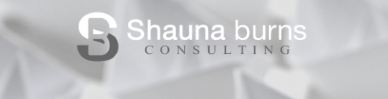
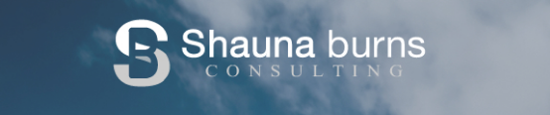

I would consider this heading but swopping the font about on the two lines. This is also one of the layouts I like for a header.
