Logo brief…
- My wife and I are about to start a family food blog, featuring YouTube videos and accompanying recipes. The blog will feature cooking sessions (videos) with members of our family (The Yeows) who are amazing cooks. Viatnamese/Malaysian/Western fusion. Many of the recipes are passed down the generations. Some are new age. To get a feel of the type of stuff we'll be cooking and baking, have a look at my facebook timeline on https://www.facebook.com/casper.yeow , https://www.facebook.com/kupkekcakes/ and https://www.facebook.com/kuegirl/ . Many of the recipes have been passed down many generations. Some history and tradition involved.
We want the logo to reflect family, tradition, friendship, love of cooking and food as a social glue but has to be fun/cute and informal, with small hint of Asian. The blog will be called “Fooding with The Yeows”.
The main contributer will be my wife Teena https://www.facebook.com/teena.yeow , my mum Christina and Aunty Kim but there will be others like my sister and some of my cousins, my two daughters.
- Logo text obviously must include “Fooding with The Yeows” with a tagline “It’s all about family, friendship and great food!”

From the left – Mum, Aunty Kim and my sister Poh on the farthest right.
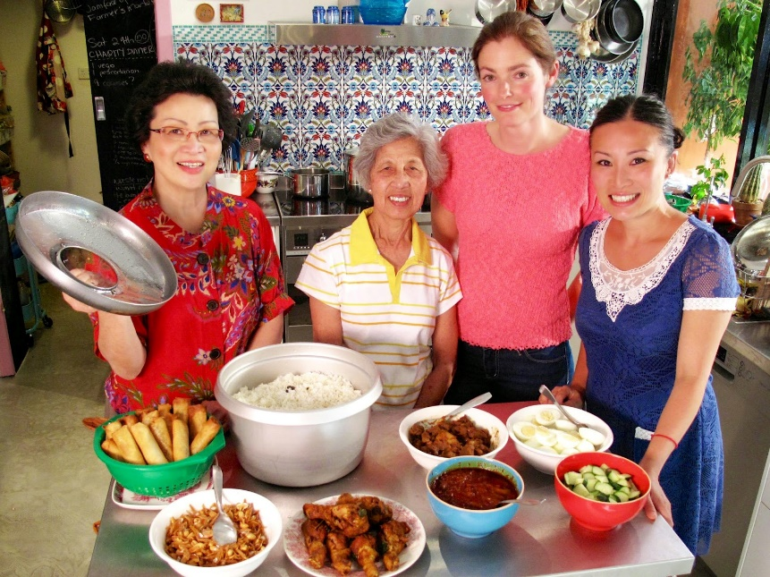
Figure 1 – Mama Yeow, Auntie Kim and Poh

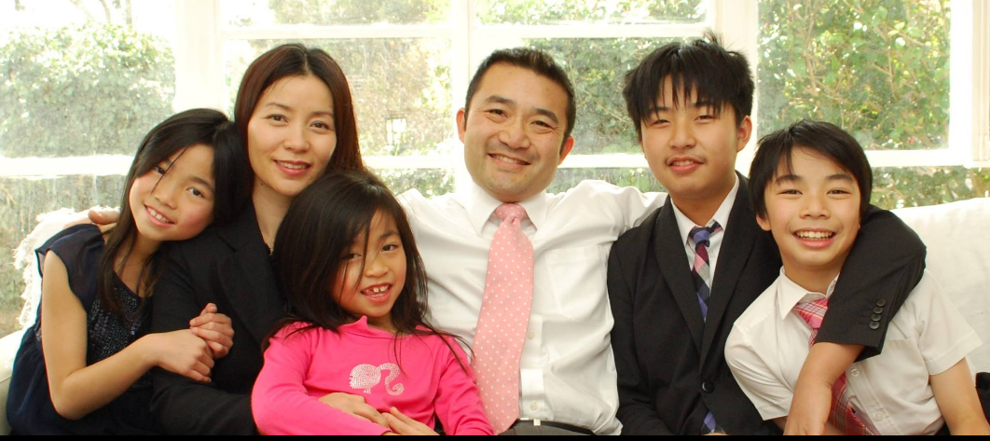
Figure 2 - Teena , myself and the kids
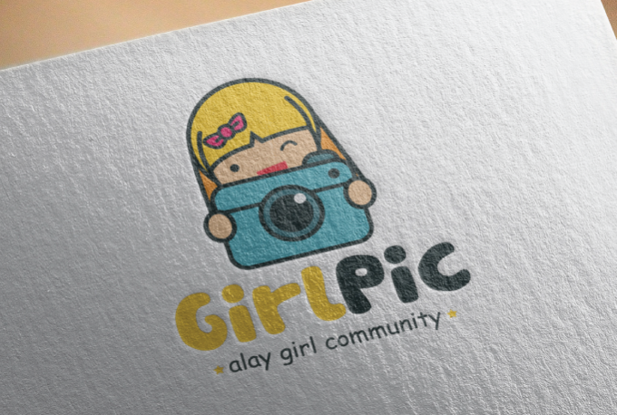
Figure 3. Style of logo I like

