BRIEF: Rebranding for Improve Group Who are we?
Improve Group is a training roganisation and a bit more, as we strive to bring our customers the business solutions in a form of auditing, consulting and training. The company has been on the market for 10 years and is unique in its way, we want to IMPROVE at everything we do, especially our Customers Business. Improve as a name has originated from Kaizen, one of the Lean Business Concepts.

Our current logo and the portfolio
Main company: http://www.improvegroup.com.au/
Other Business Units Involved:
http://www.worksafeskills.com.au/
https://www.glassskills.com.au/
http://leanskills.biz/

Current Logo:

Running man in the logo represents a person who is striving to improve. He has originated from the man running with the baton to pass it on in the competition. This reflected the message of staying competitive in the marketplace. 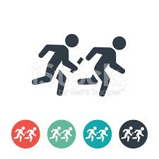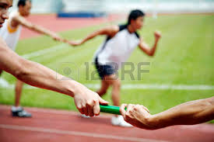
However, a further investigation showed that he may be too rushed, a bit similar to a man from an emergency exit sign, and a bit too sporty for a Registered Training Organization type of business.

Nevertheless, we are a small business and we are known and remembered by the running man. As a result we are looking to have more of a brand evolution rather than the brand overhaul. We believe we shouldn’t move too far away from where we are now. We just need to improve and simplify, but not to create all the new things at once.

New Business Structure:
We are currently undergoing the rebranding and consolidating all brands into one. New structure is going to be following:
Improve Group:
- Health and Safety – to replace Australasian College of Health and Safety

- Skills and Competencies – to replace Glass Skills Australia and add other skills

- Productivity and Efficiency – to Replace Lean Skills Australasia

Requirements:
One main logo (umbrella brand) for Improve Group with a headline:
Improve Group – safer, smarter, stronger workplaces


mprove Group

safer, smarter, stronger workplaces

We would like to see the evolution of the ‘Running man’ and we really like the concept above. We are expecting you to present a similar concept to the above by transforming our current running man into the ‘business builder’. Please only follow the example above.
3 sub-brand logos:
We would like to extend the main theme to the 3 business units:
Health and Safety - running man could wear some safety gear or be putting the first block on, or safety hat – to differentiate him for safety

Skills and Competencies – running man could do some work, or be putting a second block up

Productivity and Efficiency – running man is improving productivity at work, or putting a third block up…
Examples are circled here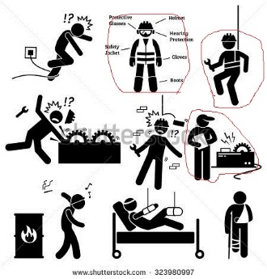

Please include the sub-brand names into the sub logos (i.e. one sub-logo will be Safety man + Health and Safety, one will be Work man+ Skills and Competencies, etc.)

Recommended colors:
Our team really likes the Orange and dark/light Grey scale of logo, with white where needed, e.g. on a reverse logo. Think of using capital I for Improve and capital G for Group, or present your version. We like Darker Grey for Improve and a light grey color for Group.
Colour Improve Group orange is made using the following colour values: PMS Orange 021 (pantone matching system). CMYK: 0, 78, 100, 0 RGB: 255, 92, 0 Hexidecimal: #FF5C00 or use orange from the running man, not the text!

Fonts:
Current fonts are outdated. We like lower case letters with/or rounded corners as it shows our friendliness and approachability, but we leave it up for a designer to present the font. We don’t like if the font is too stretchy.

Other:
We don’t want to be restrictive to the creative part, but we went to the stage we are quite sure what we would like to have, we just need a good execution and a clear path of the transition between the old and the new logo. However, if you think that your concept is stronger, feel free to present it to us. We will definitely choose one.

